Health Inequity in Salt Lake County

A Project Report to:

Ray J. Hoobler, Ph.D., Elena Cherkaev, Ph.D., David Kieda, Ph.D., and Kim Brunisholz, Ph.D.

as part of the

Professional Master of Science and Technology Professional Experience Project

Sponsored by:

The Professional Master of Science and Technology program

Submitted By:

Grace Tan (u0930530)

Date Apr 21, 2022

Table of Contents

1 Introduction 2

2 Dataset and Methods 7

2.1 The American Community Survey 5-Year data (2015-2019) 7

2.2 The CDC/ATSDR Social Vulnerability Index 8

2.3 The Area Deprivation Index (ADI) 8

2.4 Dataset structure 9

2.5 Process of Statistic Analysis 10

2.6 Introduction: Blinder-Oaxaca Decomposition 11

2.6.1 Threefold decomposition 11

2.6.2 Twofold decomposition 12

3 Empirical Research A. Uninsured Percentage by Tracts vs. Minority Status and Language 12

3.1 Descriptive Statistics 12

3.2 Linear Regression 14

3.3 Blinder-Oaxaca decomposition 15

3.3.1 Threefold decomposition 16

3.3.2 Twofold decomposition 18

3.4 Results 20

4 Empirical Research B. Uninsured Percentage by Tracts vs. Socioeconomic Status 21

4.1 Descriptive Statistics 21

4.2 Linear Regression Analysis 24

4.3 Blinder-Oaxaca decomposition 26

4.3.1 Threefold decomposition 26

4.3.2 Twofold decomposition 29

4.4 Results 32

5 Empirical Research C. Uninsured Percentage by Tracts vs. Household Composition 33

5.1 Descriptive Statistics 33

5.2 Linear Regression Analysis 36

5.3 Blinder-Oaxaca decomposition 38

5.3.1 Threefold decomposition 38

5.3.2 Twofold decomposition 40

5.4 Results 42

6 Empirical Research D. Complete (ADI) Model 43

6.1 Descriptive Statistics 43

6.2 Linear Regression Analysis 46

6.3 Blinder-Oaxaca decomposition 50

6.3.1 Threefold decomposition 51

6.3.2 Twofold decomposition 53

6.4 Results 59

7 Discussion 61

8 Conclusions 64

References 66

Details of Regression Diagnosis in Four Project Models 69

Appendix A: Minority Status and Language Model 69

Appendix B: Socioeconomic Status Model 91

Appendix C: Household Composition Model 125

Appendix D: Complete Model 152

**Abstract:** This study uses the American Community Survey 5-Year data (2015-2019), the CDC/ATSDR Social Vulnerability index, and Area Deprivation Index (ADI) to explore health inequity in Salt Lake County. We adopt uninsured health percent as the proxy for healthcare equity in the project and set tracts with high uninsured percent as the risk group and other tracts as the safe group. We refer to SVI variables classification and classify influencing factors under four subjects, including minority status and language, socioeconomic status, household composition, and environmental impact assessment. Using the Blinder-Oaxaca Decomposition method, empirical research finds apparent health disparities in Salt Lake County. We interpret the uninsured percentage of white alone, uninsured percentage of a native-born, uninsured percentage of worked full-time, uninsured percent with a bachelor’s degree or higher as potentially picking up the effect of the health insurance market in Salt Lake County experience. Other factor, including the uninsured percentage of people who live in family households, impacts the gap of uninsured percentage by tracts in the risk group and the safe group. We suggest that strengthening higher education and creating new full-time job opportunities will significantly improve health insurance status in disadvantaged neighborhoods.

**Keywords:** health inequity; census data; ACS 5; Salt Lake County; uninsured percent; Blinder-Oaxaca Decomposition

# 1 Introduction

Equity in medical services is essential to promoting health equity and social equity because medical services reflect the basic need of individuals. Margaret Whitehead wrote in The Concepts and Principles of Equity in Health that: "Equity in health implies that ideally everyone should have a fair opportunity to attain their full health potential and, more pragmatically, that no one should be disadvantaged from achieving this potential, if it can be avoided." (1992) In the face of illness and pain, everyone should have the same opportunities to access adequate medical services regardless of their income, wealth, race, region, etc. Health equity is the basic welfare of individuals, which is bound up with the community's welfare.

According to "What We Do and Don't Know About Recent Trends in Health Insurance Coverage in the US," "Prior to the pandemic, the uninsured rate increased incrementally for several years despite an improving economy. After historic declines in the number of uninsured people and the uninsured rate following the adoption and implementation of the 2010 Affordable Care Act (ACA), resulting in nearly 20 million more people covered through 2016, the number and rate of nonelderly uninsured people began to increase in 2017. The uninsured count grew from 26.7 million (10.0%) in 2016 to 27.6 million (10.2%) in 2017, 28.2 million (10.4%) in 2018, and, as was announced this week, 29.2 million (10.8%) in 2019 (Figure 1)." (Rachel Garfield and Jennifer Tolbert)

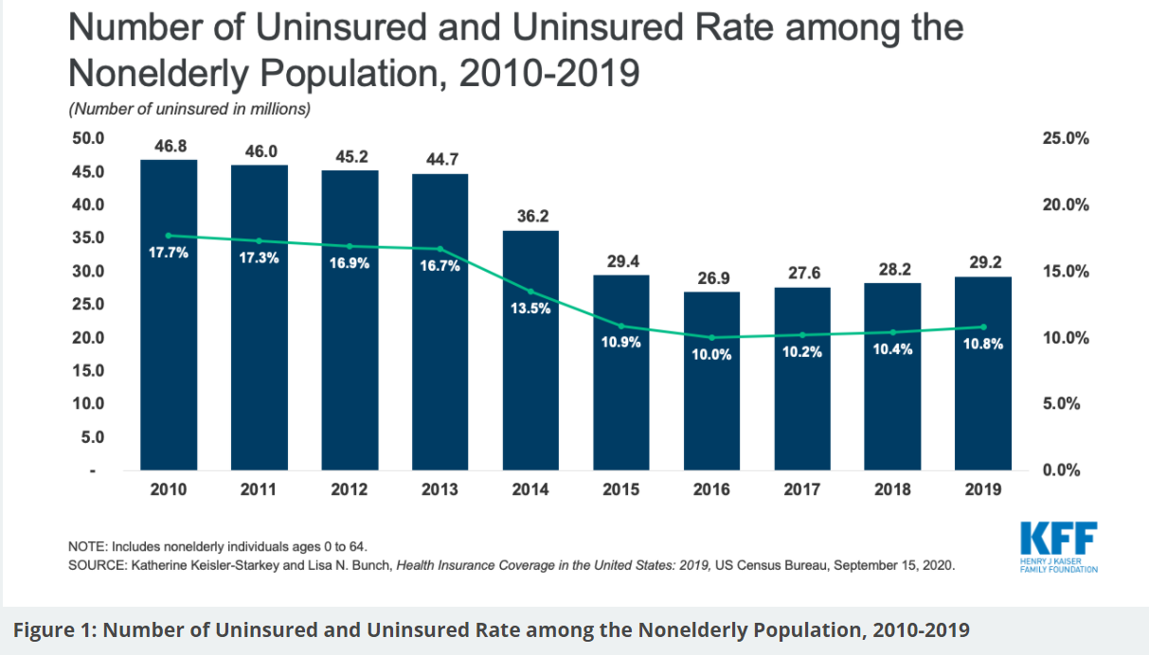

Figure 1. Number of Uninsured and Uninsured Rate among the Nonelderly Population, 2010-2019

According to the Voices for Utah Children, "Utah has one of the highest rates of uninsured kids. Could insuring them save taxpayers millions?" Utah has 82,000 children without health insurance. An estimated 8.3% of children in Utah do not have health insurance, and the state ranks 46th — among the worst in the country — for rates of uninsured children. (Jenny Rollins)

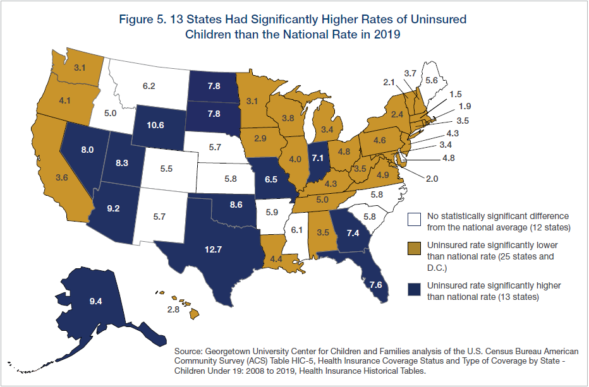

Figure 2. Uninsured Percent of Children among the States of USA. (Children's Uninsured Rate Rises by Largest Annual Jump in More Than a Decade.)

According to SVI 2018 Documentation-H, we use the data of ep. uninsured (Adjunct variable Percentage uninsured in the total civilian noninstitutionalized population estimate,

2014-2018 ACS) and draw the graph to show the uninsured percentage by tracts in Salt Lake County below.

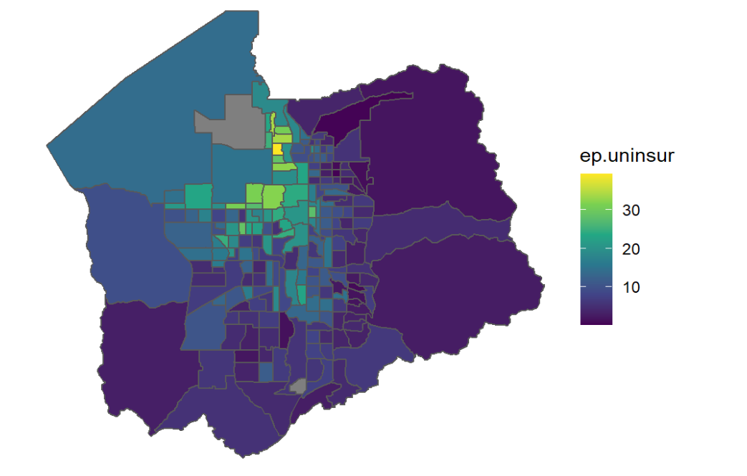

Figure 3. The Uninsured Percentage in Salt Lake County

Diversity, equity, and inclusion have become important topics across our society; however, it is often difficult to quantify these issues. Many scientists have explored the subject and done broad research in the long term. In 2007, O'Donnell *et al.* looked at the popularity of *equity* as a research topic using the number of references for the keyword "equity" in Medline indexed abstracts. Starting in 1980, when 33 articles were found, the number had increased to 294 by 2005. In 2020, there were over 8800 published articles where "equity" is found in the abstract (Figure 4 and Figure 5).



Figure 4. Medline Published Articles with "equity" in the Published Abstracts

Figure 5. The Ratio of Search Terms "equity" to "health" (per 10k) Appearing in Medline Published Abstracts.

I use publicly available datasets for this project, including the American Community Survey 5-Year data (2015-2019), the CDC/ATSDR Social Vulnerability index, and Area Deprivation Index (ADI), to explore healthcare inequity in Salt Lake County. These datasets provide information at the census tract level.

Due to limited use of the public dataset, I don't have specific data to reflect health services. For example, how many times does one person go to the hospital one year? How much money have they spent on it? I adopt the health insurance percentage as the proxy for healthcare equity in the project.

# 2 Dataset and Methods

## 2.1 The American Community Survey 5-Year data (2015-2019)

Most of the datasets in the project are from The American Community Survey 5-Year Data (ACS 5). We extract 26 columns under subjects "S2701_C05_***". These columns include percent uninsured by tracts, uninsured percent of male, uninsured percent of female, uninsured percent of age under 19 years, uninsured percent of age 19 to 64 years, uninsured percent of age 65 years and older, uninsured percent of in family households, uninsured percent of In family households!!In married-couple families, uninsured percent of in family households!!In other families, uninsured percent of in non-family households and other living arrangements, uninsured percent of Hispanic or Latino (of any race), uninsured percent of White alone, not Hispanic or Latino, uninsured percent of native-born, uninsured percent of foreign-born!! Naturalized, uninsured percent of foreign-born!! not a citizen, uninsured percent of less than high school graduate, uninsured percent of high school graduate (includes equivalency), uninsured percent of some college or associate's degree, uninsured percent of Bachelor's degree or higher, uninsured percent of worked full-time, uninsured percent of worked less than full-time, uninsured percent of did not work, uninsured percent of below 138 of the poverty threshold, uninsured percent of 138 to 399 of the poverty threshold, uninsured percent of at or above 400 of the poverty threshold. I merge 25 columns according to the tracts ID "GEOID" and generate the project's dataset (total of 26 columns, 25 columns+1 GEOID).

## 2.2 The CDC/ATSDR Social Vulnerability Index

According to the "CDC/ATSDR Social Vulnerability Index," "social vulnerability refers to the potential adverse effects on communities caused by external stresses on human health…

The CDC/ATSDR Social Vulnerability Index (CDC/ATSDR SVI) uses 15 U.S. census variables to help local officials identify communities that may need support before, during, or after disasters." I hold that English language proficiency impacts the types of careers then the health uninsured percent. Therefore I extract "EP_LIMENG" ((Persons who speak English "less than well" estimate / Population age five and overestimate) * 100)

from the "Utah.csv," which is downloaded from the website “ATSDR.” Then I merge the column with the dataset from ACS above according to the GEOID.

## 2.3 The Area Deprivation Index (ADI)

According to the website of the Center for Health Disparities Research (University of Wisconsin), ADI "allows for rankings of neighborhoods by a socioeconomic disadvantage in a region of interest (e.g., at the state or national level). It includes factors for the theoretical domains of income, education, employment, and housing quality. It can inform health delivery and policy, especially for the most disadvantaged neighborhood tracts." I consider ADI ranking demonstrates the qualities of the living environments of tracts. I extract "ADI_STATERNK" from "UT_2019_ADI_Census Block Group_v3.1.txt," which is downloaded from the website ATLAS.

Because ADI data with 12-digit FIPS and ACS 5 and SVI with 11-digit GEOID, for example,

Table 1 GEOID VS. FIPS

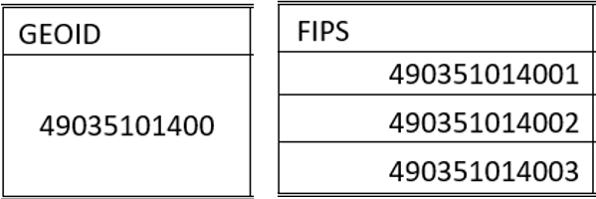

I calculate the averages of the ADI_STATERNK from the same tracts and replace the old "ADI_STATERNK" with the averages of the "ADI_STATERNK." According to the GEOID, I merge the new ADI_STATERNK with the dataset from 2.1 and 2.2 above.

## 2.4 Dataset structure

We have the dataset with 28 columns, including 26 columns from census data, 1 column from SVI, and 1 column from ADI.

I find the percent uninsured by tracts on the 80th percentile (15.86%) and split the tracts into two groups. The tracts with a percent uninsured by tracts higher than 15.86% are in risk group 1. Other tracts are in the safe group 0. I generate a column called "rank80," which indicates the group "0" and "1".

I find ADI state rank on the 80th percentile, seven, and split the tracts into two groups. The tracts with ADI state rank higher than 7 are in poor living environment group 1. Other tracts are in the safe group 0. I generate a column called "ADI80," which indicates the group "0" and "1".

There are 212 tracts in Salt Lake County. I deleted the rows from GEOID "49035112818" and "49035980000" because we missed all ACS data from these two tracts.

Then our dataset for this project has 210 rows and 30 Columns. Notice that we miss the value in the ADI table from GEOID 49035101400. When our models exclude the "ADI80" value, we have 210 entries in dataset 4. When our model includes the "ADI80" value, we have 209 entries in dataset 4.1.

## 2.5 Process of Statistic Analysis

We refer to SVI variables classification and classify influencing factors under four subjects, including minority status and language, socioeconomic status, household composition, and environmental impact assessment. We set the uninsured percentage by tracts as *y*. The tracts with a percent uninsured by tracts higher than 15.86% are at risk 1. Other tracts are in the safe group 0.

Empirical research will study how the minority status and language have an impact on *y*, how socioeconomic status has an impact on *y*, how the household composition has an impact on *y*, how minority status and language, socioeconomic status, household composition, environmental impact assessment combined have an impact on *y*. We will work on descriptive statistics, correlation analysis, linear regression analysis, regression diagnosis, and Oaxaca decomposition in every small and combined model. I will present the results and discussion.

At the end of the empirical research, I will draw a conclusion.

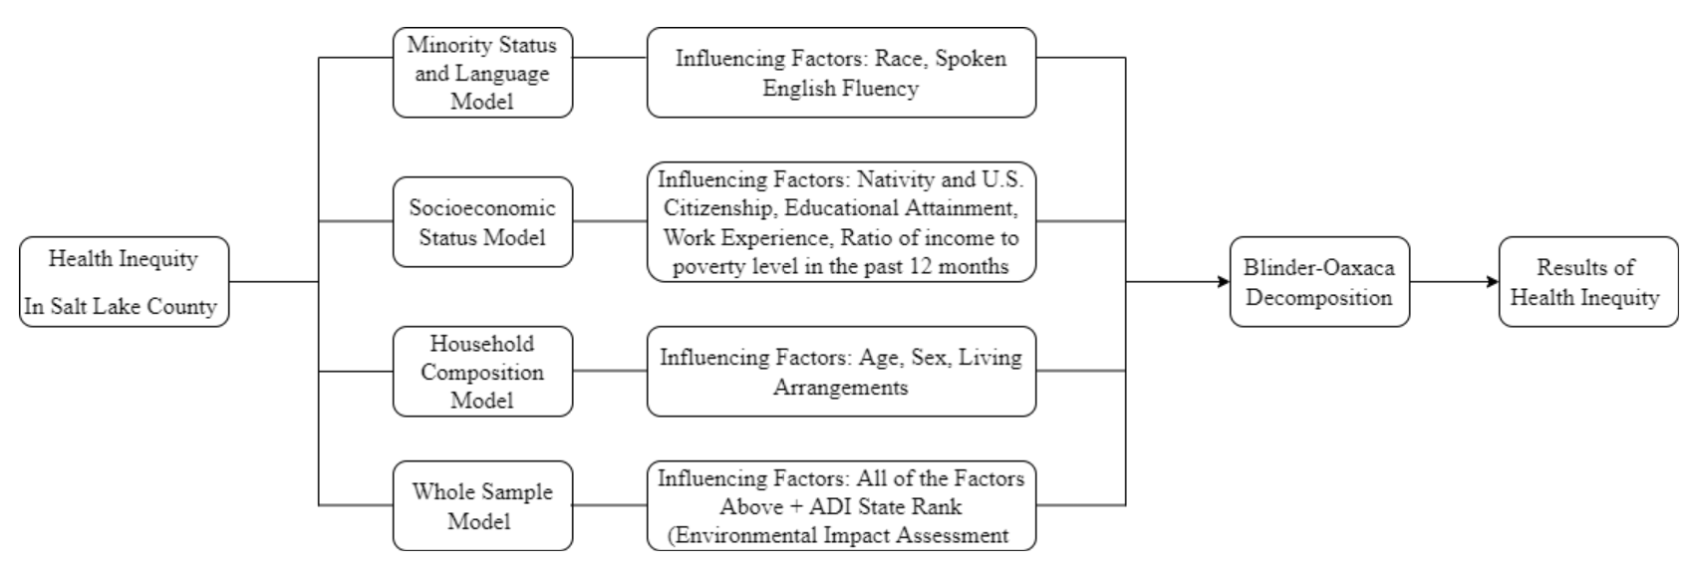

Figure 6 Project Analysis Framework

## 2.6 Introduction: Blinder-Oaxaca Decomposition

I refer to “Oaxaca: Blinder-Oaxaca Decomposition in R” by Marek Hlavac and adopt Blinder-Oaxaca Decomposition as the project model.

The Blinder-Oaxaca decomposition is a statistical method widely used to analyze types of inequity in sociology research across any two groups. According to "Oaxaca: Blinder-Oaxaca Decomposition in R," "The aim of the Blinder-Oaxaca decomposition is to explain how much of the difference in mean outcomes across two groups is due to group differences in the levels of explanatory variables, and how much is due to differences in the magnitude of regression coefficients (Oaxaca 1973; Blinder 1973)." (Marek Hlavac 2) In the project, I label the two groups as Group 0 (safe group) and Group 1 (risk group).

$$∆\overline{Y}=\overline{Y}₀-\overline{Y}₁ (1)$$

ΔY: the difference of mean uninsured percentage by tracts across two groups

Y̅₀: mean uninsured percentage by tracts of group 0

Y̅₁: mean uninsured percentage by tracts of group 1

### 2.6.1 Threefold decomposition

After we introduce linear regression, (1) can be rewritten as:

$∆\overline{Y}=\overline{X'}₀\hat{β}₀-\overline{X'}₁\hat{β}₁$ (2)

X̅₀: the mean values of explanatory variables in group 0

X̅₁: the mean values of explanatory variables in group 1

$\hat{β}₀$: the estimated regression coefficients in group 0

$\hat{β}₁:$ the estimated regression coefficients in group 1

The threefold Blinder-Oaxaca decomposition of the mean outcome difference is (3)

Interaction

Coefficients

Endowments

$∆\overline{Y}=\underbrace{(\overline{X}₀-\overline{X}₁)'\hat{β}₁}+\underbrace{\overline{X'}₁(\hat{β}₀-\hat{β}₁)}+\underbrace{(\overline{X}₀-\overline{X}₁)'(\hat{β}₀-\hat{β}₁)}$ (3)

Endowments: the contribution of differences in explanatory variables across two groups

Coefficients: due to group differences in the coefficients(discrimination).

Interaction: cross-group differences in explanatory variables and coefficients at the same time.

### 2.6.2 Twofold decomposition

The twofold Blinder-Oaxaca decomposition of the mean outcome difference is (4)

$∆\overline{Y}=\underbrace{(\overline{X}₀-\overline{X}₁)'\hat{β}ₑ}+\underbrace{\underbrace{\overline{X'}₀(\hat{β}₀-\hat{β}ₑ)}+\underbrace{\overline{X'}₁(\hat{β}ₑ-\hat{β}₁)}}$ (4)

Unexplained ( unexplained 0+unexplaned 1)

Explained

$\hat{β}ₑ:$ a vector of reference regression coefficients that are interpreted to be non-discriminatory

The explained: the mean outcome gap has often been attributed to non-discrimination

The unexplained: the mean outcome gap has often been attributed to discrimination. It can be further decomposed into two sub-components, labeled "unexplained 0" (discrimination in favor of Group 0) and "unexplained 1" (discrimination against Group 1).

# 3 Empirical Research A. Uninsured Percentage by Tracts vs. Minority Status and Language

## 3.1 Descriptive Statistics

Minority status and language contain race and English language proficiency variables. It includes three influencing factors: uninsured percent of Hispanic or Latino (of any race), uninsured percent of White alone (not Hispanic or Latino), and the percentage of persons who speak English "less than well."

Table 2 Descriptive Statistics of Minority Status(%)

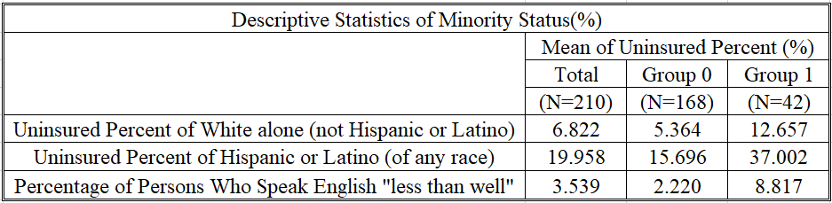

Table 3 Descriptive Statistics of Uninsured Percentage by Tracts(%)

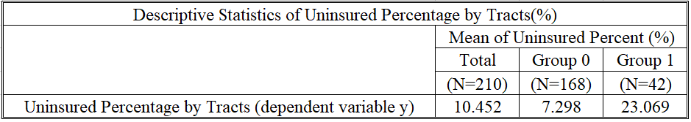

We have found that the means of uninsured percent of white alone and the means of percentage of persons who speak English 'less than well' are lower than the means of uninsured percentage by tracts in total, group 0 and group 1. However, the means of uninsured percent of Hispanics or Latino (of any race) are higher than the means of uninsured percentage by tracts in total, group 0 and group 1. We have found obvious health disparities in the race. The health insured status of white alone is better than that of other races.

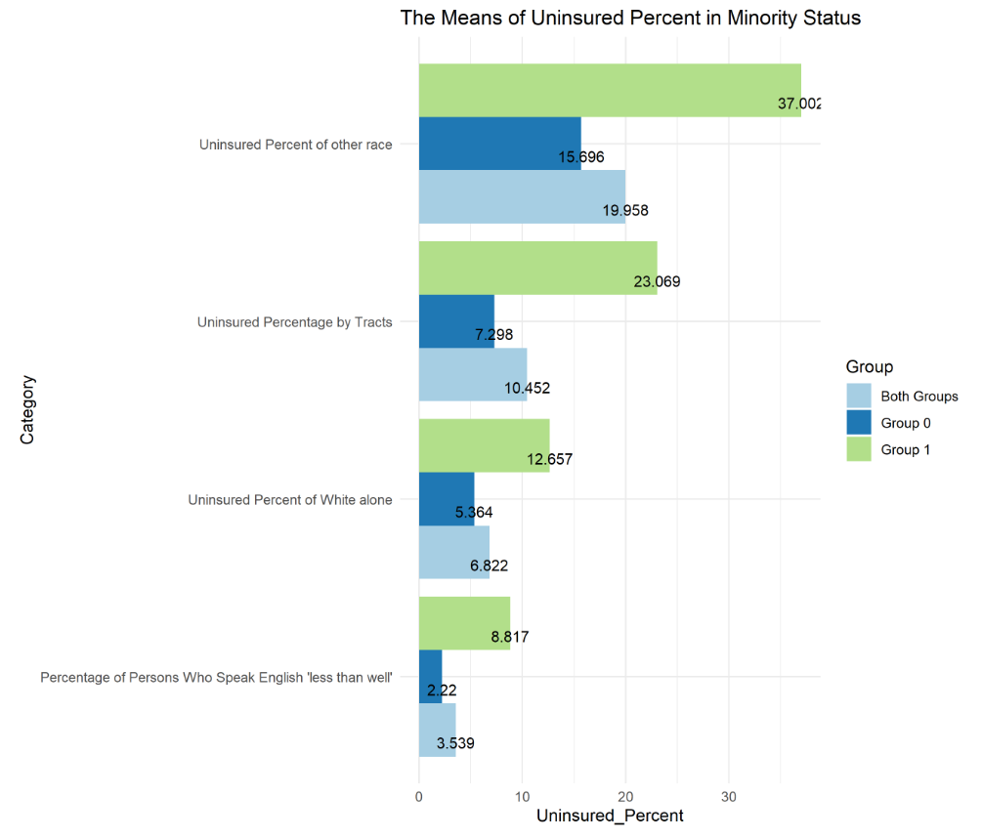

Figure 7 The Means of Uninsured Percent in Minority Status

## 3.2 Linear Regression

According to “What is a Box Cox Transformation?”, “The Box-Cox transformation is named after statisticians George Box and Sir David Roxbee Cox, who collaborated on a 1964 paper and developed the technique…A Box-Cox transformation transforms non-normal dependent variables into a normal shape” (Statistics How To). The transformation to improve the test results of regression diagnosis, including normality, independence, and homoscedasticity of residuals, has been effective.

I build a minority status linear regression model using this formula

$$Uninsured Percent by Tracts with Best Lambda \sim Uninsured Percent of Hispanic or Latino (of any race)+Percentage of Persons Who Speak English "less than well" + Uninsured Percent of White alone (not Hispanic or Latino)$$

Table 4 Linear Regression Coefficients in Minority Status Model

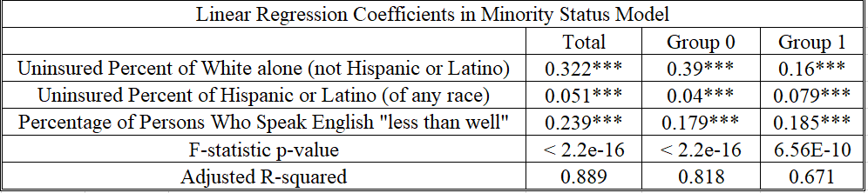

Signif. codes: 0 ‘***’ 0.001 ‘**’ 0.01 ‘*’ 0.05 ‘.’ 0.1 ‘ ’ 1

All of the influencing factors affect uninsured percent by tracts in both groups, group 0 and group 1.

F-statistic p-values mean that the regression model fits the data better than the model with no independent variables.

Adjusted R-squared: 0.8889 and 0.8183 Goodness-of-fit measure

Because the project's goal is how influence factors impact uninsured percentage by tracts rather than predictions, the small R-squared value of 0.671 will not affect the results.

## 3.3 Blinder-Oaxaca decomposition

I am interested in decomposing the uninsured percentage gap between tracts of group 0 and group 1. The uninsured percentage gap could be due to group differences in the level of uninsured percentage determinants such as race, income, education, etc. In this model, I will focus on race and English language fluency.

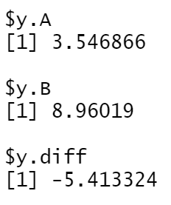

Figure 8 The Mean Uninsured Percentage by Tracts after Transformation

In Oaxaca decomposition, we have 210 entries, including 168 entries in group 0 (A) and 42 entries in group 1(B). The actual mean uninsured percentage by tracts is -15.771% (7.298%- 23.069%). After data transformation, the *y* component indicates that the mean uninsured percentage by tracts is 3.547% for group 0 (A) and 8.96% for group 1(B), leaving the difference of approximately -5.413% to be explained by the Blinder-Oaxaca decomposition.

### 3.3.1 Threefold decomposition

This is the plot of the threefold decomposition variable by variable.

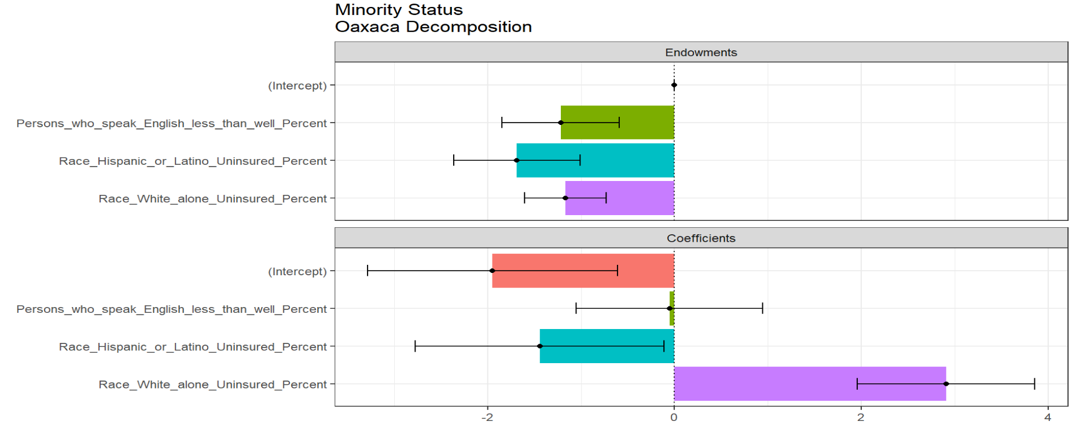

Figure 9 Plot of the Threefold Decomposition of Minority Status Model

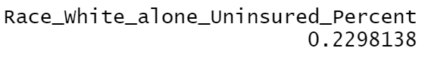

Figure 10 Differences in the Regression Coefficients on White Alone

As figure 9 shows, most variables are either insignificant or exhibit only marginal statistical significance in the endowments and coefficient components. The only variable which achieves clear statistical significance is the uninsured percentage of white alone.

As the difference in the uninsured percent of white alone coefficients between the safe group and risk group shows, the uninsured percent payoff of an additional uninsured percentage of white alone is more significant for the safe group by almost 0.23%. Note that 0.23% is the uninsured percentage after transformation. It’s not the actual uninsured percentage. As Figure 9 makes clear, differences in the regression coefficients on the uninsured percentage of white alone account for the decisive portion of the uninsured percentage by tracts gap in minority status and language model.

### 3.3.2 Twofold decomposition

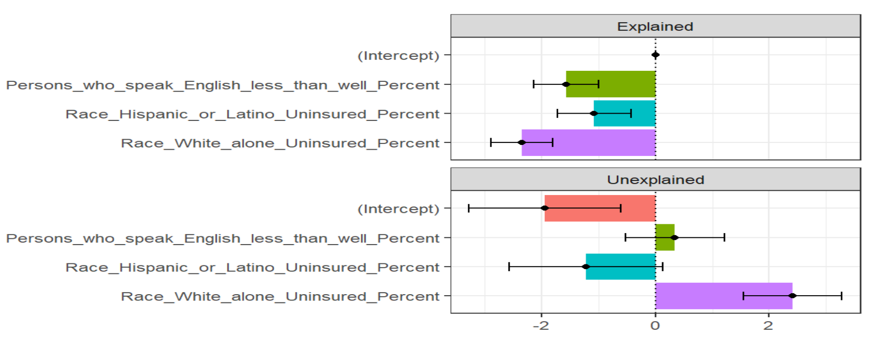

Figure 11 The Explained and Unexplained Components of a Twofold Blinder-Oaxaca Decomposition of Safe Group 0 vs. Risk Group 1 Gap

Figure 11 provides a variable-by-variable twofold decomposition. The results are consistent with the threefold composition. It appears that the gap of uninsured percentage by tracts is driven largely by safe groups’ greater returns to the uninsured percentage of white alone.

Let’s explore the unexplained component even further. Figure 12 visualizes how much of the unexplained portion of the uninsured percentage by tracts gap can be attributed to discrimination in favor of the safe group 0 and how much is due to discrimination against the risk group 1.

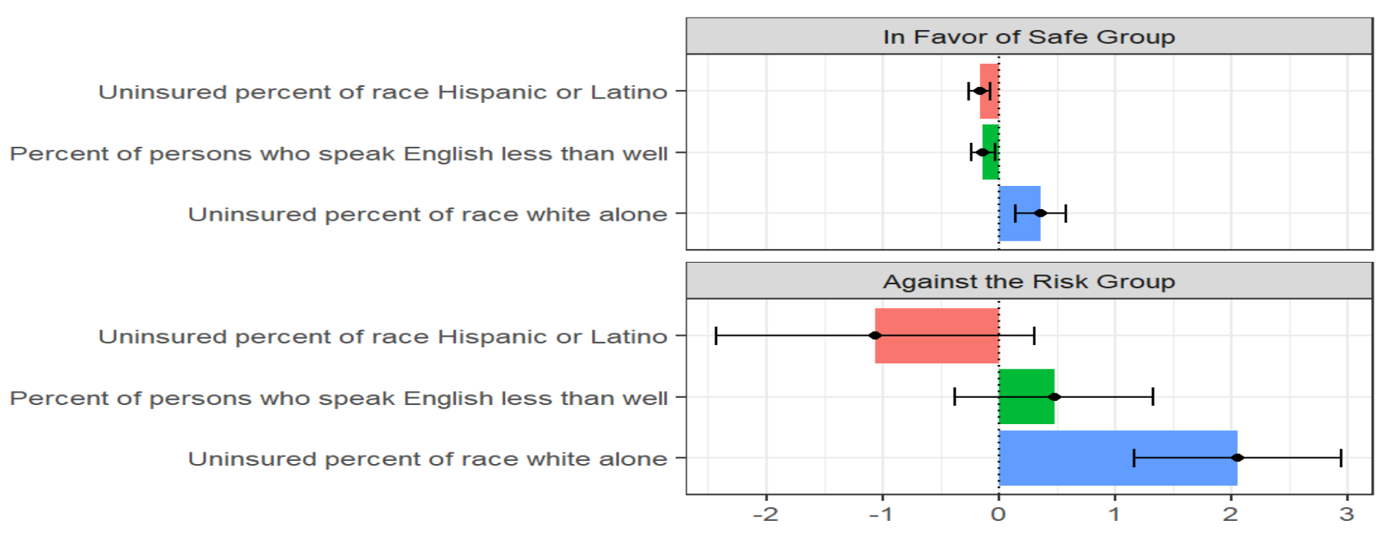

Figure 12 The Unexplained Portion's Discrimination Sub-Components in a Twofold Blinder-Oaxaca Decomposition of Safe Group 0 vs. Risk group 1

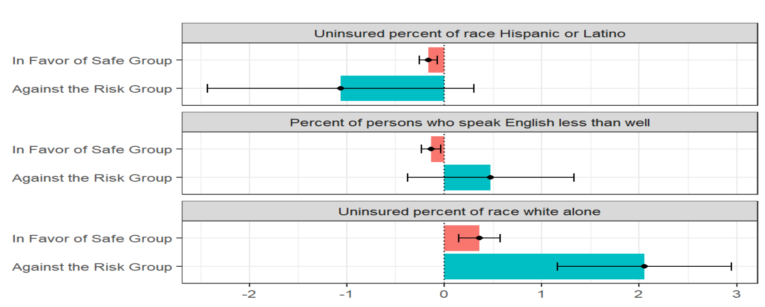

*Figure 13 The Unexplained Portion's Discrimination Sub-Components in a Twofold Blinder-Oaxaca Decomposition of Safe Group 0 vs. Risk Group 1 Gap. An Alternative Presentation*

The impacts of the uninsured percentage of white alone are more significant on the risk group than on the safe group. In other words, even if the safe group had the same average uninsured percentage of the white alone as the risk group, the risk group would, on average, reach a higher uninsured percentage of the tracts than the safe group would.

We also observe that the impacts of the percentage of persons who speak English less than well are more significant on the risk group than on the safe group. In other words, even if the safe group had the same average percentage of persons who speak English less than well as the risk group, the risk group would, on average, reach a higher uninsured percentage of the tracts than the safe group would.

## 3.4 Results

We failed to identify any additional causes of health disparities beyond race. Race white alone has better health insurance status than other types of race. The threefold decomposition result shows that differences in the regression coefficients on the uninsured percentage of white alone account for the decisive portion of the uninsured percentage by tracts gap in minority status and language model. The twofold decomposition results demonstrate that the impacts of the uninsured percentage of white alone and the percentage of persons who speak English less than well are more significant on the risk group than on the safe group. Those results make some intuitive sense if we interpret the uninsured percentage of white alone and the percentage of persons who speak English less than well, potentially picking up the effect of the health insurance market in Salt Lake County experience.

# 4 Empirical Research B. Uninsured Percentage by Tracts vs. Socioeconomic Status

## 4.1 Descriptive Statistics

Socioeconomic status contains the uninsured percent of native-born, uninsured percent of foreign-born!! Naturalized, uninsured percentage of foreign-born!! not a citizen, uninsured percent of less than high school graduate, uninsured percent of high school graduate (includes equivalency), uninsured percent of some college or associate's degree, uninsured percent of Bachelor's degree or higher, uninsured percent of worked full-time, uninsured percent of worked less than full-time, uninsured percent of did not work, uninsured percent of below 138 percent of the poverty threshold, uninsured percent of 138 to 399 percent of the poverty threshold, uninsured percent of at or above 400 percent of the poverty threshold.

Table 7 Descriptive Statistics of Socioeconomic Status (1)

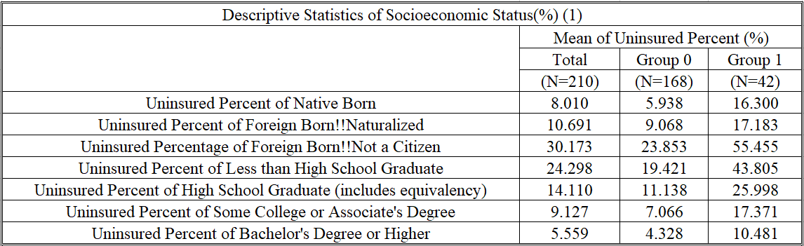

Table 8 Descriptive Statistics of Socioeconomic Status (2)

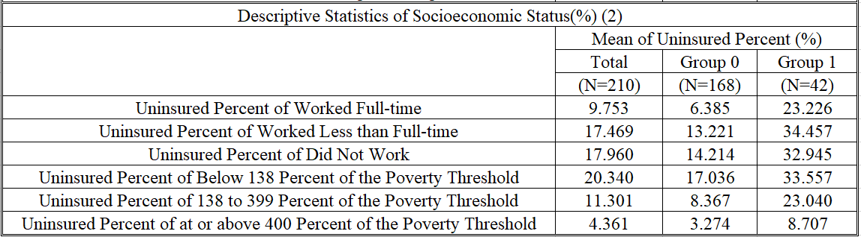

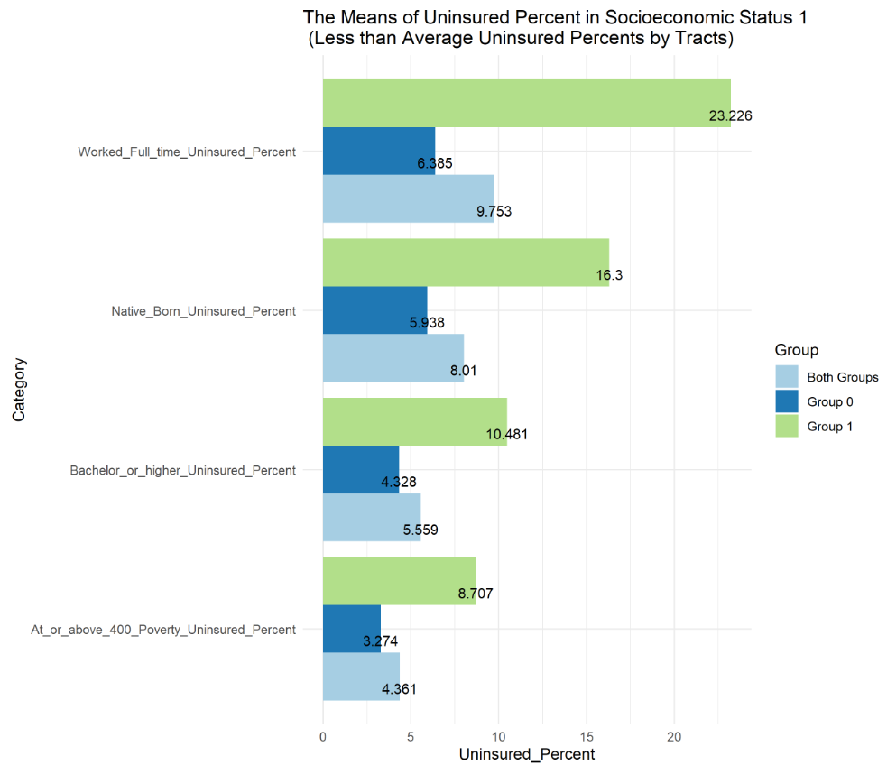

Figure 14 The Means of Uninsured Percent in Socioeconomic Status 1 (Less than Average Uninsured Percent by Tracts)

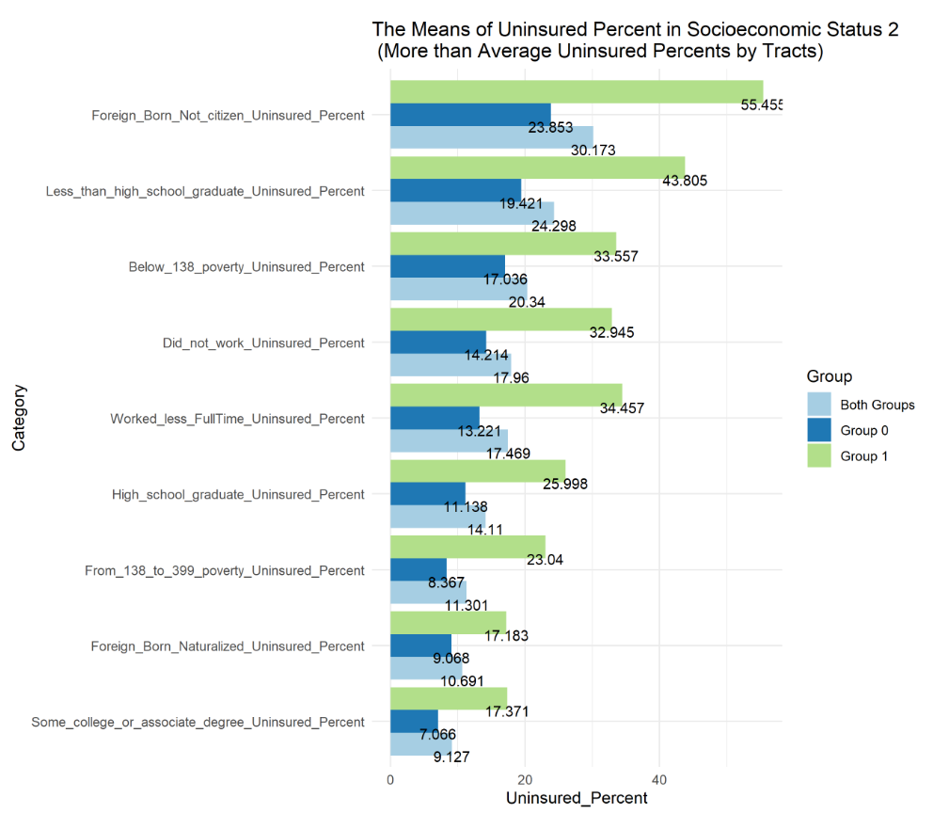

Figure 15 The Means of Uninsured Percent in Socioeconomic Status 2 (More than Average Uninsured Percent by Tracts)

We have found that the mean of uninsured percent of native-born, the mean of uninsured percent of bachelor’s degree or higher, the mean of uninsured percent of working full-time, the mean of uninsured percent of at or above 400 percent of the poverty threshold are lower than the mean of uninsured percentage by tracts in total, group 0 and group 1. However, the means of other factors are higher than the mean uninsured percentage by tracts in total or group 0 or group 1. The health insured status of native-born, Bachelor's degree or higher, worked full-time, at or above 400 percent of the poverty threshold are better than the other types of people.

## 4.2 Linear Regression Analysis

In a multiple regression model, the high correlated influencing factors impact the valid results about any individual influencing factor. To avoid multicollinearity, I adopt two steps to fix the problem.

Step 1: Use the step() function to find the best linear model with the least AIC.

Step 2: Use the method of the relative importance of regressors in linear models to merge highly correlated factors.

I refer to the introduction on the R official website (https://cran.r-project.org/) and adopt the method of the relative importance of regressors in linear models using the "relaimpo" package to find weights of factors. The recommended metric is lmg, which provides a decomposition of the model explained variance into non-negative contributions. Because uninsured percent of native-born, uninsured percent of worked full-time, uninsured percent of 138 to 399 percent of the poverty threshold are highly correlated, I generated a new column called "NativeBorn_ WorkedFulltime_ From138to399poverty_MultiFactor". Using the formula, I calculated the weighted average of uninsured percent of native-born, uninsured percent of worked full-time, uninsured percent of 138 to 399 percent of the poverty threshold.

$${NativeBorn}_{_}{WorkedFulltime}_{_}From138to{399poverty}_{__}MultiFactor=0.393* uninsured percent of native-born+ 0.337* uninsured percent of worked full-time+0.27* uninsured percent of 138 to 399 percent of the poverty threshold$$

I replace the three columns with "NativeBorn_WorkedFulltime_From138to399poverty_MultiFactor".

Then I use Box-Cox Transformation to find the best lambda and build the socioeconomic status linear regression model using this formula

$$uninsured percent by tracts with best lambda \sim uninsured percentage of foreign-born‼ not a citizen +NativeBorn_WorkedFulltime_From138to399poverty_Multifactor+uninsured percent of Bachelor' s degree or higher+uninsured percent of worked less than full-time+ uninsured percent of did not work+ uninsured percent of below 138 percent of the poverty threshold$$

These are the linear regression results.

Table 9 Linear Regression Coefficients in Socioeconomic Status Model

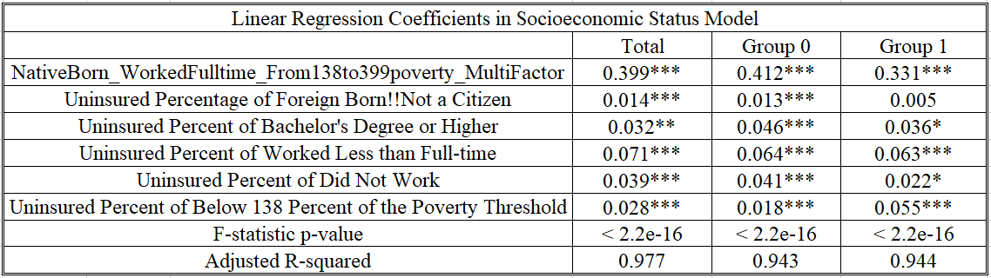

Signif. codes: 0 ‘***’ 0.001 ‘**’ 0.01 ‘*’ 0.05 ‘.’ 0.1 ‘ ’ 1

All of the influencing factors affect uninsured percent by tracts.

F-statistic p-values mean that the regression model fits the data better than the model with no independent variables.

The values of adjusted R-squared show Goodness-of-fit.

## 4.3 Blinder-Oaxaca decomposition

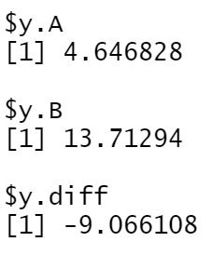

Figure 16 The Mean Uninsured Percentage by Tracts after Transformation

In Oaxaca decomposition, we have 210 entries, including 168 entries in group 0 (A) and 42 entries in group 1(B). The actual mean uninsured percentage by tracts is -15.771% (7.298%- 23.069%). After data transformation, the *y* component indicates that the mean uninsured percentage by tracts is 4.647% for group 0 (A) and 13.713% for group 1(B), leaving the difference of approximately -9.066% to be explained by the Blinder-Oaxaca decomposition.

### 4.3.1 Threefold decomposition

This is the plot of the threefold decomposition variable by variable.

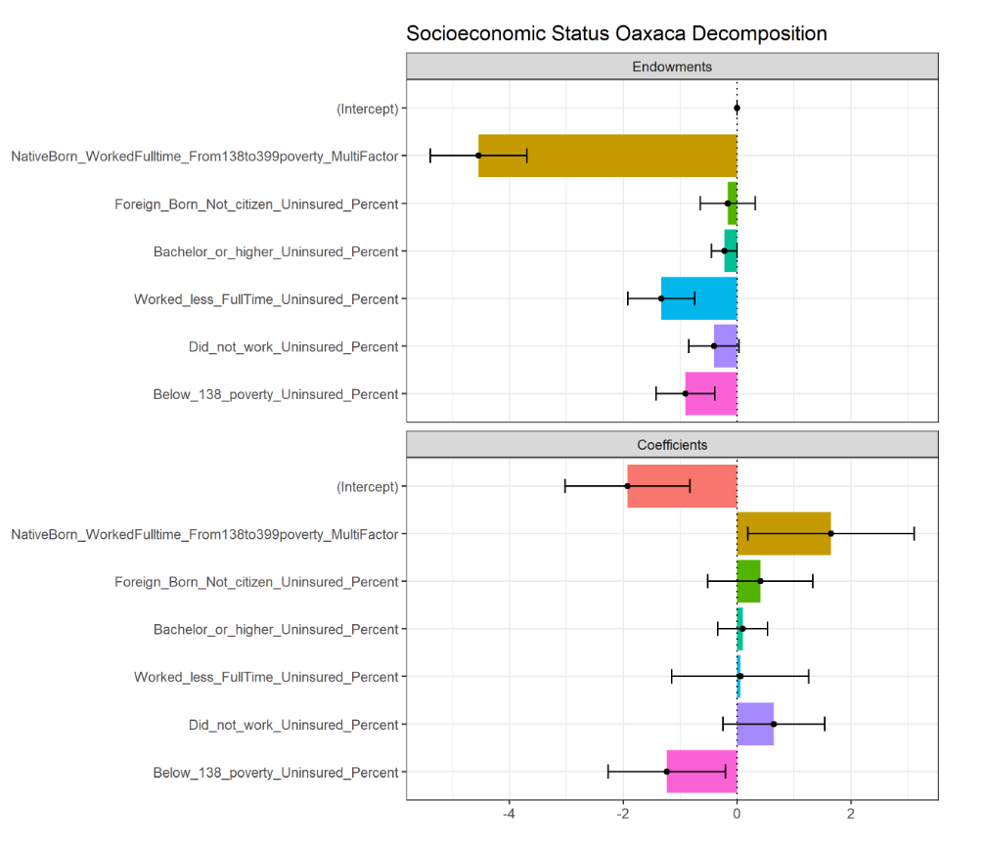

Figure 17 Plot of the Threefold Decomposition of Socioeconomic Status Model

Table 11 Differences in the Regression Coefficients on NativeBorn_WorkedFulltime_From138to399poverty_MultiFactor



The difference in the uninsured percent of people who are native-born or have full-time jobs or are in the range of 138 and 399 percent of the poverty threshold between the safe group and risk group shows, the uninsured percent payoff of an additional uninsured percentage of people who are native-born or have full-time jobs or are in the range of 138 and 399 percent of the poverty threshold is more significant for the safe group by almost 0.081%. Note that 0.081% is the uninsured percentage after transformation. It’s not the actual uninsured percentage. As Figure 17 makes clear, differences in the regression coefficients on the uninsured percentage of people who are native-born or have full-time jobs or are in the range of 138 and 399 percent of the poverty threshold account for the most significant portion of the uninsured percentage by tracts gap in socioeconomic status model. Other coefficients, including the uninsured percentage of foreign-born‼ not a citizen, uninsured percent of Bachelor's degree or higher, uninsured percent of worked less than full-time, uninsured percent of did not work have effects on the uninsured percentage by tracts gap in the socioeconomic status model too.

### 4.3.2 Twofold decomposition

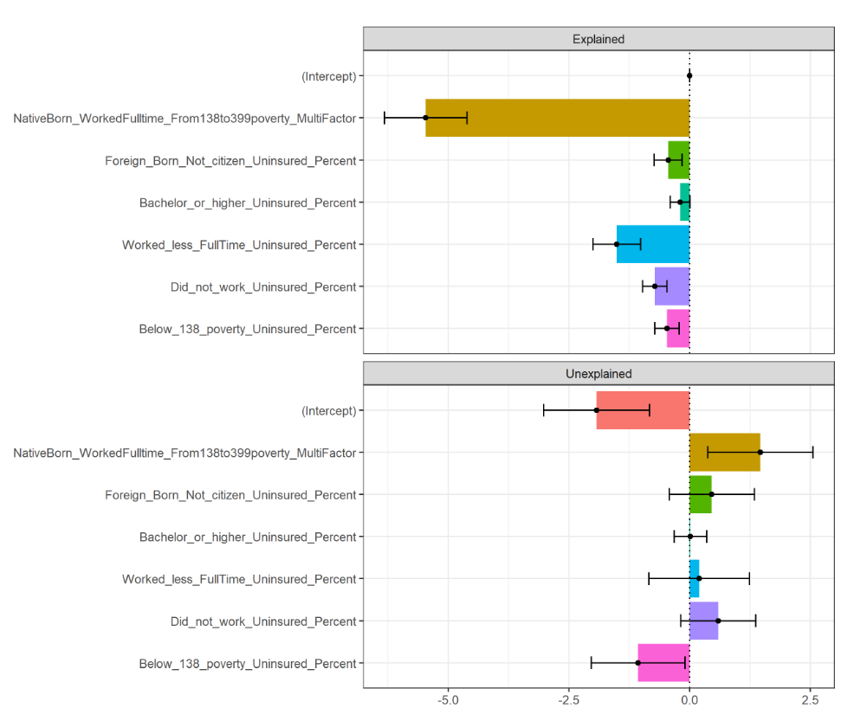

Figure 18 The Explained and Unexplained Components of a Twofold Blinder-Oaxaca Decomposition of Safe Group 0 vs. Risk Group 1 Gap

Figure 18 provides a variable-by-variable twofold decomposition. The results are consistent with the threefold composition. It appears that the gap of uninsured percentage by tracts is driven largely by safe groups’ greater returns to the uninsured percentage of people who are native-born or have full-time jobs or are in the range of 138 and 399 percent of the poverty threshold.

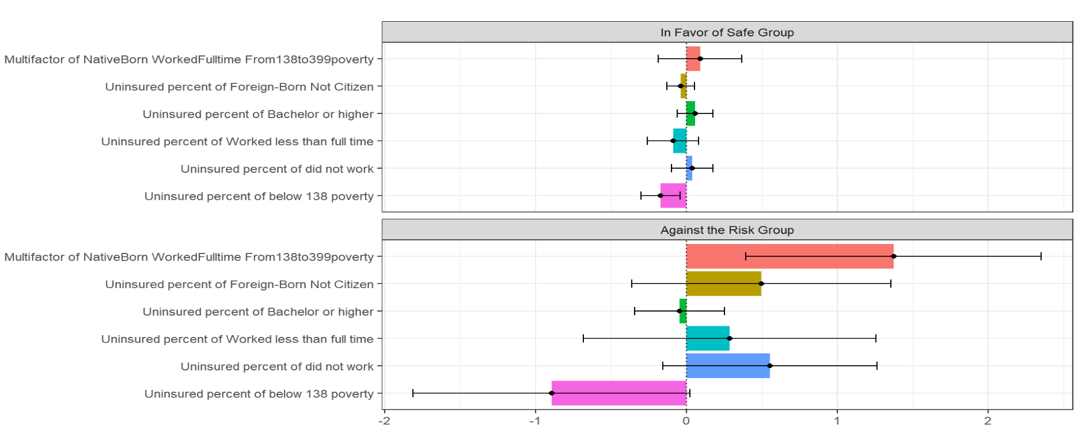

Figure 19 The unexplained portion's discrimination sub-components in a twofold Blinder-Oaxaca decomposition of safe group 0 vs. risk group 1 gap. An alternative presentation (1)

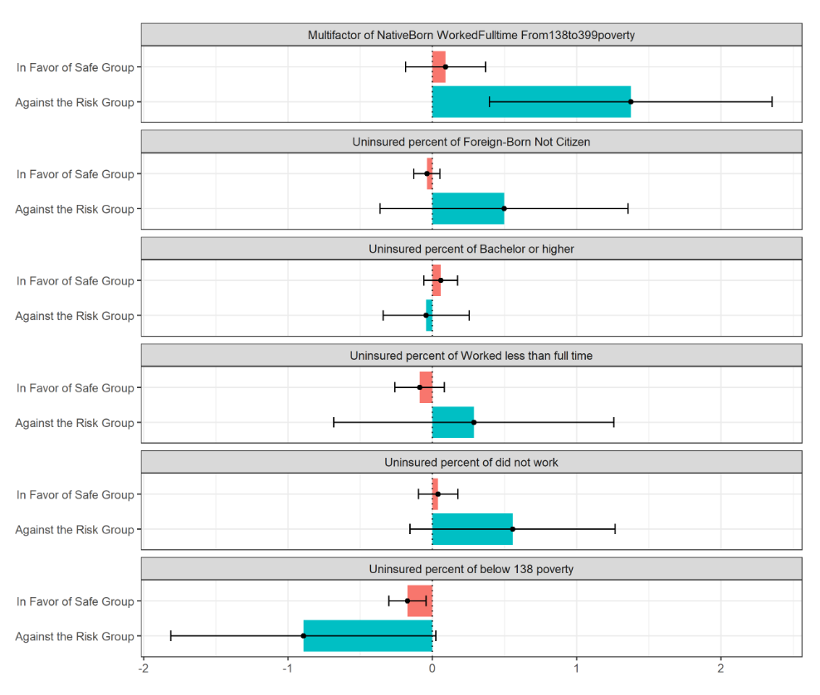

Figure 20 The Unexplained Portion's Discrimination Sub-Components in a Twofold Blinder-Oaxaca Decomposition of Safe Group 0 vs. Risk Group 1 Gap. An Alternative Presentation (2)

The impacts of the uninsured percentage of people who are native-born or have full-time jobs or are in the range of 138 and 399 percent of the poverty threshold are more significant on the risk group than on the safe group. In other words, even if the safe group had the same average uninsured percentage of the multifactor as the risk group, the risk group would, on average, reach a higher uninsured percentage of the tracts than the safe group would.

The impacts of the uninsured percentage of foreign-born‼ not a citizen, uninsured percent of worked less than full-time, uninsured percent of did not work are greater in the risk group than in the safe group.

## 4.4 Results

We have found apparent health disparities in the socioeconomic status model. People at or above 400 percent of the poverty threshold or native-born or have Bachelor’s degrees or higher or full-time jobs have better health insurance status than others. The threefold decomposition result shows differences in the regression coefficients on the uninsured percentage of native-born people, full-time jobs, or 138 and 399 percent of the poverty threshold account for the most significant portion of the uninsured percentage tracts gap in the socioeconomic status model.

Twofold decomposition results demonstrate that the impacts of the uninsured percentage of people who are native-born or have full-time jobs or are in the range of 138 and 399 percent of the poverty threshold, uninsured percentage of foreign-born‼ not a citizen, uninsured percent of worked less than full-time, uninsured percent of did not work are greater on risk group than on the safe group. Those results make some intuitive sense if we interpret the uninsured percentage of employment status, in the range of 138 and 399 percent of the poverty threshold, native-born, and bachelor's degree or higher as potentially picking up the effect of the health insurance market in Salt Lake County experience.

# 5 Empirical Research C. Uninsured Percentage by Tracts vs. Household Composition

## 5.1 Descriptive Statistics

Household Composition contains the uninsured percent of male, uninsured percent of female, uninsured percent of age under 19 years, uninsured percent of age 19 to 64 years, uninsured percent of age 65 years and older, uninsured percent of in family households, uninsured percent of in family households!! In married-couple families, uninsured percent of in family households!! In other families, the uninsured percent of in non-family households and other living arrangements.

Table 14 Descriptive Statistics of Household Composition(%)

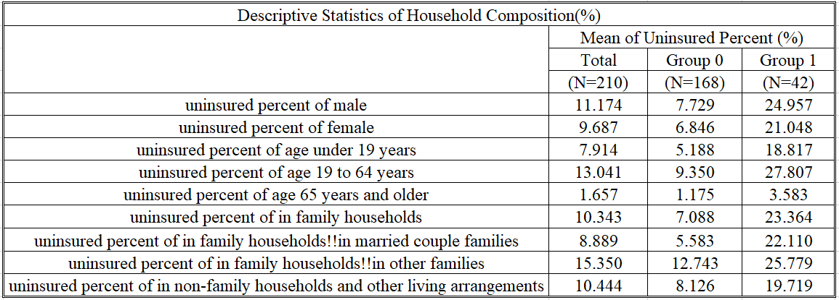

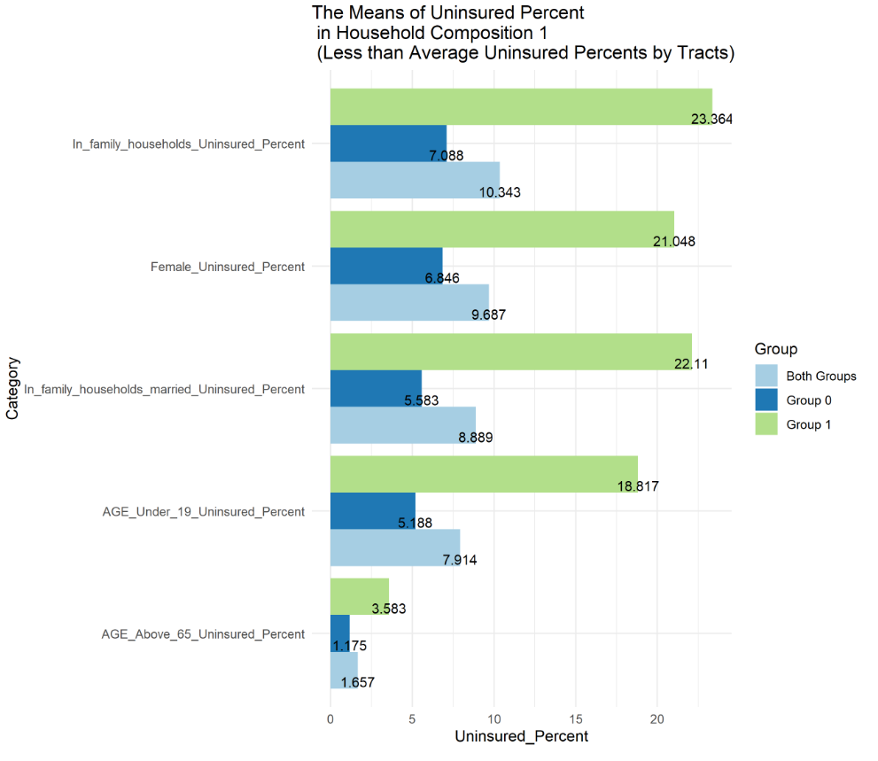

Figure 21 The Means of Uninsured Percent in Household Composition 1 (Less than Average Uninsured Percent by Tracts)

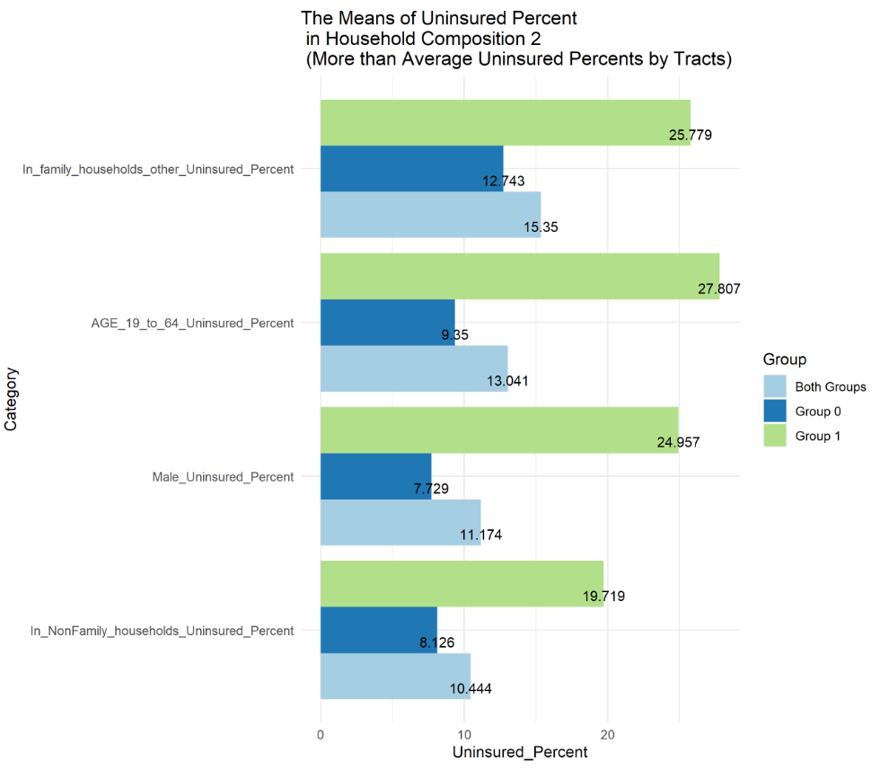

Figure 22 The Means of Uninsured Percent in Household Composition 2 (More than Average Uninsured Percent by Tracts)

We have found that the means of uninsured percent of females, the means of uninsured percent of age under 19 years, the means of uninsured percent of age 65 years and older, the means of uninsured percent in family households!! In married couples, the means of uninsured percent in family households!! are lower than the means of the uninsured percentage by tracts in total, groups 0 and 1. However, the means of other factors are higher than the mean uninsured percentage by tracts in whole or group 0 or group 1. The health insured status of age 65 years and older is better than the one of other factors—this type of person benefits from US Medicare.

## 5.2 Linear Regression Analysis

In a multiple regression model, the high correlated influencing factors impact the valid results about any individual influencing factor. To avoid multicollinearity, I adopt two steps to fix the problem. The first step is to use the step() function for the best linear model with the least AIC. The second step is to use the method of the relative importance of regressors in linear models for merging highly correlated factors.

Because the uninsured percent of female, uninsured percent of male, uninsured percent of age 19 to 64 years, uninsured percent of in family households!!in married-couple families, uninsured percent of in family households have correlation coefficients higher than 0.85. I merge these factors and generate a column called "Age19To64_Sex_InFamilyHousehold_married_multifactor" using this formula

I replace the five columns, including the uninsured percent of females, uninsured percent of males, uninsured percent of age 19 to 64 years, uninsured percent of in family households!!in married-couple families, uninsured percent of in family households with Age19To64_Sex_InFamilyHousehold_married_multifactor.

Then I use Box Cox Transformation to find the best lambda and build the socioeconomic status linear regression model using this formula

$$the uninsured percent by tracts with best lambda \sim +Age19To64_Sex_InFamilyHousehold_married_multifactor+uninsured percent of in non-family households and other living arrangements$$

These are the linear regression results.

Table 15 Linear Regression Coefficients in Household Composition Model

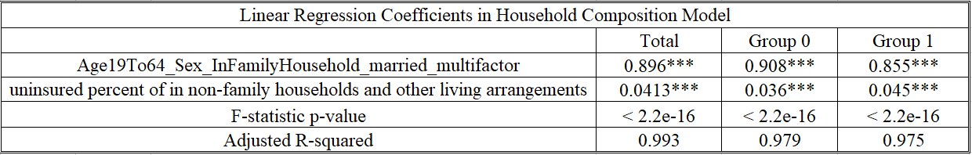

Signif. codes: 0 ‘***’ 0.001 ‘**’ 0.01 ‘*’ 0.05 ‘.’ 0.1 ‘ ’ 1

All of the influencing factors affect uninsured percent by tracts.

F-statistic p-values mean that the regression model fits the data better than the model with no independent variables.

The values of adjusted R-squared show Goodness-of-fit.

## 5.3 Blinder-Oaxaca decomposition

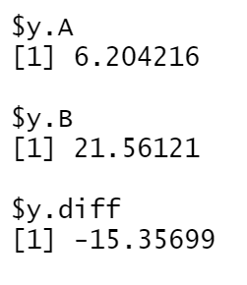

Figure 23 The Mean Uninsured Percentage by Tracts after Transformation

In Oaxaca decomposition, we have 210 entries, including 168 entries in group 0 (A) and 42 entries in group 1(B). The actual mean uninsured percentage by tracts is -15.771% (7.298%- 23.069%). After data transformation, the *y* component indicates that the mean uninsured percentage by tracts is 6.204% for group 0 (A) and 21.561% for group 1(B), leaving the difference of approximately -15.357% to be explained by the Blinder-Oaxaca decomposition.

### 5.3.1 Threefold decomposition

This is the plot of the threefold decomposition variable by variable.

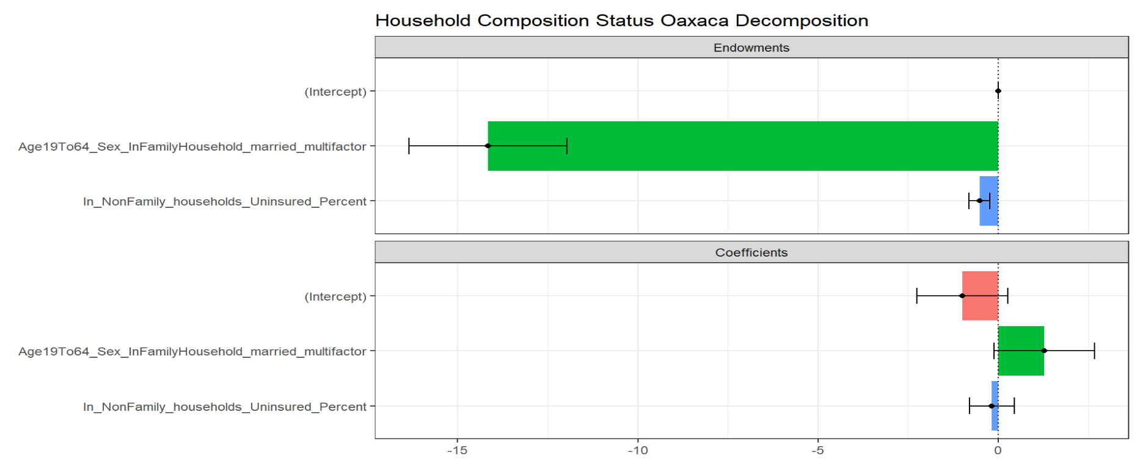

Figure 24 Threefold Decomposition of Household Composition Status

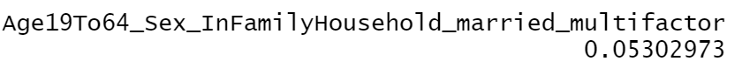

Figure 25 Differences in the Regression Coefficients on Age19To64_Sex_InFamilyHousehold_married_multifactor

The difference in the uninsured percent of people who are from19 to 64 years old or live in family households or family households!! In married-couple families between the safe group and risk group shows, the uninsured percent payoff of an additional uninsured percentage of the multifactor is more significant for the safe group by almost 0.05%. Note that 0.05% is the uninsured percentage after transformation. It’s not the actual uninsured percentage. As Figure 24 clarifies, there are differences in the regression coefficients on the uninsured percentage of people who are from19 to 64 years old or live in family households or family households!! In married-couple families, the household composition status model accounts for the decisive portion of the uninsured percentage by tracts gap.

### 5.3.2 Twofold decomposition

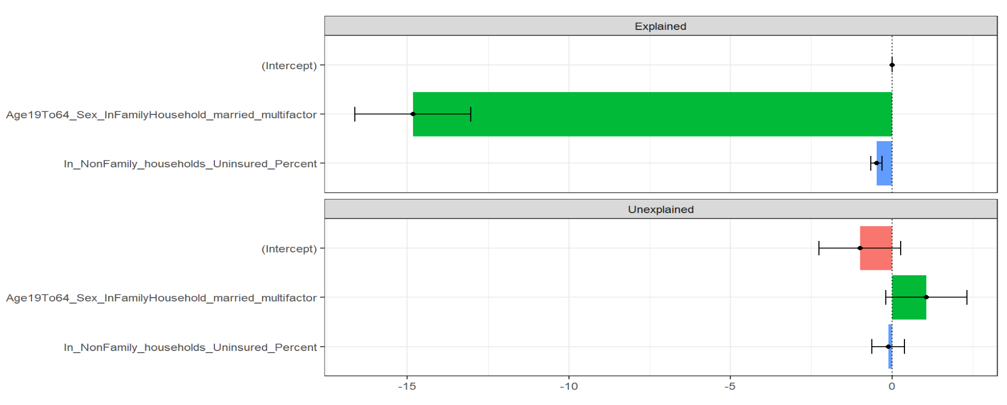

Figure 26 The Explained and Unexplained Components of a Twofold Blinder-Oaxaca Decomposition of Safe Group 0 vs. Risk Group 1 Gap

Figure 26 provides a variable-by-variable twofold decomposition. The results are consistent with the threefold composition. The gap of uninsured percentage by tracts is driven largely by safe groups’ greater returns to the uninsured percentage of people who are from19 to 64 years old or live in family households or family households!! In married-couple families.

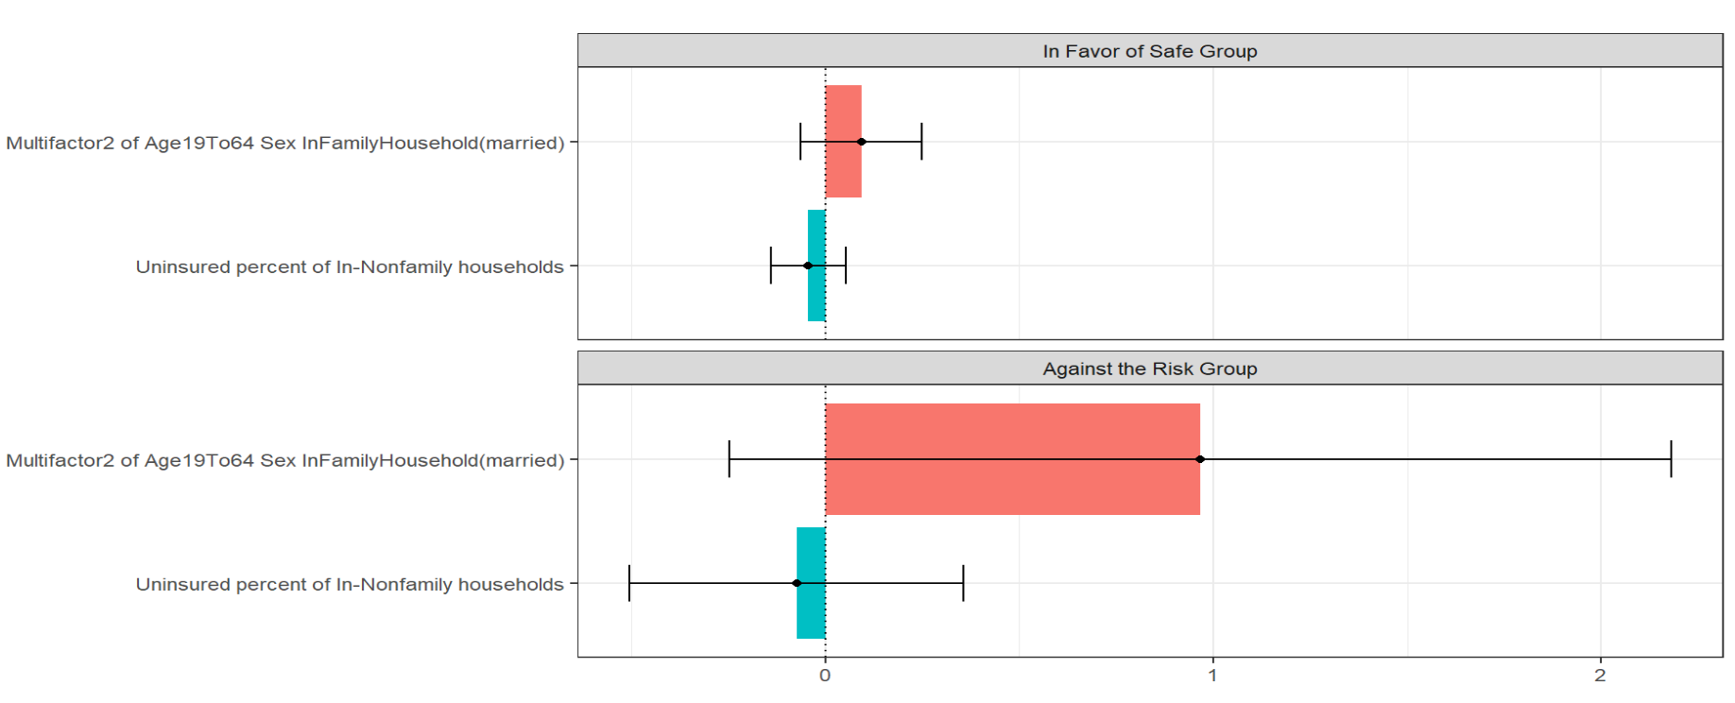

Figure 27 The Unexplained Portion's Discrimination Sub-Components in a Twofold Blinder-Oaxaca Decomposition of Safe Group 0 vs. Risk Group 1 Gap

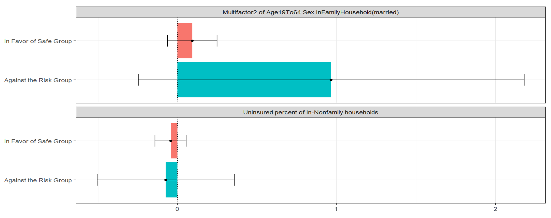

Figure 28 The Unexplained Portion's Discrimination Sub-Components in a Twofold Blinder-Oaxaca Decomposition of Safe Group 0 vs. Risk Group 1 Gap. An Alternative Presentation

The impacts of the uninsured percentage of people who are from19 to 64 years old or live in family households or family households!! In married-couple families are more significant on the risk group than on the safe group. In other words, even if the safe group had the same average uninsured percentage of the multifactor as the risk group, the risk group would, on average, reach a higher uninsured percentage of the tracts than the safe group would.

## 5.4 Results

We have found that people under 19 years and age 65 years and older and females have better health insurance status than other types of people in family households. Furthermore, the means of uninsured percentages of females are lower than males'. The correlation analysis results show that the uninsured percentage of females and males are highly correlated. And the datasets provide information at the census tract level. I hold that health inequity stems from income inequity rather than discrimination on sex here. Women who live in disadvantaged tracts have a higher uninsured percentage than those in rich tracts. The findings apply equally to men. All of the influencing factors affect uninsured percentage by tracts in both groups except the factor of uninsured percent of age 65 years and older because people aged 65 years and older benefit from US Medicare and are not impacted by the tracts they live in.

The threefold decomposition result shows differences in the regression coefficients on the uninsured percentage of people who are from19 to 64 years old or live in family households or family households!! In married-couple families account for the decisive portion of the uninsured percentage by tracts gap.

Twofold decomposition results demonstrate the impacts of the uninsured percentage of people who are from19 to 64 years old or live in family households or family households!! In married-couple families are more significant on the risk group than on the safe group. Those results make some intuitive sense if we interpret the uninsured percentage of people who are from19 to 64 years old or live in family households as potentially picking up the effect of the health insurance market in Salt Lake County experience.

# 6 Empirical Research D. Complete (ADI) Model

## 6.1 Descriptive Statistics

Complete (ADI) Model contains all of the influencing factors included in the models above (minority status model, socioeconomic status model, household composition model). And I added ADI80, which indicates the most disadvantaged neighborhood groups as group 1 and others as 0. In this model, we have 209 tracts because there is a missing value in ADI state rank.

Table 18 Descriptive Statistics of ADI State Rank

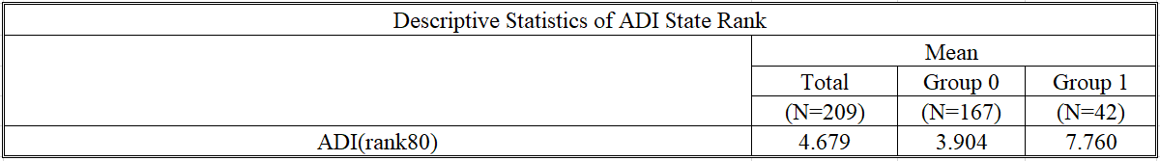

Table 19 Descriptive Statistics of ADI80

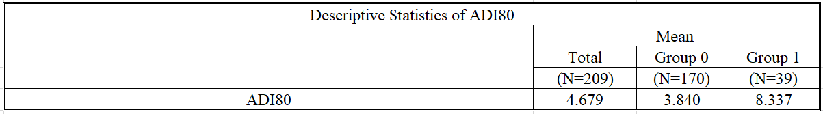

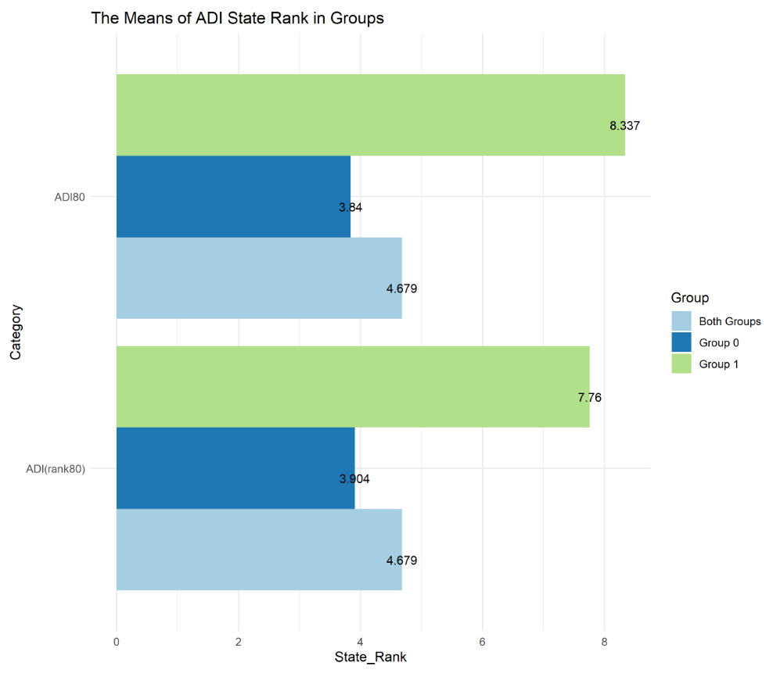

Figure 29 The Means of ADI State Rank in Groups

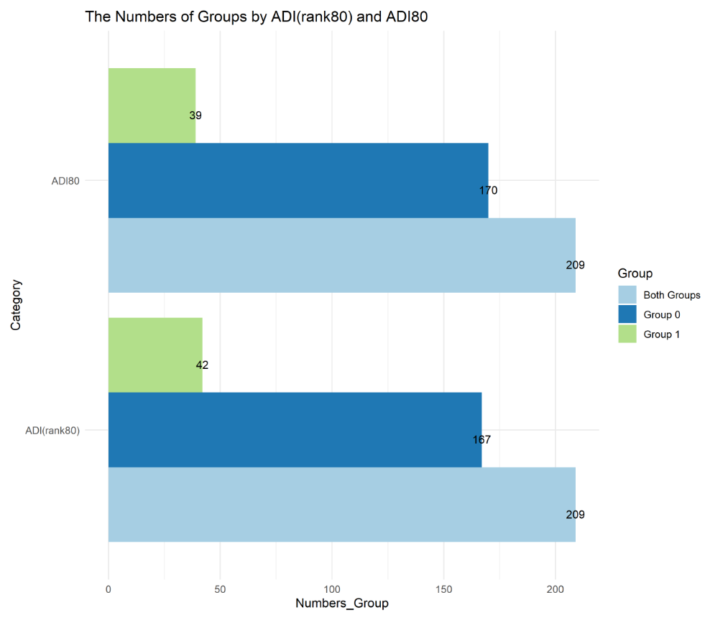

Figure 30 The Numbers of Groups by ADI(rank80) and ADI80

We can find that the most disadvantaged neighborhood tracts are highly correlated with the risk tracts with a high uninsured percentage. The means in ADI state rank and ADI80 are higher in group 1 than in group 0. And the higher values in ADI mean more disadvantaged neighborhood tracts. There are 167 tracts in the safe group 0 and 42 tracts in the risk group 1. And we observe that there are 39 most disadvantaged neighborhood tracts and 170 other tracts. The numbers of tracts in different classifications are very close. And the means of ADI in different classifications/groups are very close too.

## 6.2 Linear Regression Analysis

To avoid multicollinearity, I adopt two steps to fix the problem. The first step is to use the method of the relative importance of regressors in linear models for merging highly correlated factors.

I find six factors are highly correlated, including uninsured percent of native-born, uninsured percent of worked full-time, uninsured percent of male, uninsured percent of the age 19 to 64 years, uninsured percent of in family households, uninsured percent of in family households!! In married-couple families.

I merge them into one column called "NativeBorn_WorkFullTime_Male_Age19To64_InFamilyHouseholds_married_multifactor" using this formula

I replace the 6 columns with " NativeBorn_WorkFullTime_Male_Age19To64_InFamilyHouseholds_married_multifactor ".

Then I find "NativeBorn_WorkFullTime_Male_Age19To64_InFamilyHouseholds_married_multifactor", uninsured percent of worked less than full-time, uninsured percent of the female are highly correlated too. The second step is to merge these three columns and generate a new column called “WorkLessFullTime_Female_ NativeBorn_WorkFullTime_Male_Age19To64_InFamilyHouseholds_married_multifactor2” using this formula

I replace the three columns with " WorkLessFullTime_Female_ NativeBorn_WorkFullTime_Male_Age19To64_InFamilyHouseholds_married_multifactor2".

Then I use Box Cox Transformation to find the best lambda and build the complete linear regression model using this formula

$$uninsured percentage by tracts with best lambda \sim uninsured percentage of white alone (not Hispanic or Latino)+WorkLessFullTime_Sex_ NativeBorn_WorkFullTime_Age19To64_InFamilyHouseholds_married_multifactor2+uninsured percentage of Hispanic or Latino (of any race)+percentage of persons who speak English "less than well +uninsured percent of foreign-born!! Naturalized+ uninsured percentage of foreign-born!! not a citizen + uninsured percent of less than high school graduate + uninsured percent of high school graduate (includes equivalency) + uninsured percent of some college or associate's degree + uninsured percent of Bachelor's degree or higher + uninsured percent of did not work + uninsured percent of below 138 percent of the poverty threshold + uninsured percent of 138 to 399 percent of the poverty threshold + uninsured percent of at or above 400 percent of the poverty threshold + uninsured percent of age under 19 years +uninsured percent of age 65 years and older + uninsured percent of in family households!! In other families + uninsured percent of in non-family households and other living arrangements) + ADI80$$

These are the linear regression results.

Table 20 Linear Regression Coefficients in Complete (ADI) Model (1)

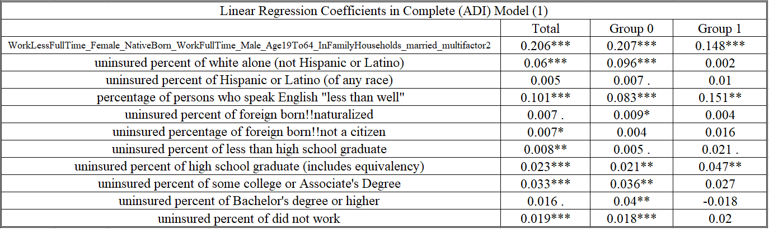

Table 21 Linear Regression Coefficients in Complete (ADI) Model (2)

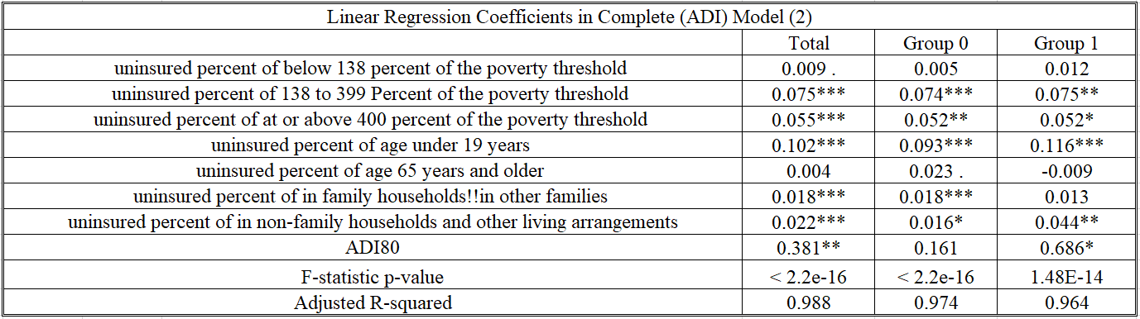

Signif. codes: 0 ‘***’ 0.001 ‘**’ 0.01 ‘*’ 0.05 ‘.’ 0.1 ‘ ’ 1

All of the influencing factors affect uninsured percent by tracts.

F-statistic p-values mean that the regression model fits the data better than the model with no independent variables.

The values of adjusted R-squared show Goodness-of-fit.

## 6.3 Blinder-Oaxaca decomposition

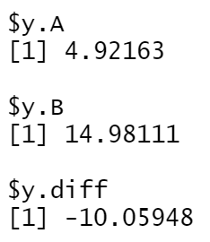

Figure 31 The Mean Uninsured Percentage by Tracts after Transformation

In Oaxaca decomposition, we have 209 entries, including 167 entries in group 0 (A) and 42 entries in group 1(B). The actual mean uninsured percentage by tracts is -15.762% (7.307%- 23.069%). After data transformation, the *y* component indicates that the mean uninsured percentage by tracts is 4.922% for group 0 (A) and 14.981% for group 1(B), leaving the difference of approximately -10.059% to be explained by the Blinder-Oaxaca decomposition.

### 6.3.1 Threefold decomposition

This is the plot of the threefold decomposition variable by variable.

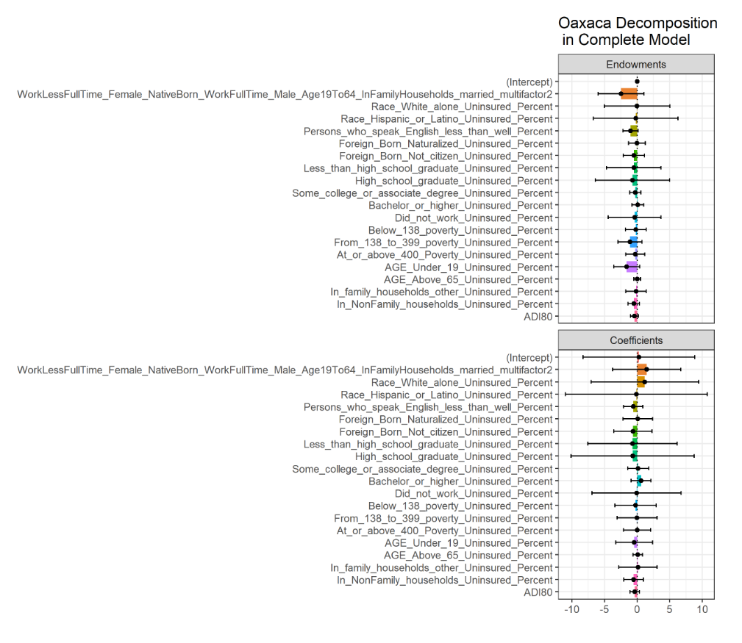

Figure 32 Plot of the Threefold Decomposition of Complete (ADI) Model

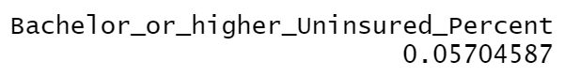

Figure 33 Differences in the Regression Coefficients on Bachelor or Higher



Figure 34 Differences in the Regression Coefficients on Multifactor 2

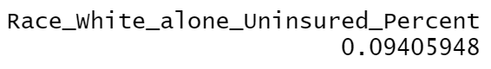

Figure 35 Differences in the Regression Coefficients on White Alone

As the difference in the uninsured percent of white alone coefficients between the safe group and risk group shows, the uninsured percent payoff of an additional uninsured percentage of white alone is more significant for the safe group by almost 0.094%. Note that 0.094% is the uninsured percentage after transformation. It’s not the actual uninsured percentage.

As the difference in the uninsured percent of Bachelor's degree or higher coefficients between the safe group and risk group shows, the uninsured percent payoff of an additional uninsured percentage of Bachelor's degree or higher is more significant for the safe group by almost 0.057%. Note that 0.057% is the uninsured percentage after transformation. It’s not the actual uninsured percentage.

As the difference in the uninsured percent of people who are native-born or age from 19 to 64, or in family households, or have full-time work or less than full-time work coefficients between the safe group and risk group shows, the uninsured percent payoff of an additional uninsured percentage of the multifactor is more significant for the safe group by almost 0.059%. Note that 0.059% is the uninsured percentage after transformation. It’s not the actual uninsured percentage.

As Figure 32 makes clear, differences in the regression coefficients on the uninsured percentage of white alone, uninsured percent of Bachelor's degree or higher, uninsured percent of people who are native-born or age from 19 to 64, or in family households, or have full-time work or less than full-time work account for the portions of the uninsured percentage by tracts gap in the complete model.

### 6.3.2 Twofold decomposition

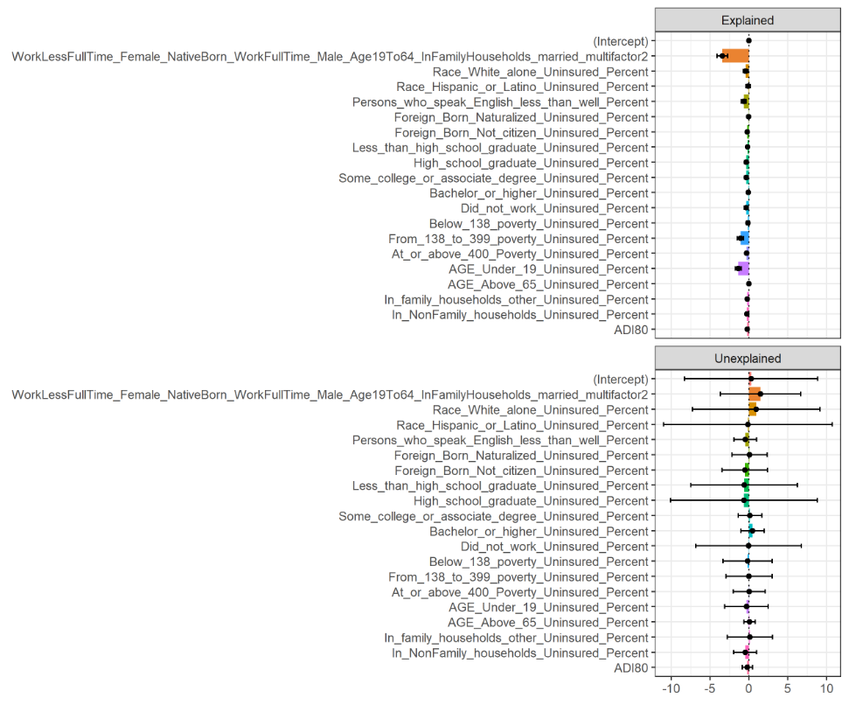

Figure 36 The Explained and Unexplained Components of a Twofold Blinder-Oaxaca Decomposition of Safe Group 0 vs. Risk Group 1 Gap

Figure 36 provides a variable-by-variable twofold decomposition. The results are consistent with the threefold composition. It appears that the gap of uninsured percentage by tracts is driven largely by safe groups’ greater returns to the uninsured percentage of white alone, uninsured percent of Bachelor's degree or higher, uninsured percent of people who are native-born or age from 19 to 64, or in family households, or have full-time work or less than full-time work.

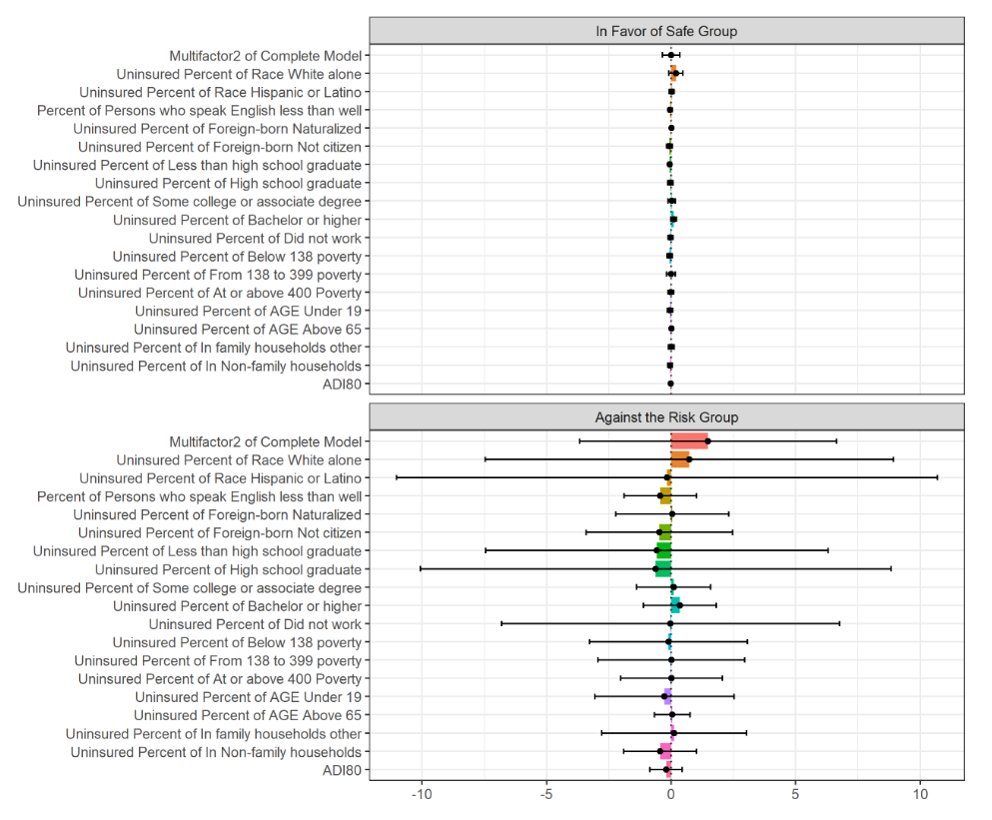

Figure 37 The Unexplained Portion's Discrimination Sub-Components in a Twofold Blinder-Oaxaca Decomposition of Safe group 0 vs. Risk Group 1 Gap.

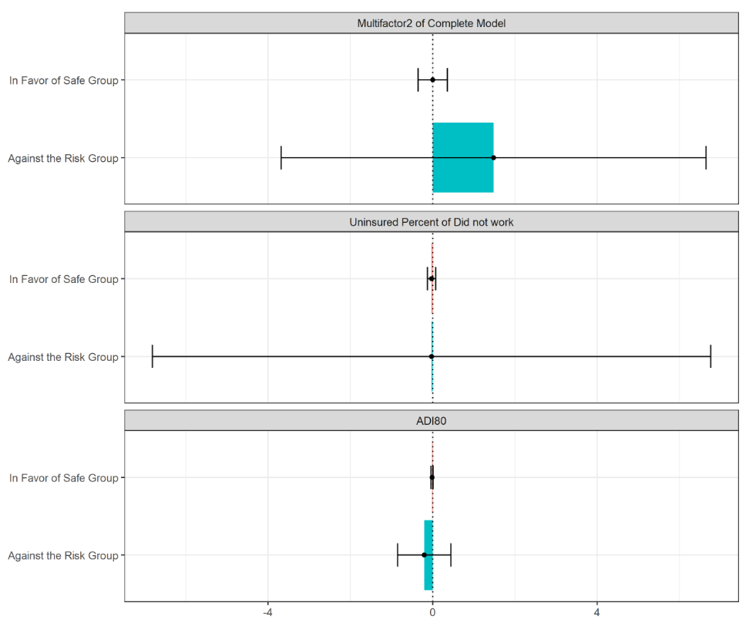

Figure 38 The Unexplained Portion's Discrimination Sub-Components in a Twofold Blinder-Oaxaca Decomposition of Safe Group 0 vs. Risk Group 1 Gap. An Alternative Presentation (1)

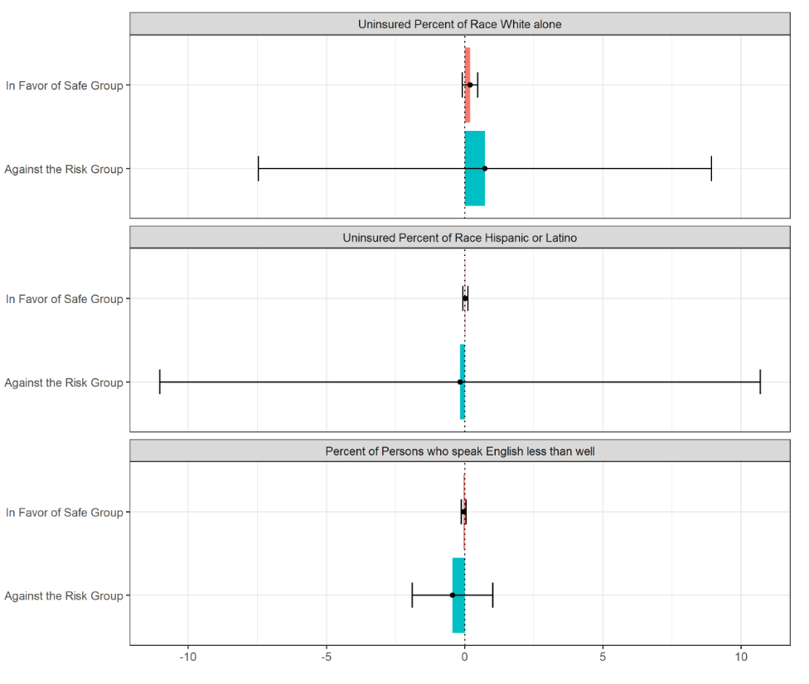

Figure 39 The Unexplained Portion's Discrimination Sub-Components in a Twofold Blinder-Oaxaca Decomposition of Safe Group 0 vs. Risk Group 1 Gap. An Alternative Presentation (2)

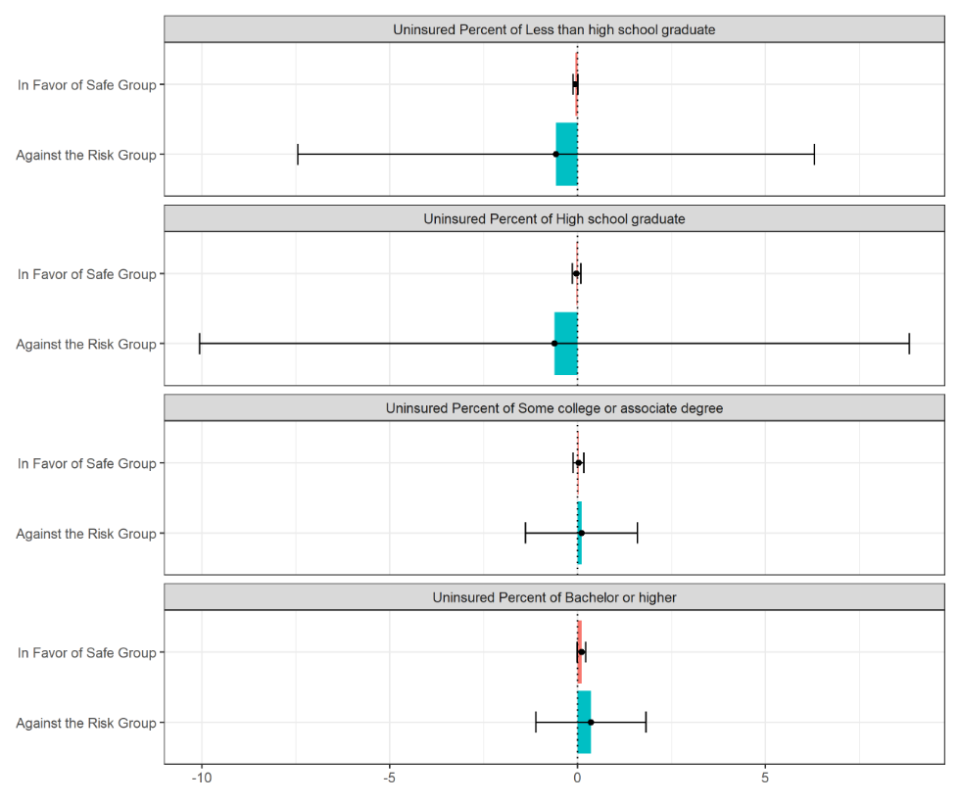

Figure 40 The Unexplained Portion's Discrimination Sub-Components in a Twofold Blinder-Oaxaca Decomposition of Safe Group 0 vs. Risk Group 1 Gap. An Alternative Presentation (3)

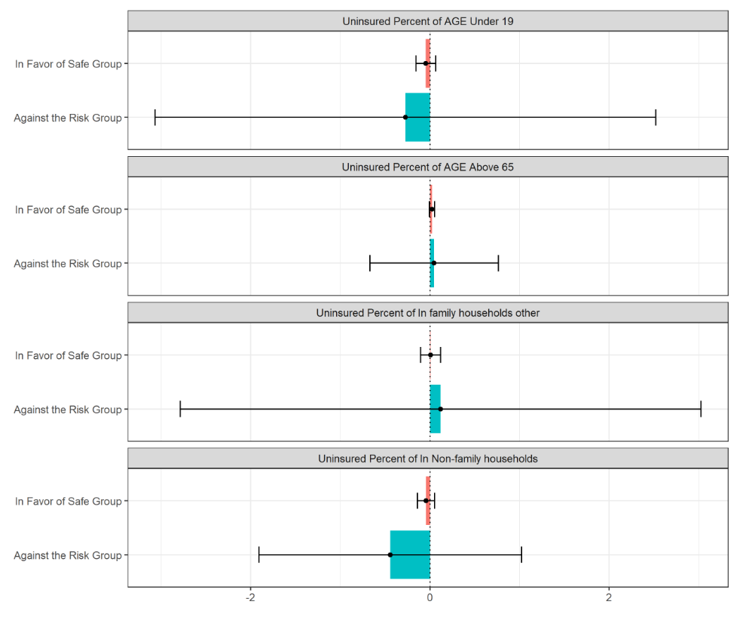

Figure 41 The Unexplained Portion's Discrimination Sub-Components in a Twofold Blinder-Oaxaca Decomposition of Safe Group 0 vs. Risk Group 1 Gap. An Alternative Presentation (4)

The impacts of the uninsured percentage of white alone are more significant on the risk group than on the safe group. In other words, even if the safe group had the same average uninsured percentage of the white alone as the risk group, the risk group would, on average, reach a higher uninsured percentage of the tracts than the safe group would.

We also observe that the impacts of uninsured percentages of Bachelor's degree or higher, uninsured percent of people who are native-born or age from 19 to 64, or in family households, or have full-time work or less than full-time work are more significant on risk group than on the safe group too.

## 6.4 Results

1. We have found apparent health disparities in the complete model. The most disadvantaged neighborhood tracts are highly correlated with the risk tracts with a high uninsured percentage.

Threefold decomposition result shows that differences in the regression coefficients on the uninsured percentage of white alone, uninsured percentages of Bachelor's degree or higher, uninsured percent of people who are native-born or age from 19 to 64, or in family households, or have full-time work or less than full-time work account for the portions of the uninsured percentage by tracts gap in the complete model. Twofold decomposition results show that the impacts of the uninsured percentage of white alone, uninsured percentages of Bachelor's degree or higher, uninsured percent of people who are native-born or age from 19 to 64, or in family households, or have full-time work or less than full-time work are greater on the risk group than on the safe group.

Those results make some intuitive sense if we interpret the uninsured percentage of white alone, uninsured percentages of Bachelor's degree or higher, uninsured percent of people who are native-born or age from 19 to 64, or in family households, or have jobs as potentially picking up the effect of the health insurance market in Salt Lake County experience in the complete model.

2. After comparing the minority status and language model, socioeconomic status model, household composition model with the complete model, I maintain that we interpret the uninsured percentage of white alone, uninsured percentage of native-borns, uninsured percentage of worked full-time, uninsured percent of bachelor’s degree or higher as potentially picking up the effect of the health insurance market in Salt Lake County experience. Another factor, including the uninsured percentage of people who live in family households, impacts the gap of uninsured percentage by tracts in the risk group and the safe group.

I hold that our analysis results are reasonable. As is known to all, there is a wealth gap between white and other races. Furthermore, according to the website of World Population Review, "According to the most recent ACS, the racial composition of Salt Lake City was: White: 72.84%...". Therefore, differences in the regression coefficients on the uninsured percentage of white alone account for the decisive portion of the uninsured percentage by tracts gap.

Native-born people have a lower cost of living. For example, they live in their parent's house. They have obtained diplomas in local universities and have built social networks to help them find a job. They have fewer financial worries and can afford healthcare fees.

People who have full-time jobs have a lower uninsured percentage. It reflects the USA healthcare reality. Nancy De Lew, George Greenberg, and Kraig Kinchen report in “A layman's guide to the U.S. health care system” that "The United States primarily relies on employers to voluntarily provide health insurance coverage to their employees and dependents; government programs are confined to the elderly, the disabled, and some of the poor. " Uninsured percentage of people who have full-time jobs fundamentally impact the health market. Katherine Keisler-Starkey and Lisa N. Bunch Report in Health Insurance Coverage in the United States: 2020 that "87.0 percent of full-time, year-round workers had private insurance coverage, up from 85.1 percent in 2018. In contrast, those who worked less than full-time, year-round were less likely to be covered by private insurance in 2020 than in 2018 (68.5 percent in 2018 and 66.7 percent in 2020)." (2021) Therefore, I hold that the uninsured percentage of working full time rather than working less than full-time has an effect on healthcare insurance status.

People who have bachelor’s degrees or higher are more able to get full-time job opportunities. And they are more knowledgeable about healthcare and how to obtain the maximum health benefits from healthcare insurance.

Other factors, people living in family households are more financially stable with the support of their family members. These types of people incline to lower the uninsured percentage of the tracts too.

3. We notice that the uninsured percentage of a native-born, uninsured percentage of worked full-time, uninsured percentage of people in the range of 138 and 399 percent of the poverty threshold are highly correlated. It suggests that if the uninsured percentage of full-time workers decreases, the uninsured percentage of people in the range of 138 and 399 percent of the poverty threshold goes down. Their fluctuations change the uninsured percentage of native-born in the same direction.

# 7 Discussion

1 We choose variables based on common sense. Therefore, it is possible that other valuable factors are not collected in the project. We haven’t found the uninsured percentages about career types from ACS 5. After regression diagnosis in small models, we excluded some variables which have no effect on linear models and Blinder-Oaxaca Decomposition results, for example, the uninsured percentage of foreign-born!!naturalized, the uninsured percentage of less than high school graduates, the uninsured percentage of high school graduate (includes equivalency), the uninsured percentage of some college or associate's degree, the uninsured percentage of at or above 400 percent of the poverty threshold, etc.

2 In the minority status and language model, socioeconomic status model, household composition model, residuals are approximately normal and independent. In the complete (ADI) model, the residuals have passed the normality and independent tests. We also find that in the complete (ADI) model, the p-value of the BP test has increased too. It suggests that if we increase the number of independent variables of linear regression, the results of regression diagnosis improve. However, the problem of heteroscedasticity is always in all of the models. We observe that group 1 data pass all of the regression diagnosis tests. Then we study the scatter plots. As we can see from the scatter plots of the dataset in appendices A, B, C, and D, most of the points lie within the confidence bands in group 1, which is expected for the given distribution. However, we observe that there are many outliers in the scatter plots of both groups (group 0 and group 1) and group 0.

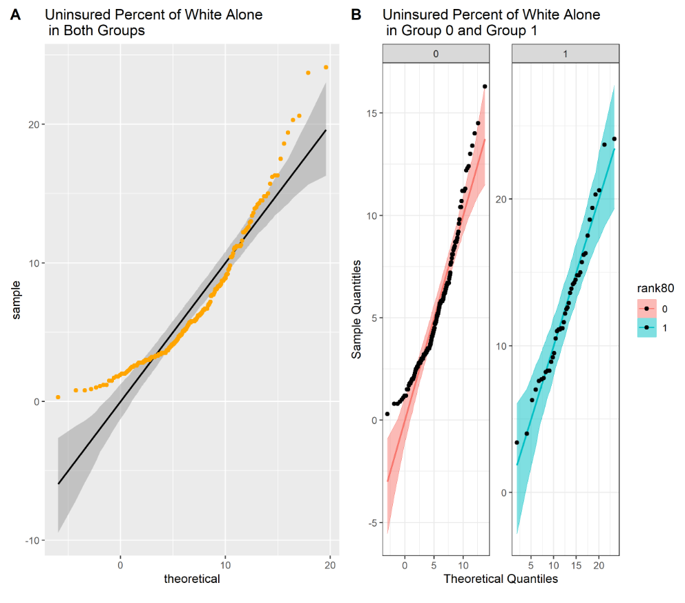

Figure A 4 Scatter Plots of Uninsured Percent of White Alone

This is why residuals in group 1 pass normality, independence, and homoscedasticity tests in all four models. However, residuals in group 0 and both groups can’t pass homoscedasticity tests. Outliers and heteroscedasticity are reasonable because our columns are from different datasets that describe various factors. To decrease the variance of the residuals, we performed weighted least squares estimation, using log function on variables, etc.; however, they did not reduce the variance of the residuals. Because of heteroscedasticity and subjective ideas of data transformation, the results are not correct, although they look reasonable. In future work, we could make data analysis on segments, for example, the first 20th percentile of the dataset, the last 20th percentile of the dataset, and the middle between them, to avoid too many outliers and improve correctness.

3. I’ve uploaded the presentation of the project proposal, datasets, codes, final reports, and presentation of the final report to [my account on GitHub](https://github.com/GraceTan888/Health-Inequity-in-Salt-Lake-County-).

# 8 Conclusions

Through the project, we get an understanding of the diversity of Salt Lake County. In the empirical research on uninsured percentage by tracts in Salt Lake County, we have found a 15.7% gap between the risk group (23%) and the safe group (7.3%). As the results of models show, the uninsured percentage of white alone, uninsured percentage of native-born, uninsured percentage of worked full-time, uninsured percent of bachelor’s degree or higher, uninsured percentage of people who live in family households impact the uninsured percentage by tracts more greatly on the risk group than on the safe group. I hold that health inequity stems from income inequity rather than other discrimination factors, for example, sex. The factors that affect the uninsured percentage gap by tracts are relevant to income and wealth. We notice that the uninsured percentage of a native-born, uninsured percentage of worked full-time are highly correlated with the uninsured percentage of people in the range of 138 and 399 percent of the poverty threshold. To change the unbalanced status quo, we can pursue higher education attainments and increase the employment rate, although people can’t choose their race and birthplace. Therefore, I suggest that strengthening higher education and creating new full-time job opportunities will significantly improve health insurance status in disadvantaged neighborhoods. Also, I encourage people to build harmonious relationships with family members for their support. I expect people in Salt Lake County to embrace a more healthcare equitable society right.

**Author Contributions**:Thank you to Ray Hoobler, Ph.D., for the guidance on the reports.

**Conflicts of Interest**: The authors declare no conflict of interest.

**Sponsor Information**

The Professional Master of Science and Technology program

Ray Hoobler, Ph.D.

[Ray.Hoobler@utah.edu](mailto:Ray.Hoobler@utah.edu)

801-585-5630

# References

1. Whitehead, M. "The concepts and principles of equity and health." International journal of health services : planning, administration, evaluation vol. 22,3 (1992): 429-45. doi:10.2190/986L-LHQ6-2VTE-YRRN

2. Garfield, Rachel and Tolbert, Jennifer. "What We Do and Don't Know About Recent Trends in Health Insurance Coverage in the US." *KFF*, 17 Sept. 2020, [www.kff.org/policy-watch/what-we-do-and-dont-know-about-recent-trends-in-health-insurance-coverage-in-the-us](http://www.kff.org/policy-watch/what-we-do-and-dont-know-about-recent-trends-in-health-insurance-coverage-in-the-us).

3. Rollins, Jenny. "Utah Has One of the Highest Rates of Uninsured Kids. Could Insuring Them Save Taxpayers Millions?" *KSL.Com*, Oct 7 2021, [www.ksl.com/article/50256885/Utah-has-one-of-the-highest-rates-of-uninsured-kids-could-insuring-them-save-taxpayers-millions](http://www.ksl.com/article/50256885/Utah-has-one-of-the-highest-rates-of-uninsured-kids-could-insuring-them-save-taxpayers-millions).

4. Alker, Joan, and Alexandra Corcoran. "Children's Uninsured Rate Rises by Largest Annual Jump in More Than a Decade." *Ccf.Georgetown.Edu*, Oct. 2020, ccf.georgetown.edu/wp-content/uploads/2020/10/ACS-Uninsured-Kids-2020_10-06-edit-3.pdf.

5. "CDC SVI 2018 Documentation." *Atsdr.Cdc.Gov*, Jan 31 2020, [www.atsdr.cdc.gov/placeandhealth/svi/documentation/pdf/SVI2018Documentation-H.pdf](http://www.atsdr.cdc.gov/placeandhealth/svi/documentation/pdf/SVI2018Documentation-H.pdf).

6. "CDC/ATSDR Social Vulnerability Index." *ATSDR*, www.atsdr.cdc.gov/placeandhealth/svi/index.html. Accessed Mar 11. 2022.

7. "About the Area Deprivation Index (ADI)." *Neighborhood Atlas*, www.neighborhoodatlas.medicine.wisc.edu. Accessed Mar 12 2022.

8. Hlavac, Marek. “Oaxaca: Blinder-Oaxaca Decomposition in R.” SSRN, 20 Nov. 2014, <https://papers.ssrn.com/sol3/papers.cfm?abstract_id=2528391>.

9. Hlavac, Marek (2018). oaxaca: Blinder-Oaxaca Decomposition in R. R package version

0.1.4. <https://CRAN.R-project.org/package=oaxaca>

10. "Lecture 12 Heteroscedasticity." *Bauer*, www.bauer.uh.edu/rsusmel/phd/ec1-12.pdf.

Accessed Mar 12 2022.

11. Zach. "How to Interpret a Scale-Location Plot (With Examples)." *Statology*, Nov 25 2020, [www.statology.org/scale-location-plot](http://www.statology.org/scale-location-plot).

12. "Package 'Relaimpo.'" *R Official Website*, Oct 20. 2021,

cran.r-project.org/web/packages/relaimpo/relaimpo.pdf.

13. "Further Residual Plot Examples." *PSU*, online.stat.psu.edu/stat462/node/124. Accessed Mar 14. 2022.

14. "Salt Lake City, Utah Population 2022." *World Population Review*, worldpopulationreview.com/us-cities/salt-lake-city-ut-population. Accessed Mar 15 2022.

15. “What Is a Box Cox Transformation?” *Statistics How To*, [www.statisticshowto.com/box-cox-transformation. Accessed 25 Mar. 2022](http://www.statisticshowto.com/box-cox-transformation.%20Accessed%2025%20Mar.%202022).

16. “Psychologists Love To Report ‘Marginally Significant’ Results, According To A New Analysis.” *The British Psychological Society*, digest.bps.org.uk/2019/03/12/psychologists-love-to-report-marginally-significant-results-according-to-a-new-analysis. Accessed 4 Apr. 2022.

17. Lew, Nancy, et al. “A Layman’s Guide to the U.S. Health Care System.” *NCBI*, 1992, [www.ncbi.nlm.nih.gov/pmc/articles/PMC4193322](http://www.ncbi.nlm.nih.gov/pmc/articles/PMC4193322).

18. “Step: Choose a Model by AIC in a Stepwise Algorithm.” *RDocumentation Search All Packages and Functions*, [www.rdocumentation.org/packages/stats/versions/3.6.2/topics/step. Accessed 5 Apr. 2022](http://www.rdocumentation.org/packages/stats/versions/3.6.2/topics/step.%20Accessed%205%20Apr.%202022).

19. Keisler-Starkey, Katherine, and Lisa Bunch. “Health Insurance Coverage in the United States: 2020.” *United States Census Bureau*, 14 Sept. 2021, www.census.gov/library/publications/2021/demo/p60-274.html.

# Details of Regression Diagnosis in Four Project Models

# Appendix A: Minority Status and Language Model

1. **Correlation Analysis**

In this model, I do the correlation analysis of 3 factors, including the uninsured percentage of Hispanics or Latino (of any race), the percentage of persons who speak English "less than well," and the uninsured percentage of white alone (not Hispanic or Latino).

In a multiple regression model, the high correlated influencing factors impact the valid results about any individual influencing factor. To avoid multicollinearity, I do correlation analysis and deal with the influencing factors with correlation coefficients higher than 0.85.

Table A 1 Correlation Coefficients



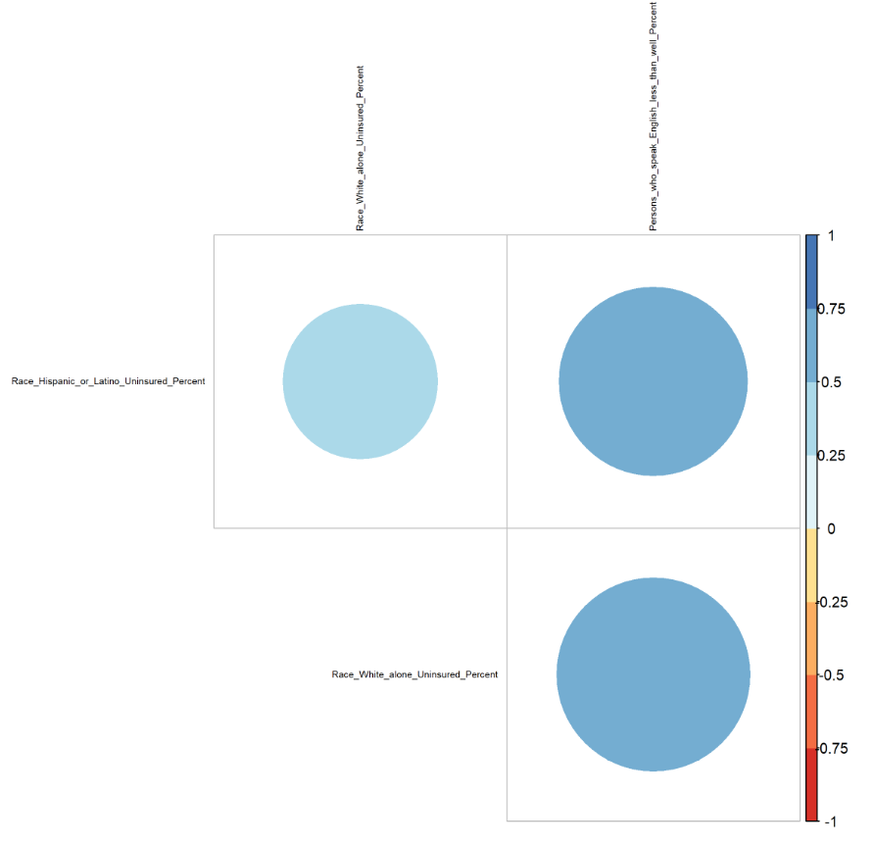

Figure A 1 Correlation Coefficients in Minority Status Model

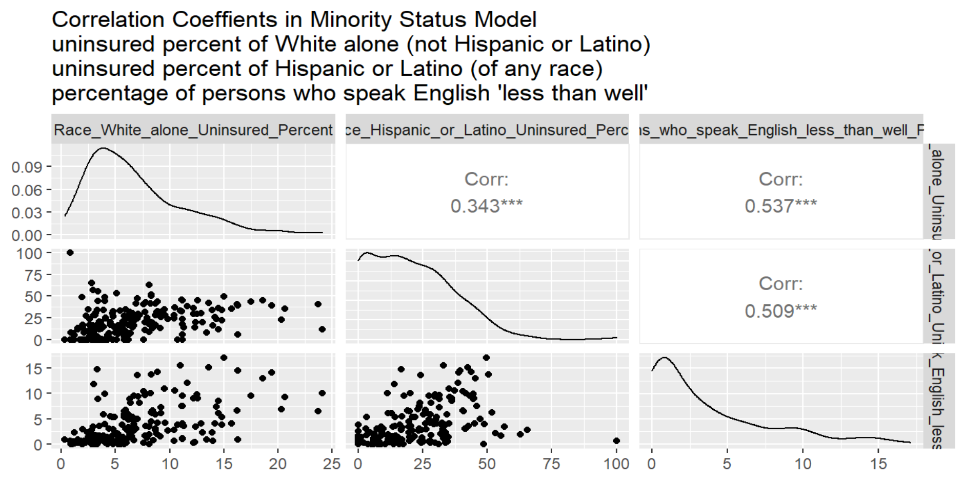

Figure A 2 Correlation Coefficients in Minority Status Model Alternative

1. **Linear Regression Analysis**

*2.1 The Scatter plots of factors*

I build a minority status linear regression model using this formula

$$Uninsured Percent by Tracts \sim Uninsured Percent of Hispanic or Latino (of any race)+Percentage of Persons Who Speak English "less than well" + Uninsured Percent of White alone (not Hispanic or Latino)$$

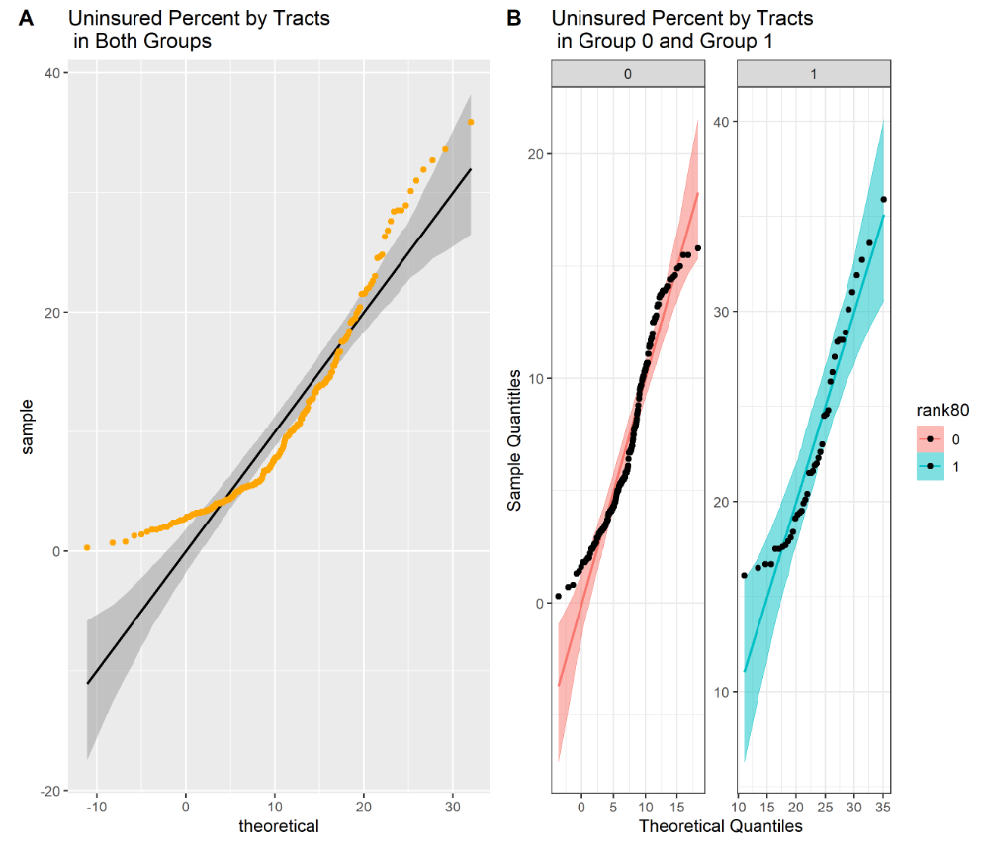

Figure A 3 Scatter Plots of Uninsured Percent by Tracts



Figure A 4 Scatter Plots of Uninsured Percent of White Alone

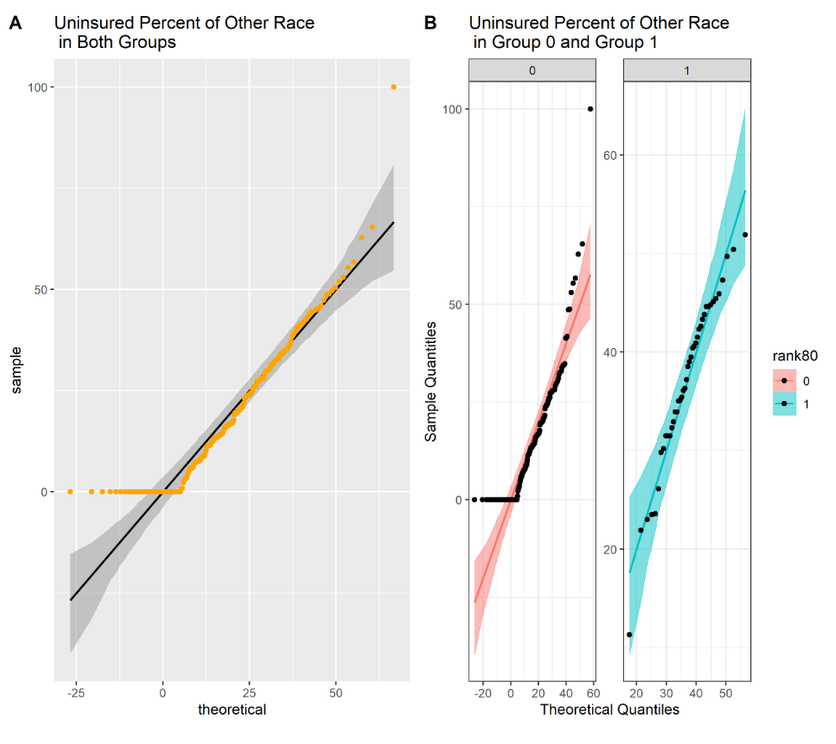

Figure A 5 Scatter Plots of Uninsured Percent of Hispanic or Latino (of any race)

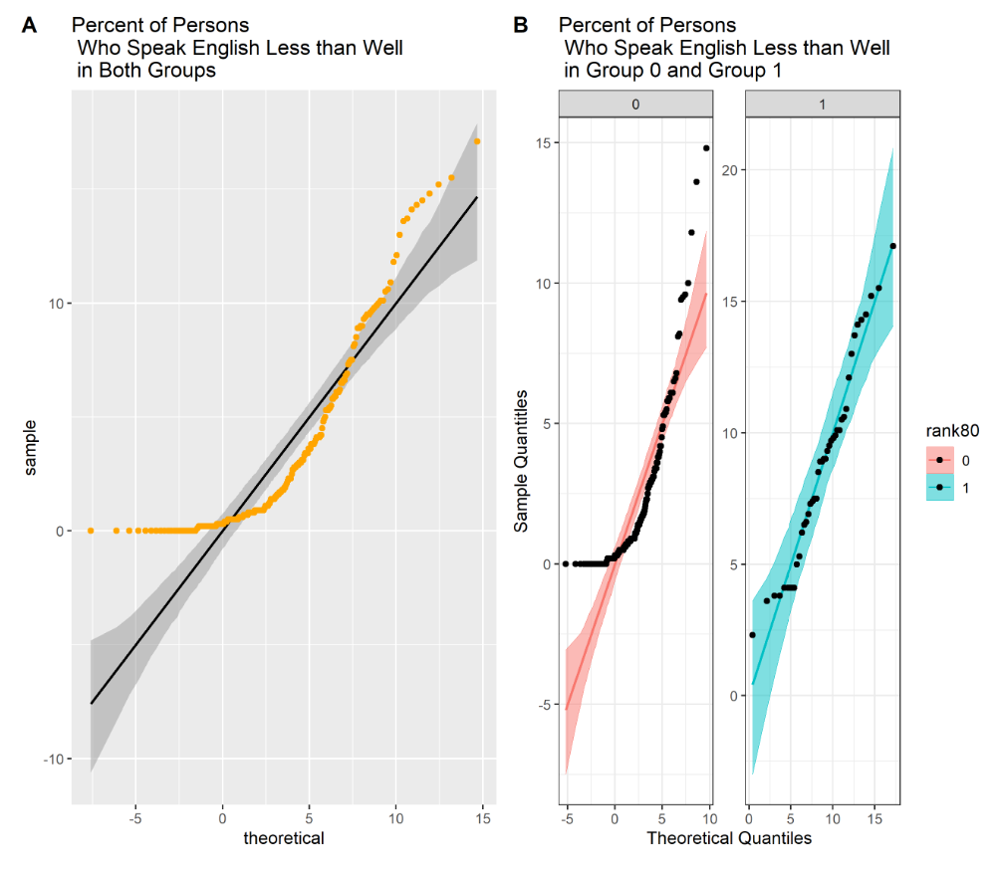

Figure A 6 Scatter Plots of Percentage of Persons Who Speak English "Less than Well"

As we can see, most of the points lie within the confidence bands in group 1, which is expected for the given distribution. However, we observe many outliers in the scatter plots of both groups and group 0.

* 1. *Box-Cox Transformation*

I build a minority status linear regression model using this formula

$$Uninsured Percent by Tracts \sim Uninsured Percent of Hispanic or Latino (of any race)+Percentage of Persons Who Speak English "less than well" + Uninsured Percent of White alone (not Hispanic or Latino)$$

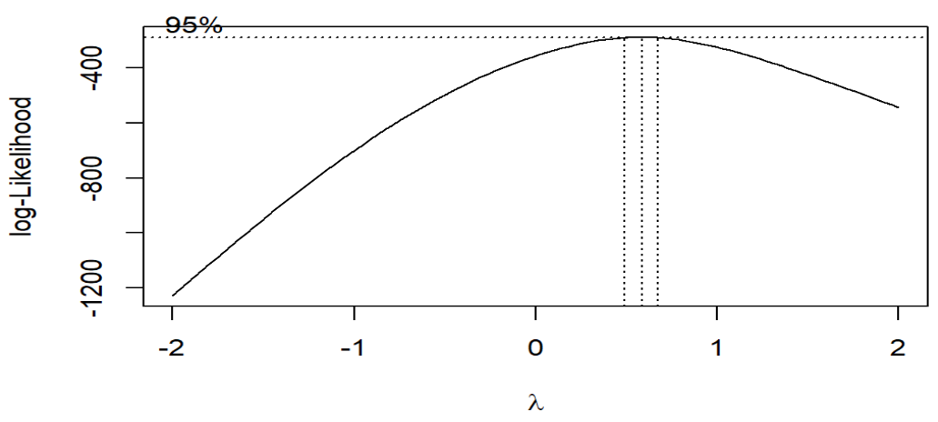

Figure A 7 Best λ

Best lambda=0.5858586

1. **Regression Diagnosis**

Regression diagnosis checks if residuals are normally distributed, residuals are independent, the mean of the residuals is zero, the sum of the residuals is zero, and residuals have a constant variance.

a. Check Both Groups

*3.1 Check if residuals are normally distributed*

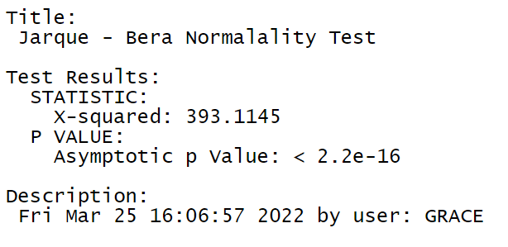

Figure 26 Normality Test

Null Hypothesis: Skewness and Kurtosis are equal to zero(normal distribution). p <= 0.01 : very strong presumption against null hypothesis. It is not normally distributed.

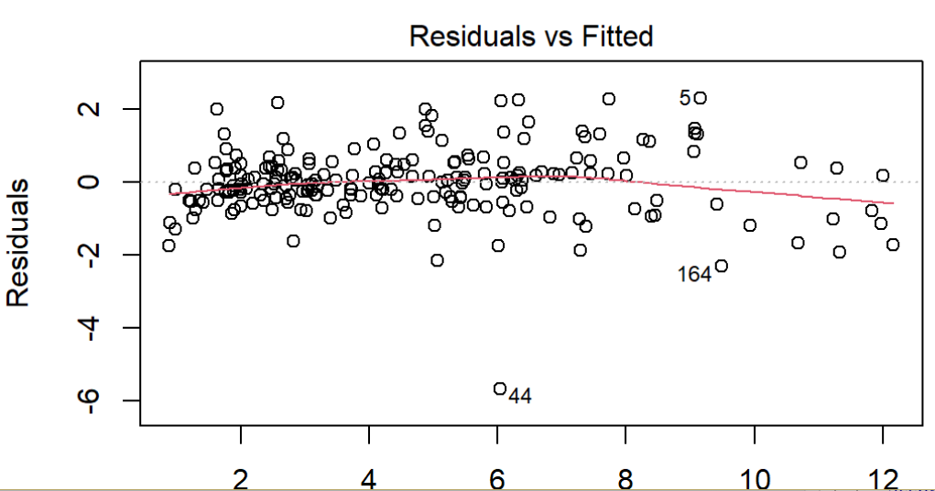

Figure A 9 Residual plot after Box-Cox Transformation (1)

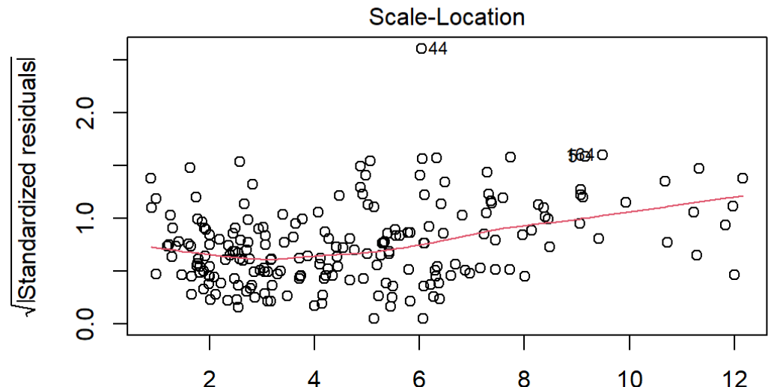

Figure A 10 Residual plot after Box-Cox Transformation (2)

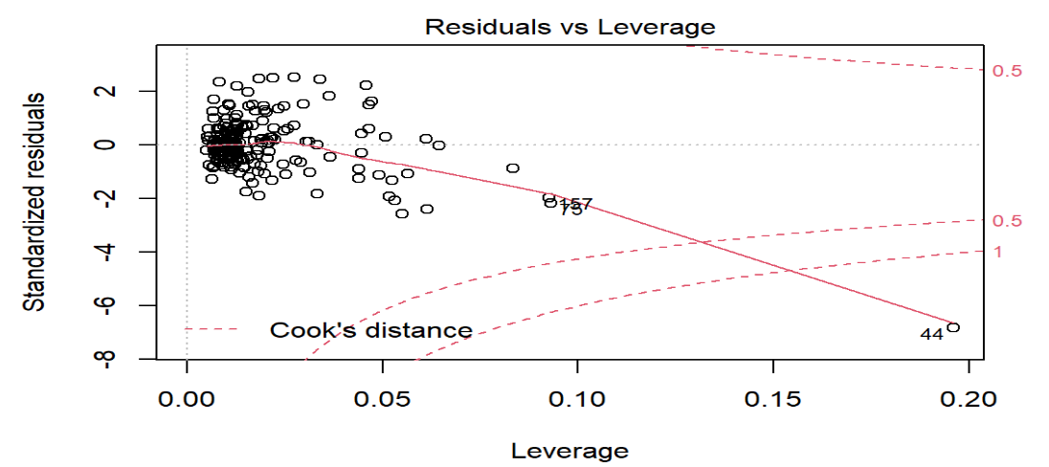

Figure A 11 Residual plot after Box-Cox Transformation (3)

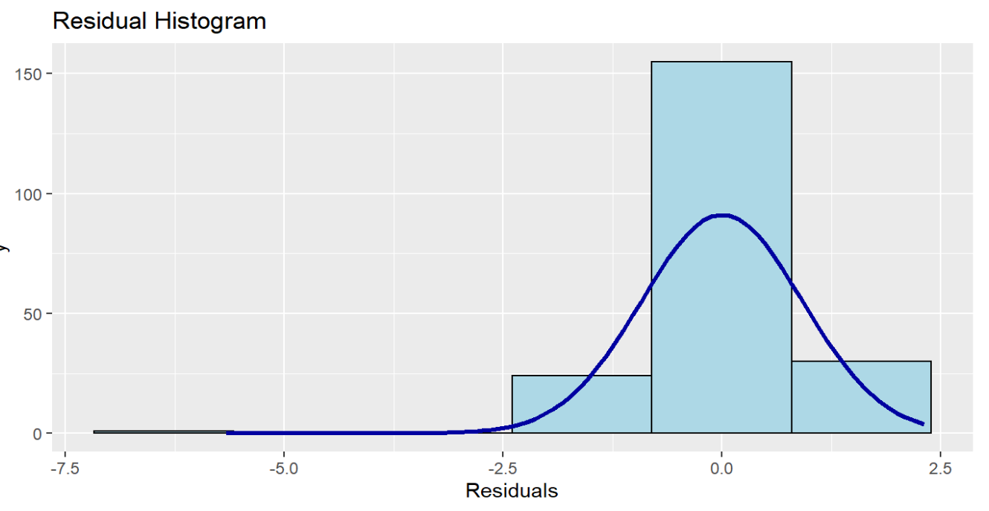

Figure A 12 Residual Histogram in Minority Status

The minority status linear regression model uses a large sample (210 entries which are bigger than 30), and the histogram of residuals is similar to the normal distribution. According to the Law of Large Numbers and Central Limit Theorem, we can accept the normality of residuals, although the residuals are not normally distributed using Jarque - Bera Normalality Test.

*3.2 Check if residuals are independent.*

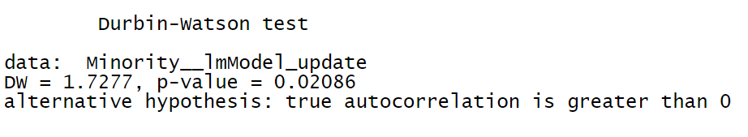

Figure A 13 Independence Test

The Durbin Watson statistic tests the hypothesis that there is no autocorrelation. If there is no autocorrelation (where subsequent observations are related), the Durbin-Watson statistic should be between 1.5 and 2.5, and the p-value will be above 0.05.

Our DW satisfies the condition (DW = 1.7277 (1.5<1.7277<2.5)) but p-value doesn’t (p-value = 0.02086 (0.02086<0.05)).

I deal with the influencing factors in the minority status model as independent ones, although it partly satisfies the DW test.

*3.3 Check if the mean of the residuals is zero and the sum of the residuals is zero.*

sum of the residuals = 6.21031e-15

mean of the residuals = 2.962402e-17

The mean of the errors is close to zero. The sum of the errors is close to zero.

*3.4 Check if residuals have constant variance*

However, it doesn't pass the studentized Breusch-Pagan test. Heteroscedasticity is present in the regression model.

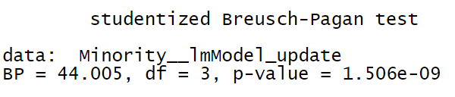

Figure A 14 Heteroscedasticity Test

From the scatter plots of the dataset, we have some outliers. And from plots of residuals, regression outliers with high leverage affect heteroscedasticity when performing a least-squares regression analysis. Because our columns are from different datasets that describe various factors, heteroscedasticity is reasonable.

b. Check Group 0

*3.5 Check if residuals are normally distributed*

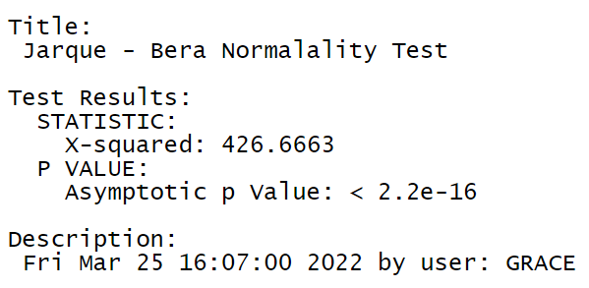

Figure A 15 Normality Test in Group 0

Null Hypothesis: Skewness and Kurtosis are equal to zero(normal distribution). p <= 0.01 : very strong presumption against null hypothesis. It is not normally distributed.

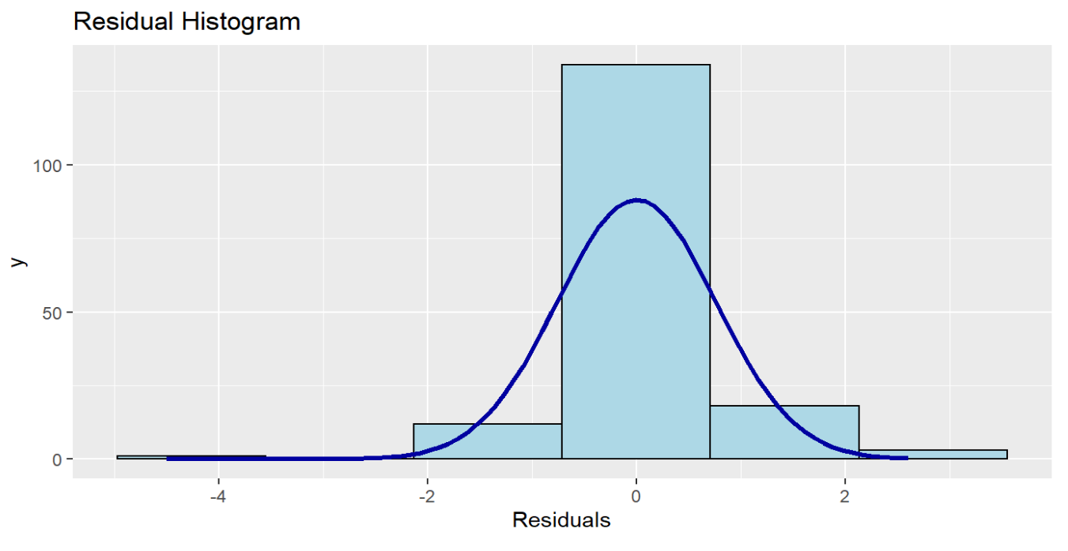

Figure A 16 Residual Histogram in Minority Status in Group 0

The minority status linear regression model uses a large sample (168 entries which are bigger than 30), and the histogram of residuals is similar to the normal distribution. According to the Law of Large Numbers and Central Limit Theorem, we can accept the normality of residuals, although the residuals are not normally distributed using Jarque - Bera Normalality Test.

*3.6 Check if residuals are independent.*

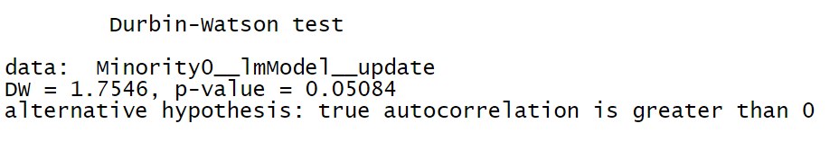

Figure A 17 Independence Test in Group 0

The Durbin Watson statistic tests the hypothesis that there is no autocorrelation. If there is no autocorrelation (where subsequent observations are related), the Durbin-Watson statistic should be between 1.5 and 2.5, and the p-value will be above 0.05.

Our DW satisfies the condition (DW = 1.7546 (1.5<1.7546<2.5)) but p-value doesn’t (p-value = 0.05084 (0.05084>0.05)).

The influencing factors in the minority status model are independent.

*3.7 Check if the mean of the residuals is zero and the sum of the residuals is zero.*

sum of the residuals = 3.434752e-16

mean of the residuals = 2.215516e-18

The mean of the errors is close to zero. The sum of the errors is close to zero.

*3.8 Check if residuals have constant variance*

However, it doesn't pass the studentized Breusch-Pagan test. Heteroscedasticity is present in the regression model.

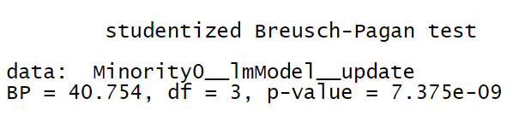

Figure A 18 Heteroscedasticity Test in Group 0

From the scatter plots of the dataset, we have some outliers. And from plots of residuals, regression outliers with high leverage affect heteroscedasticity when performing a least-squares regression analysis. Because our columns are from different datasets that describe various factors, heteroscedasticity is reasonable.

c. Check Group 1

*3.9 Check if residuals are normally distributed*

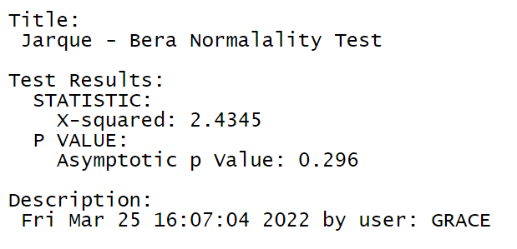

Figure A 19 Normality Test in Group 1

Null Hypothesis: Skewness and Kurtosis are equal to zero(normal distribution). p <= 0.01 : very strong presumption against null hypothesis. It is normally distributed.

Table A 2 KS Normality Test in Group 1

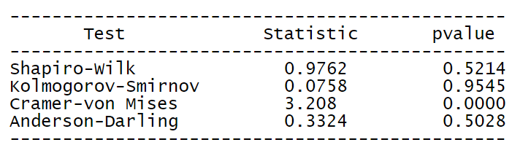

Kolmogorov-Smirnov p >0.05. Residuals of group 1 are normally distributed.

*3.10 Check if residuals are independent.*

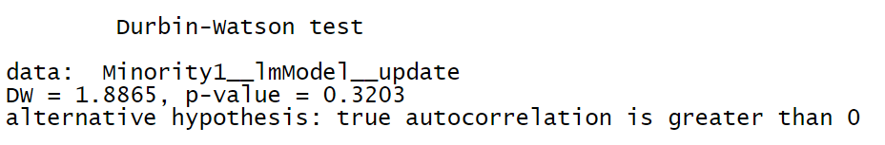

Figure A 20 Independence Test in Group 1

The Durbin Watson statistic tests the hypothesis that there is no autocorrelation. If there is no autocorrelation (where subsequent observations are related), the Durbin-Watson statistic should be between 1.5 and 2.5, and the p-value will be above 0.05.

Our DW satisfies the condition (DW = 1.8865 (1.5< 1.8865<2.5)) but p-value doesn’t (p-value = 0.3203 (0.3203>0.05)).

The influencing factors in group 1 are independent.

*3.11 Check if the mean of the residuals is zero and the sum of the residuals is zero.*

sum of the residuals = -2.775558e-17

mean of the residuals = -6.711728e-19

The mean of the errors is close to zero. The sum of the errors is close to zero.

*3.12 Check if residuals have constant variance*

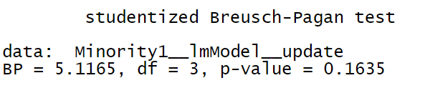

Figure A 21 Heteroscedasticity Test in Group 1

The null hypothesis of the Breusch-Pagan test is homoscedasticity (= variance does not depend on auxiliary regressors). If the p-value becomes "small"(the p-value is less than 0.05), the null hypothesis is rejected. Residuals have constant variance in group 1.

d. Summary of Regression Diagnosis

Table A 3 Summary of Regression Diagnosis in Minority Status and Language Model

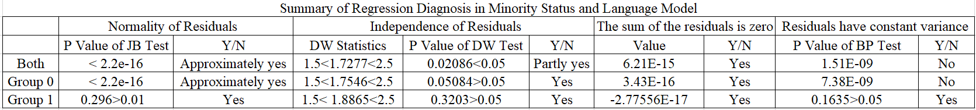

Residuals in both groups and group 0 do not pass the test of homoscedasticity because there are many outliers in the scatter plots of both groups and group 0.

As we can see, residuals in group 1 pass the normality, independence, and homoscedasticity tests because most of the points lie within the confidence bands in group 1, which is expected for the given distribution.

**4 *Blinder-Oaxaca Decomposition***



Figure A 22 The Mean Uninsured Percentage by Tracts after Transformation

Table A 4 Threefold Decomposition Result

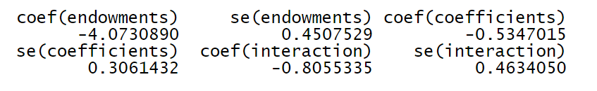

The results of the threefold decomposition suggest that, of the -5.413% difference, approximately -4.073% can be attributed to group differences in endowments (i.e., race, English language), -0.535% to differences in coefficients, and the remaining -0.805% is accounted for by the interaction of the two.



Figure A 23 Plot of the Threefold Decomposition of Minority Status Model



Figure A 24 Differences in the Regression Coefficients on White Alone

Table A 5 The Results of Twofold Decomposition

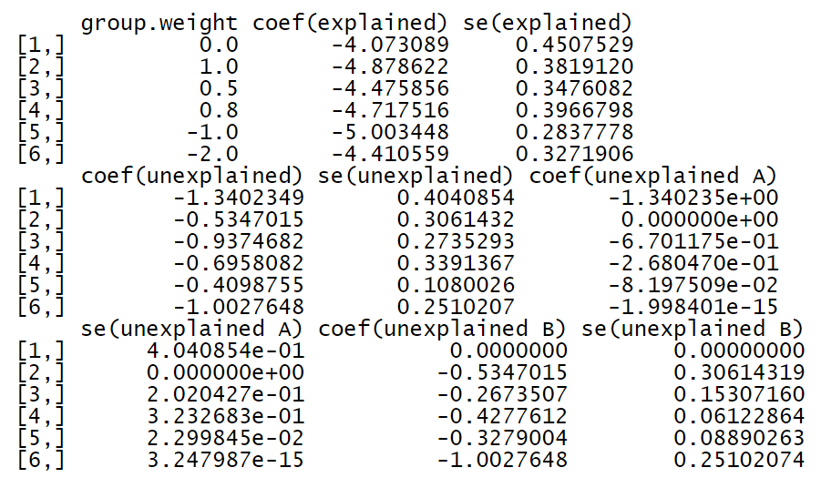

The column of the Group. Weight = -1 indicates that the reference coefficients come from pooled regressions without the group indicator variable included as a covariate.

The results of the overall twofold decomposition indicate that the -5.413% uninsured percentage gap between the safe group and the risk group can be decomposed into -5.003%, which can be explained by group differences in the explanatory variables and -0.41% that is unexplained.

Let us assume that the unexplained component of the uninsured percentage gap occurs due to discrimination and that the pooled regression coefficients are non-discriminatory. The Blinder-Oaxaca decomposition would then also indicate that -0.08% of the unexplained part originates from discrimination in favor of safe group 0 (component "unexplained A"),

while -0.33% comes from discrimination against those who are in the risk group (component "unexplained B").



Figure A 25 The Explained and Unexplained Components of a Twofold Blinder-Oaxaca Decomposition of Safe Group 0 vs. Risk Group 1 Gap



Figure A 26 The Unexplained Portion's Discrimination Sub-Components in a Twofold Blinder-Oaxaca Decomposition of Safe Group 0 vs. Risk group 1



Figure A 27 The Unexplained Portion's Discrimination Sub-Components in a Twofold Blinder-Oaxaca Decomposition of Safe Group 0 vs. Risk Group 1 Gap. An Alternative Presentation

Table A 6 Twofold Blinder-Oaxaca Decomposition Results

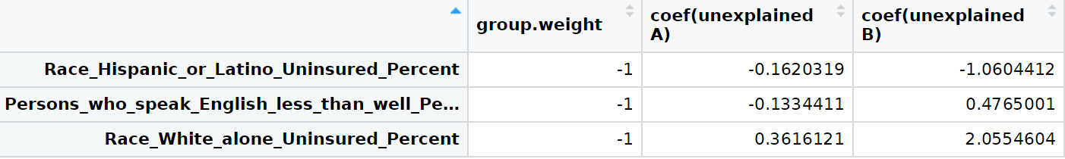

# Appendix B: Socioeconomic Status Model

1. **Correlation Analysis**

In this model, I do the correlation analysis of 13 factors: the uninsured percent of native-born and the uninsured percent of foreign-born!! Naturalized, uninsured percentage of foreign-born!! not a citizen, uninsured percent of less than high school graduate, uninsured percent of high school graduate (includes equivalency), uninsured percent of some college or associate's degree, uninsured percent of Bachelor's degree or higher, uninsured percent of worked full-time, uninsured percent of worked less than full-time, uninsured percent of did not work, uninsured percent of below 138 percent of the poverty threshold, uninsured percent of 138 to 399 percent of the poverty threshold, uninsured percent of at or above 400 percent of the poverty threshold.

Table B 1 Correlation Coefficients (1)

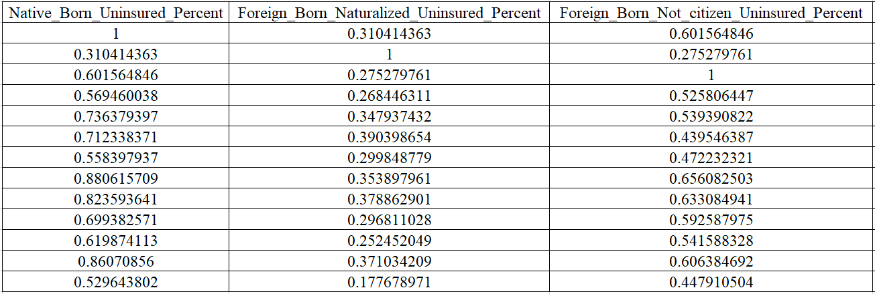

Table B 2 Correlation Coefficients (2)

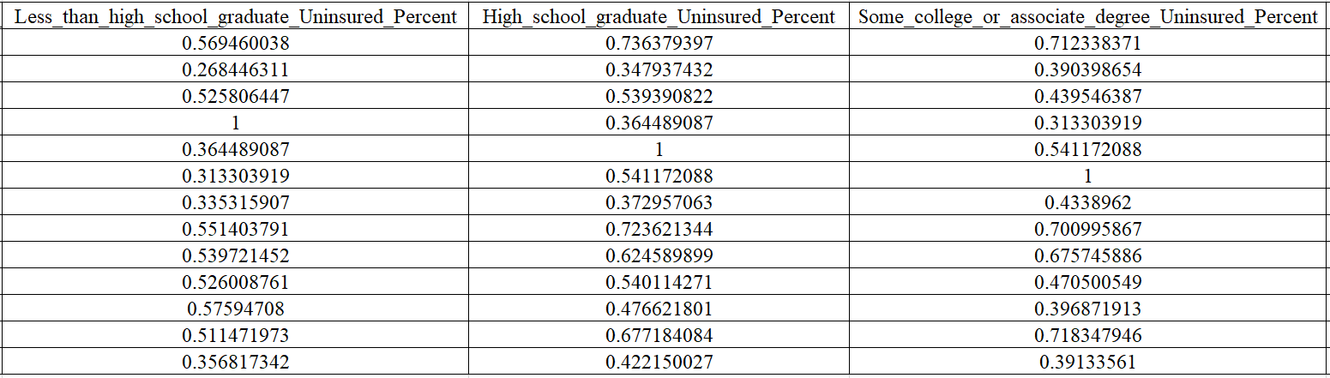

Table B 3 Correlation Coefficients (3)

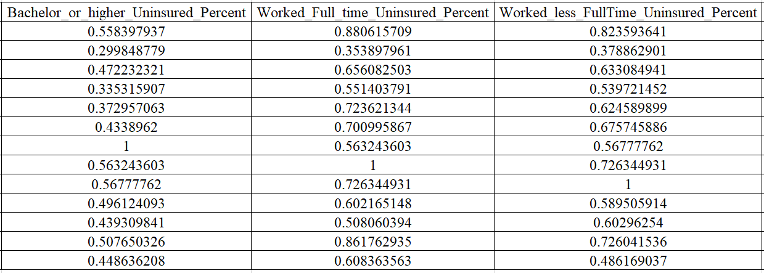

Table B 4 Correlation Coefficients (4)

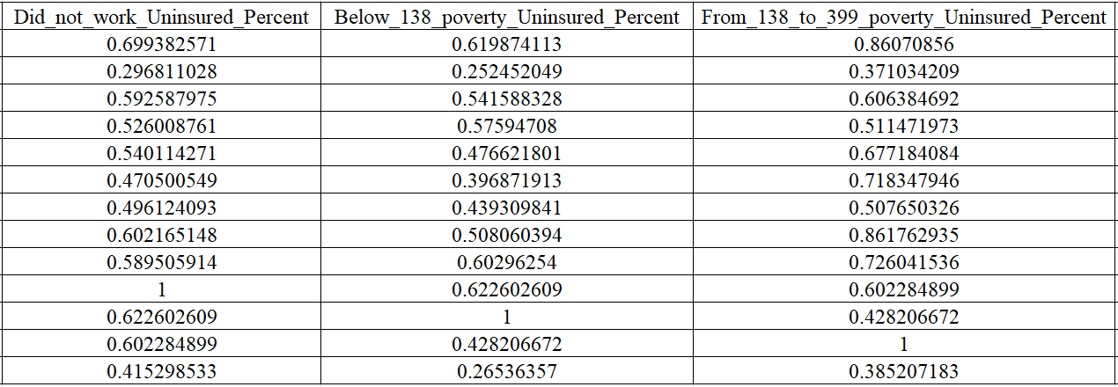

Table B 5 Correlation Coefficients (5)

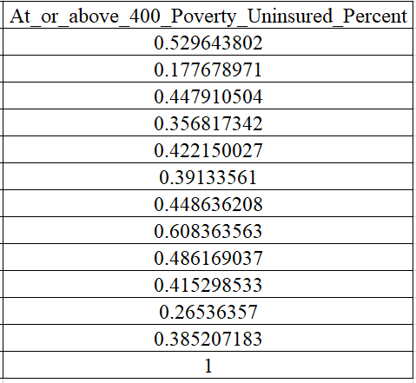

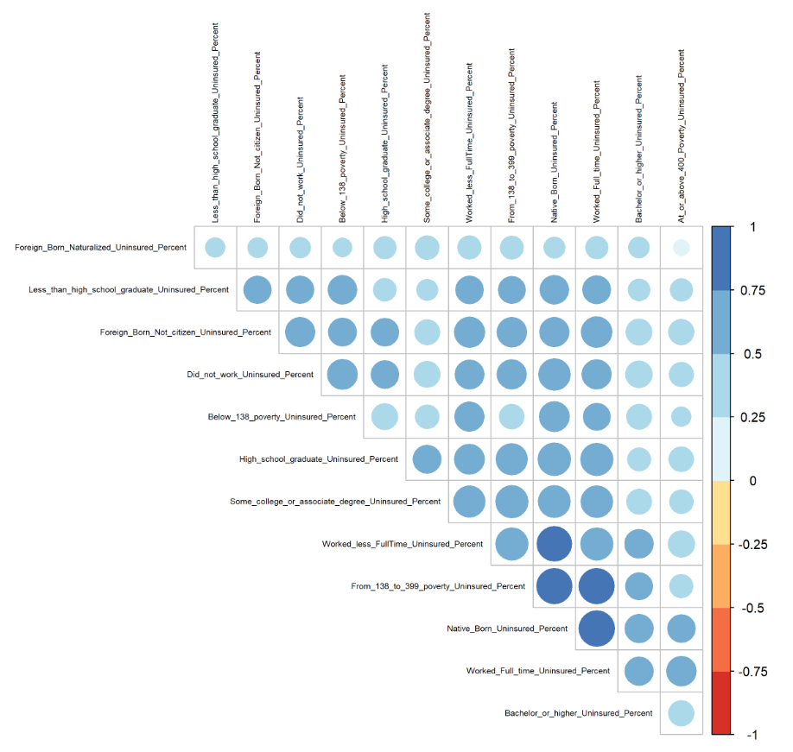

Figure B 1 Correlation Coefficients in Socioeconomic Status Model

In a multiple regression model, the high correlated influencing factors impact the valid results about any individual influencing factor. To avoid multicollinearity, I adopt two steps to fix the problem.

Step 1: Use the step() function to find the best linear model with the least AIC.

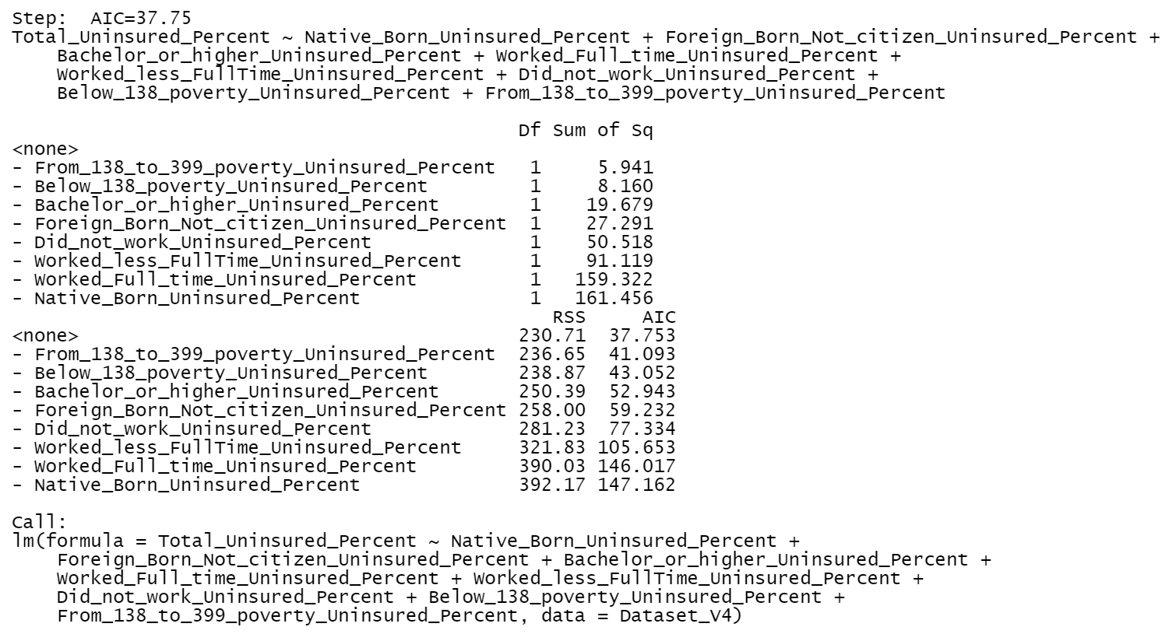

Figure B 2 The best linear model with the least AIC in Socioeconomic Status Model

Then I do the correlation analysis of 8 factors, including the uninsured percent of the native-born and uninsured percentage of foreign-born!! not a citizen, uninsured percent of Bachelor's degree or higher, uninsured percent of worked full-time, uninsured percent of worked less than full-time, uninsured percent of did not work, uninsured percent of below 138 percent of the poverty threshold, uninsured percent of 138 to 399 percent of the poverty threshold.

Table B 6 Correlation Coefficients after Using step() (1)

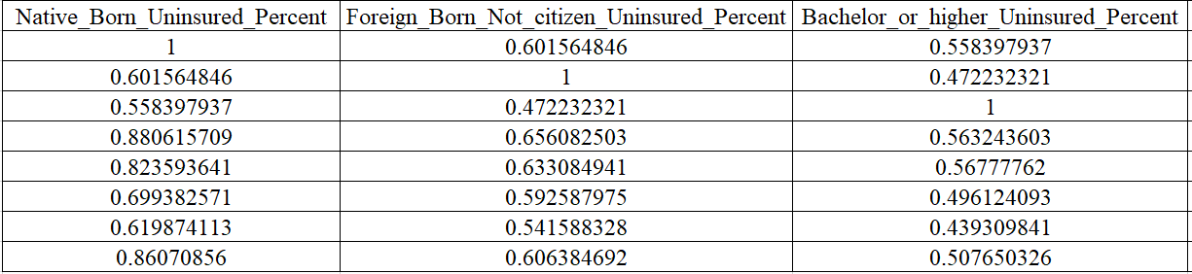

Table B 7 Correlation Coefficients after Using step() (2)

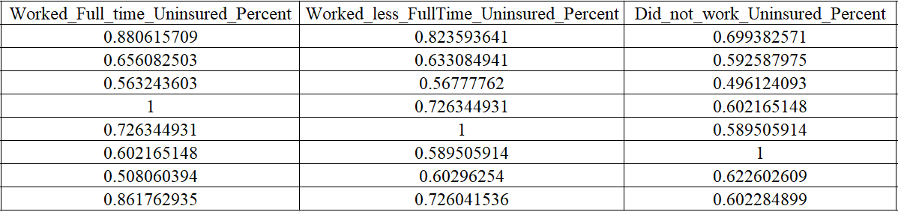

Table B 8 Correlation Coefficients after Using step() (3)

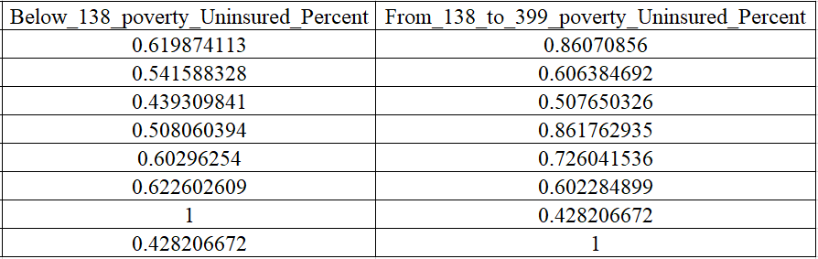

I find the uninsured percent of native-born, uninsured percent of worked full-time, uninsured percent of 138 to 399 percent of the poverty threshold with correlation coefficients are higher than 0.85.

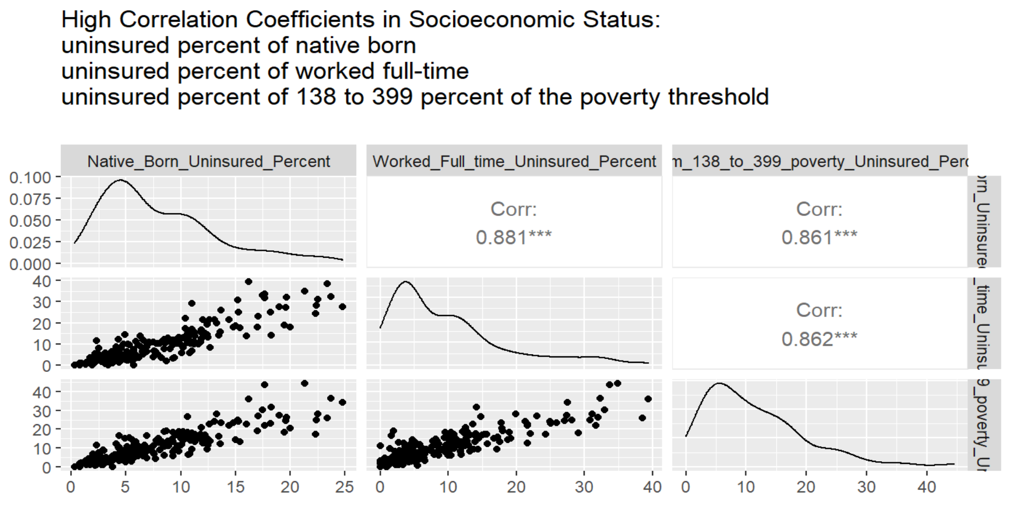

Figure B 3 High Correlation Coefficients in Socioeconomic Status

Step 2: Use the relative importance of regressors in linear models to merge highly correlated factors.

I build a socioeconomic status linear regression model using this formula

$$Uninsured Percent by Tracts \sim the uninsured percent of native-born+uninsured percentage of foreign-born‼ not a citizen+uninsured percent of {Bachelor}^{'}s degree or higher+uninsured percent of worked full-time+uninsured percent of worked less than full-time+ uninsured percent of did not work+ uninsured percent of below 138 percent of the poverty threshold+uninsured percent of 138 to 399 percent of the poverty threshold$$

This is the results of Relative importance metrics using the linear regression model above:

Table B 9 Relative Importance Metrics in Socioeconomic Status Model

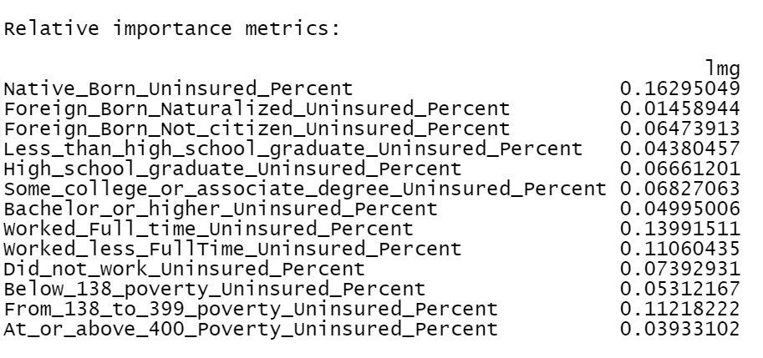

I generate a new column called "NativeBorn_ WorkedFulltime_ From138to399poverty_MultiFactor" and calculate the weighted average of uninsured percent of native-born, uninsured percent of worked full-time, uninsured percent of 138 to 399 percent of the poverty threshold using the formula.

$${NativeBorn}_{_}{WorkedFulltime}_{_}From138to{399poverty}_{__}MultiFactor=0.39260654350624* uninsured percent of native-born+ 0.337105999014764* uninsured percent of worked full-time+0.270287457478996* uninsured percent of 138 to 399 percent of the poverty threshold$$

I replace the three columns with "NativeBorn_WorkedFulltime_From138to399poverty_MultiFactor".

Then I do the correlation analysis of 6 factors, including NativeBorn_WorkedFulltime_From138to399poverty_MultiFactor, uninsured percentage of foreign-born!! not a citizen, uninsured percent of Bachelor's degree or higher, uninsured percent of worked less than full-time, uninsured percent of did not work, uninsured percent of below 138 percent of the poverty threshold.

Table B 10 Correlation Coefficients after Using step() and Relative Importance of Regressors in Socioeconomic Status Model (1)

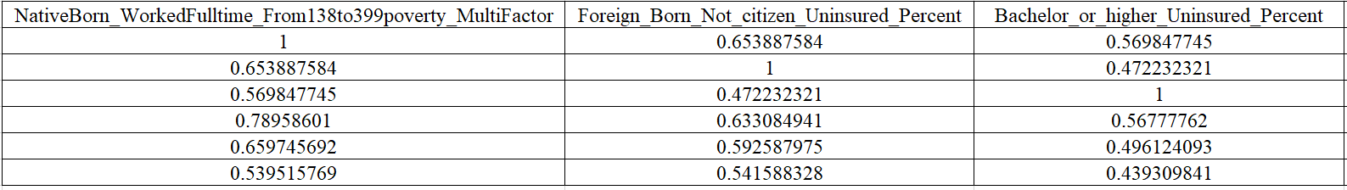

Table B 11 Correlation Coefficients after Using step() and Relative Importance of Regressors in Socioeconomic Status Model (2)

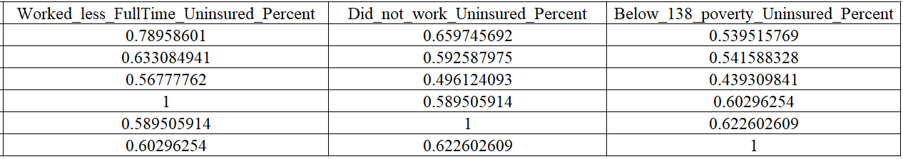

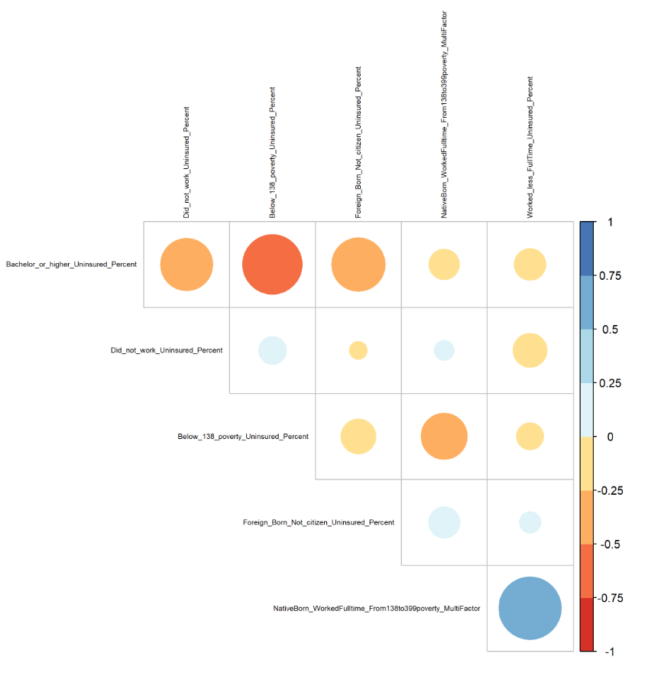

Figure B 4 Correlation Coefficients in Socioeconomic Status Model After Using step() and Relative Importance of Regressors

Now no correlation coefficients are higher than 0.85.

1. **Linear Regression Analysis**

I build a socioeconomic status linear regression model using this formula

$$Uninsured Percentage by Tracts \sim NativeBorn_WorkedFulltime_From138to399poverty_MultiFactor+uninsured percentage of foreign-born‼ not a citizen+uninsured percent of {Bachelor}^{'}s degree or higher+uninsured percent of worked less than full-time+ uninsured percent of did not work+ uninsured percent of below 138 percent of the poverty threshold$$

*2.1 The Scatter plots of factors*

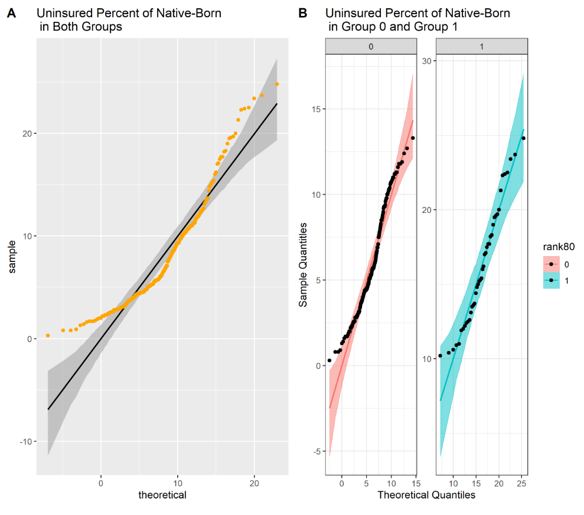

Figure B 5 Scatter Plots of Uninsured Percent of Native-Born

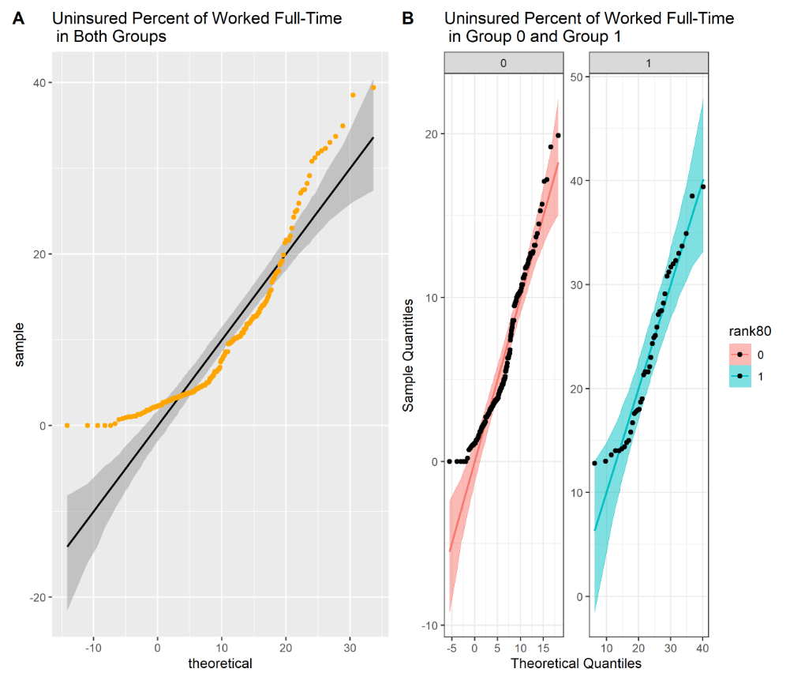

Figure B 6 Scatter Plots of Uninsured Percent of Worked Full-time

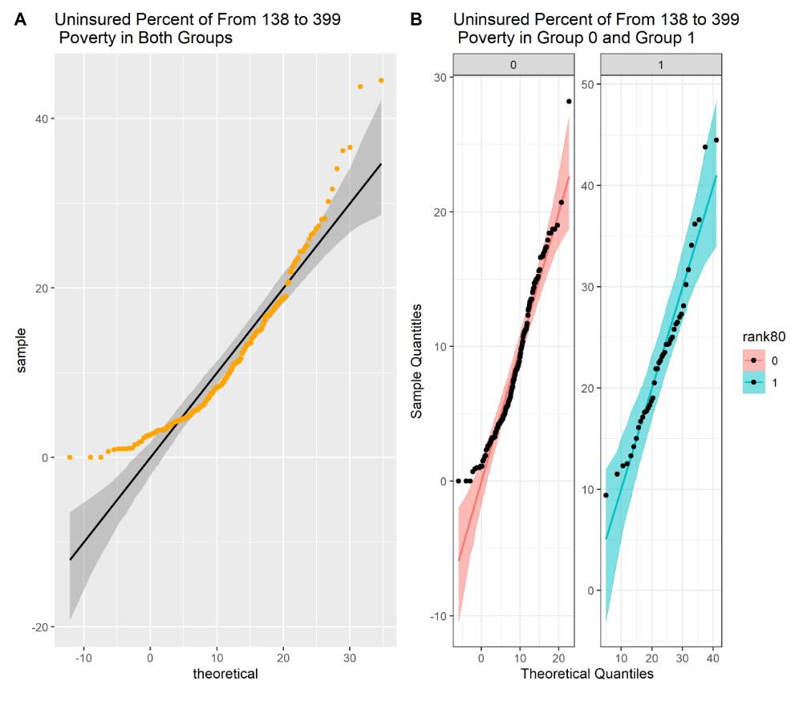

Figure B 7 Scatter Plots of Uninsured Percent of 138 to 399 Percent of the Poverty Threshold

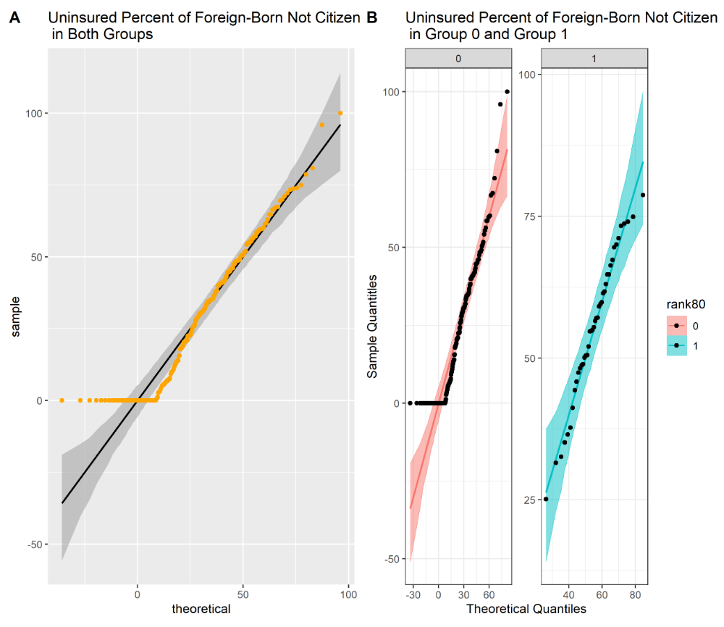

Figure B 8 Scatter Plots of Uninsured Percentage of Foreign-Born!!Not a Citizen

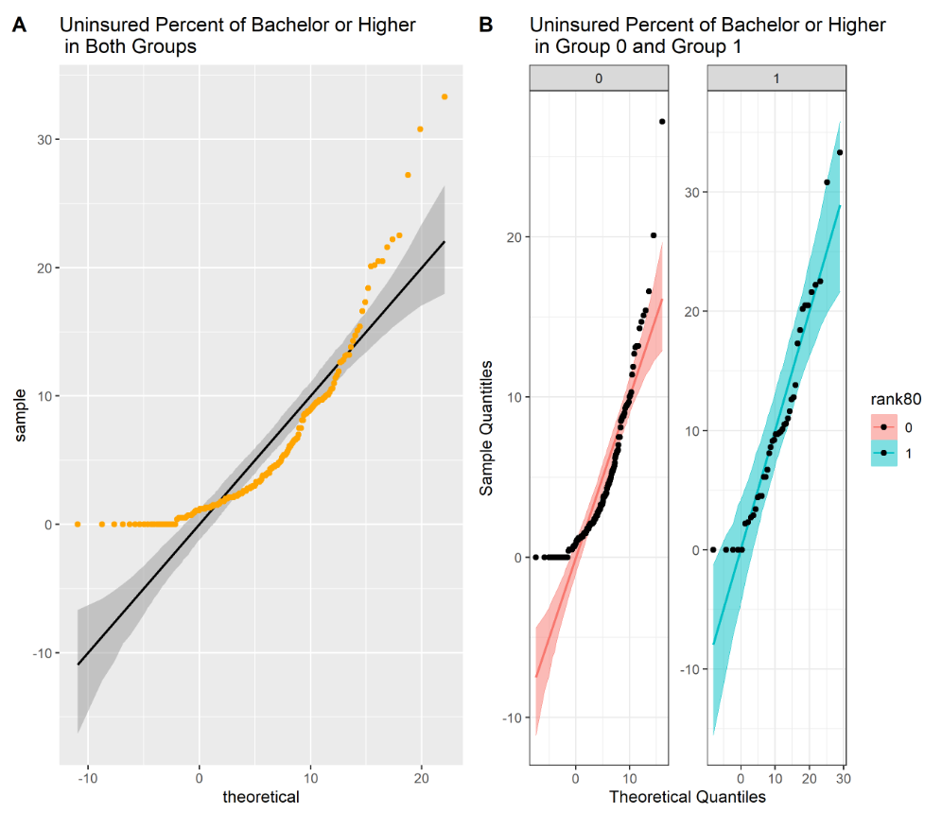

Figure B 9 Scatter Plot of Uninsured Percent of Bachelor's Degree or Higher

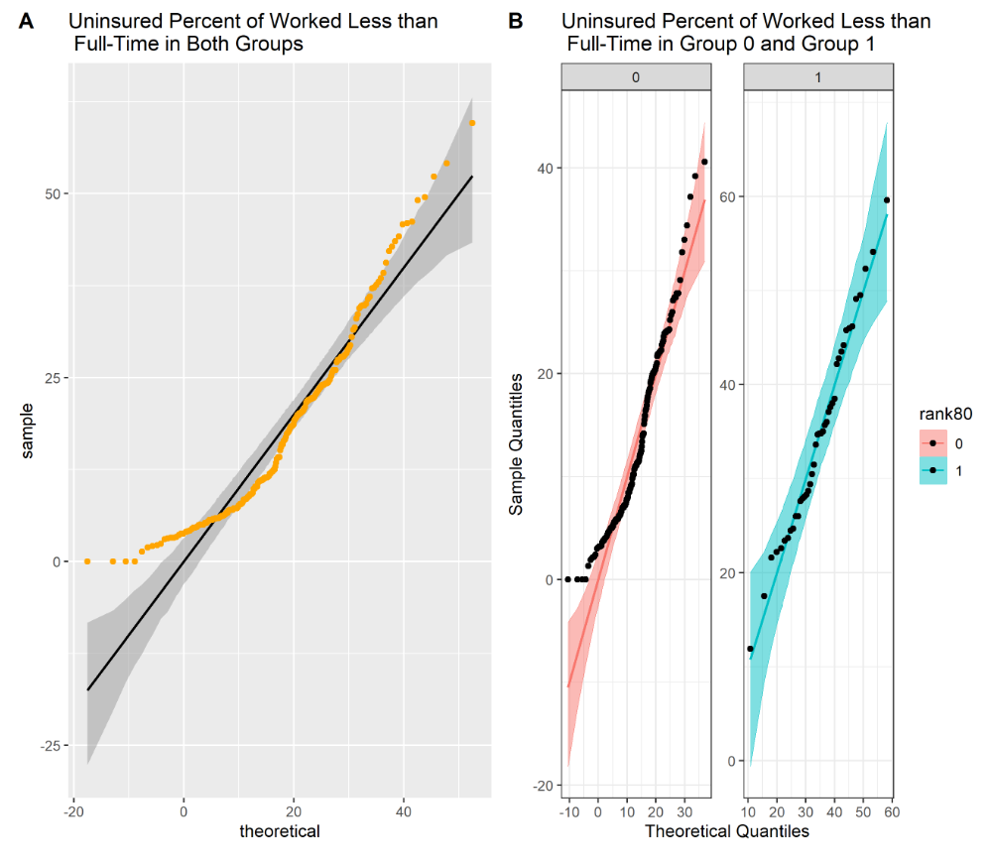

Figure B 10 Scatter Plots of Uninsured Percent of Worked Less than Full-time

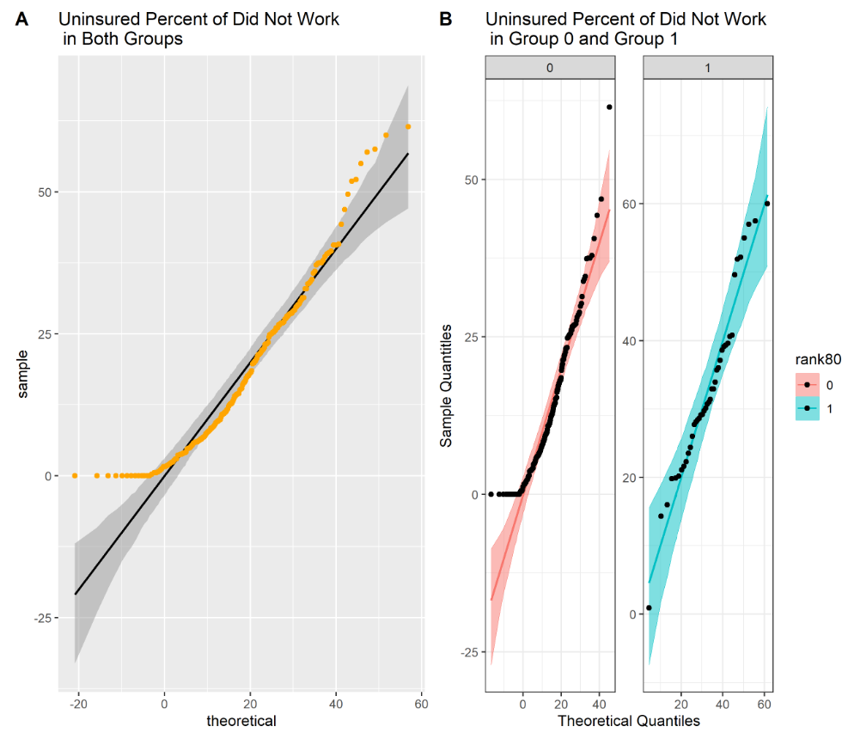

Figure B 11 Scatter Plot of Uninsured Percent of Did Not Work

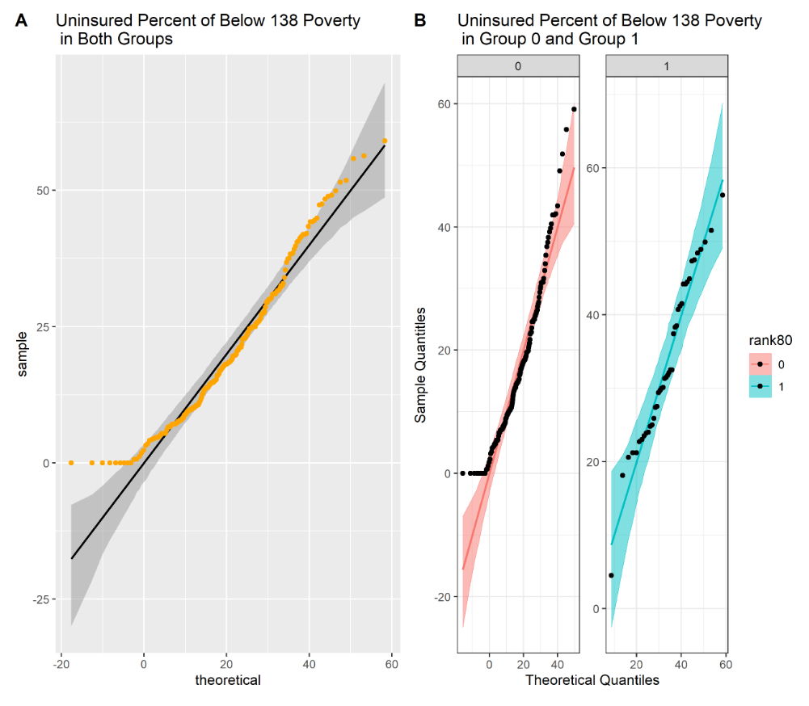

Figure B 12 Scatter Plot of Uninsured Percent of Below 138 Percent of the Poverty Threshold

As we can see, most of the points lie within the confidence bands in group 1, which is expected for the given distribution. However, we observe many outliers in the scatter plots of both groups and group 0.

* 1. *Box-Cox Transformation*

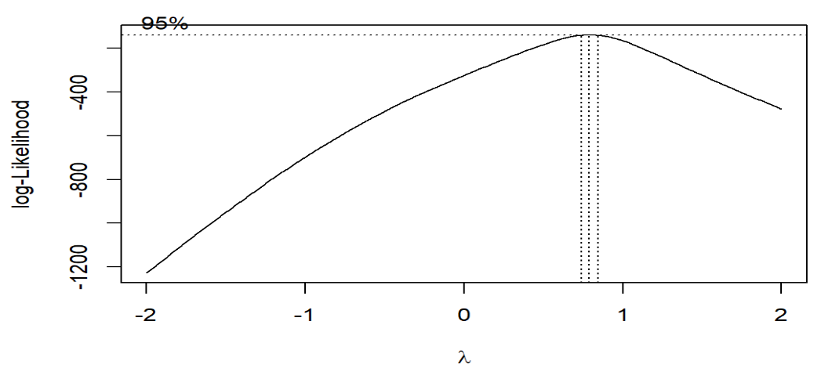

Figure B 13 Best λ

Best lambda=0.7878788

1. **Regression Diagnosis**
2. Check Both Groups

*3.1 Check if residuals are normally distributed*

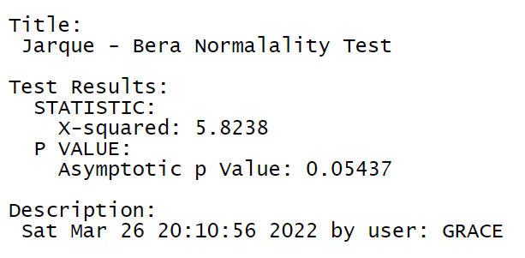

Figure B 14 Normality Test

Null Hypothesis: Skewness and Kurtosis are equal to zero(normal distribution). p <= 0.01 : very strong presumption against null hypothesis. It is normally distributed.

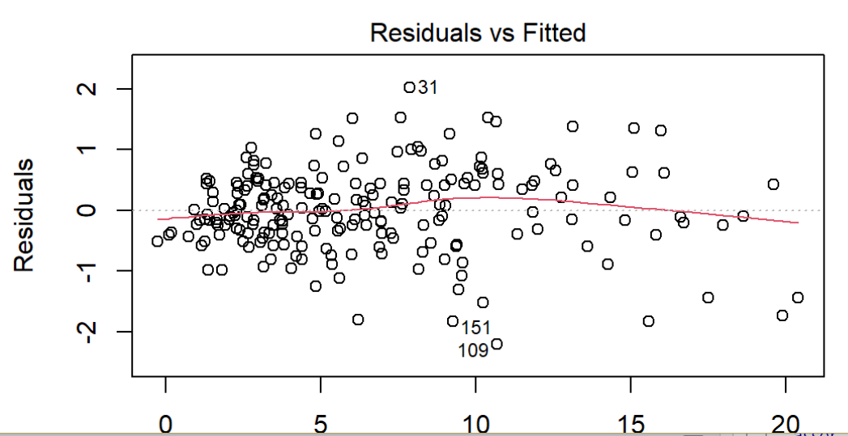

Figure B 15 Residual plot (1)

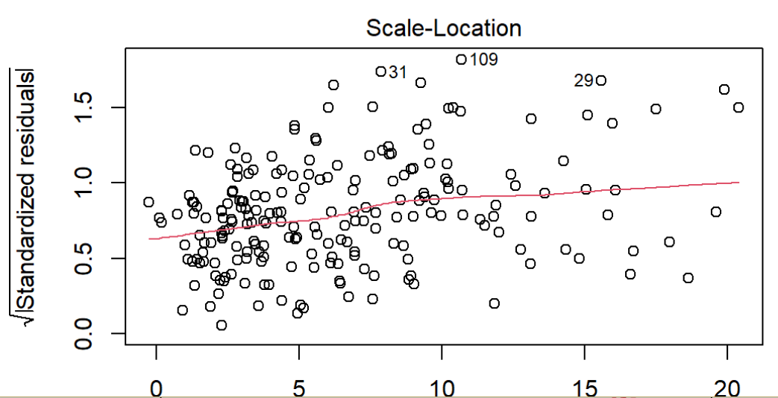

Figure B 16 Residual plot (2)

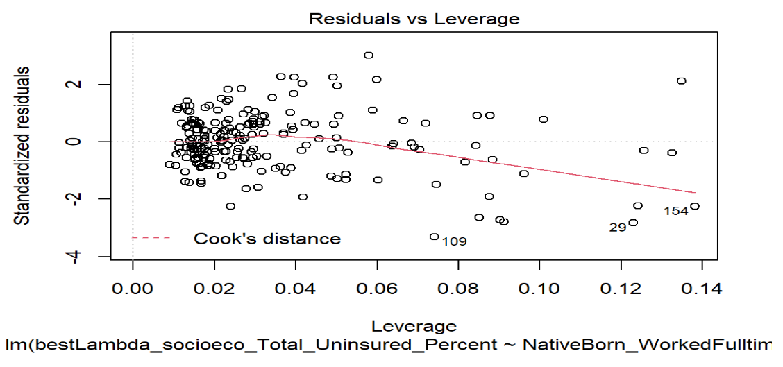

Figure B 17 Residual plot (3)

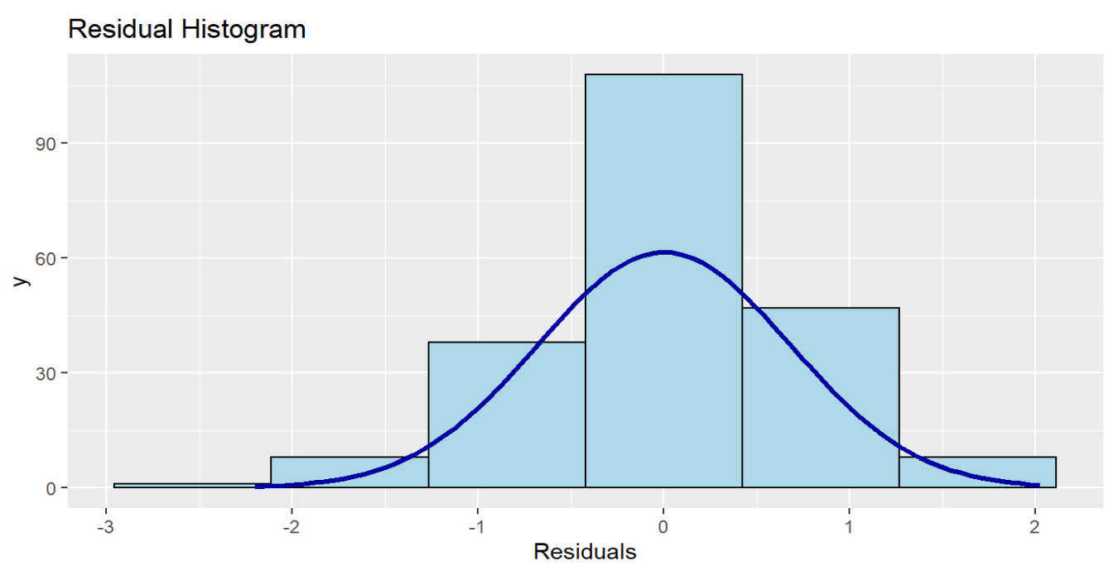

Figure B 18 Residual Histogram in Socioeconomic Status Model

*3.2 Check if residuals are independent.*

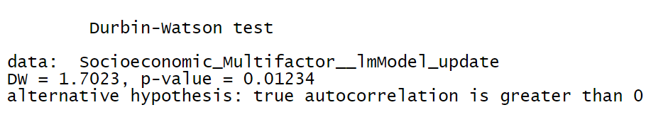

Figure B 19 Independence Test

The Durbin Watson statistic tests the hypothesis that there is no autocorrelation. If there is no autocorrelation (where subsequent observations are related), the Durbin-Watson statistic should be between 1.5 and 2.5, and the p-value will be above 0.05.

Our DW satisfies the condition (DW = 1.7023 (1.5<1.7023<2.5)) but p-value doesn’t (p-value = 0.01234 (0.01234<0.05)).

I deal with the influencing factors in the minority status model as independent ones, although it partly satisfies the DW test.

*3.3 Check if the mean of the residuals is zero and the sum of the residuals is zero.*

sum of the residuals = -1.257328e-14

mean of the residuals =-5.989675e-17

The mean of the errors is close to zero. The sum of the errors is close to zero.

*3.4 Check if residuals have constant variance*

However, it doesn't pass the studentized Breusch-Pagan test. Heteroscedasticity is present in the regression model.

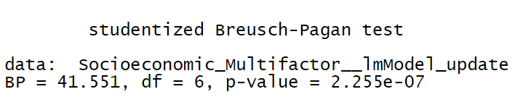

Figure B 20 Heteroscedasticity Test

From the scatter plots of the dataset, we have some outliers. And from plots of residuals, regression outliers with high leverage effect heteroscedasticity when performing a least-squares regression analysis. Because our columns are from different datasets that describe various factors, heteroscedasticity is reasonable.

b. Check Group 0

*3.5 Check if residuals are normally distributed*

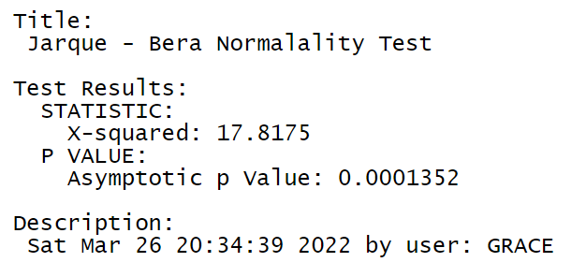

Figure B 21 Normality Test in Group 0

Null Hypothesis: Skewness and Kurtosis are equal to zero(normal distribution). p <= 0.01 : very strong presumption against null hypothesis. It is not normally distributed.

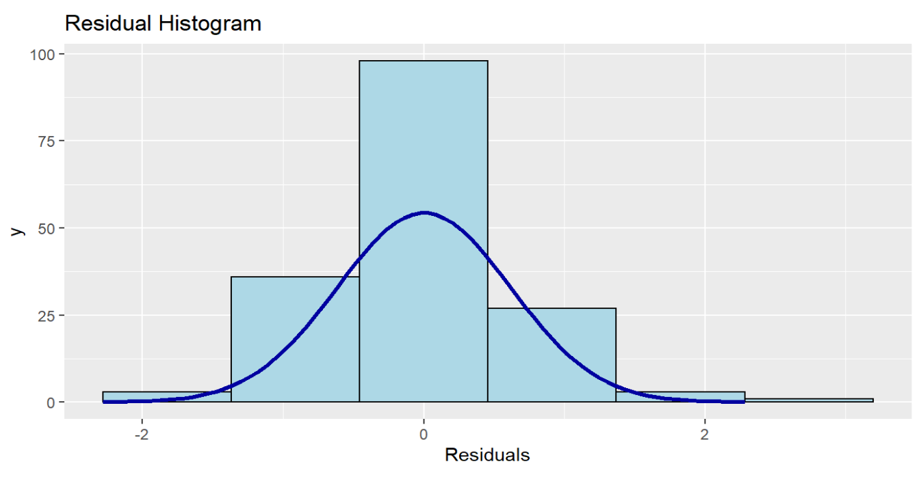

Figure B 22 Residual Histogram in Group 0

The minority status linear regression model uses a large sample (168 entries which are bigger than 30), and the histogram of residuals is similar to the normal distribution. According to the Law of Large Numbers and Central Limit Theorem, we can accept the normality of residuals, although the residuals are not normally distributed using Jarque - Bera Normalality Test.

*3.6 Check if residuals are independent.*

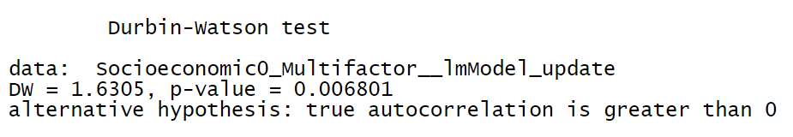

Figure B 23 Independence Test in Group 0

The Durbin Watson statistic tests the hypothesis that there is no autocorrelation. If there is no autocorrelation (where subsequent observations are related), the Durbin-Watson statistic should be between 1.5 and 2.5, and the p-value will be above 0.05.

Our DW satisfies the condition (DW = 1.6305 (1.5<1.6305<2.5)) but p-value doesn’t (p-value = 0.006801 (0.006801<0.05)).

*3.7 Check if the mean of the residuals is zero and the sum of the residuals is zero.*

sum of the residuals = 9.554857e-15

mean of the residuals = 5.688488e-17

The mean of the errors is close to zero. The sum of the errors is close to zero.

*3.8 Check if residuals have constant variance*

However, it doesn't pass the studentized Breusch-Pagan test. Heteroscedasticity is present in the regression model.

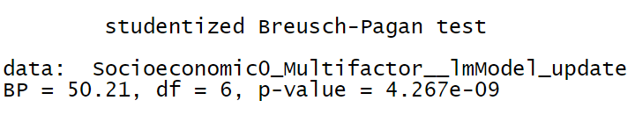

Figure B 24 Heteroscedasticity Test in Group 0

From the scatter plots of the dataset, we have some outliers. And from plots of residuals, regression outliers with high leverage effect heteroscedasticity when performing a least-squares regression analysis. Because our columns are from different datasets that describe various factors, heteroscedasticity is reasonable.

c. Check Group 1

*3.9 Check if residuals are normally distributed*

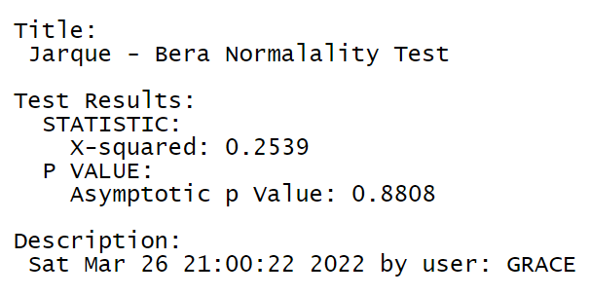

Figure B 25 Normality Test in Group 1

Null Hypothesis: Skewness and Kurtosis are equal to zero(normal distribution). p <= 0.01 : very strong presumption against null hypothesis. It is normally distributed.

*3.10 Check if residuals are independent.*

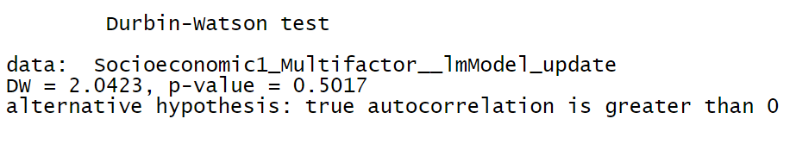

Figure B 26 Independence Test in Group 1

The Durbin Watson statistic tests the hypothesis that there is no autocorrelation. If there is no autocorrelation (where subsequent observations are related), the Durbin-Watson statistic should be between 1.5 and 2.5, and the p-value will be above 0.05.

Our DW satisfies the condition (DW = 2.0423 (1.5< 2.0423<2.5)) but p-value doesn’t (p-value = 0.5017(0.5017>0.05)).

The influencing factors in group 1 are independent.

*3.11 Check if the mean of the residuals is zero and the sum of the residuals is zero.*

sum of the residuals = -1.665335e-16

mean of the residuals = -3.992187e-18

The mean of the errors is close to zero. The sum of the errors is close to zero.

*3.12 Check if residuals have constant variance*

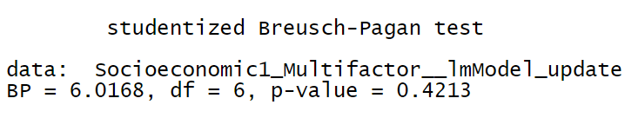

Figure B 27 Heteroscedasticity Test in Group 1

The null hypothesis of the Breusch-Pagan test is homoscedasticity (= variance does not depend on auxiliary regressors). If the p-value becomes "small"(the p-value is less than 0.05), the null hypothesis is rejected. Residuals have constant variance in group 1.

d. Summary of Regression Diagnosis

Table B 11 Summary of Regression Diagnosis in Socioeconomic Status Model

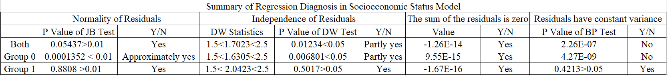

Residuals in both groups and group 0 do not pass the test of homoscedasticity because there are many outliers in the scatter plots of both groups and group 0.

As we can see, residuals in group 1 pass the normality, independence, and homoscedasticity tests because most of the points lie within the confidence bands in group 1, which is expected for the given distribution.

**4 Blinder-Oaxaca Decomposition**



Figure B 28 The Mean Uninsured Percentage by Tracts after Transformation

Table B 12 Threefold Decomposition Results

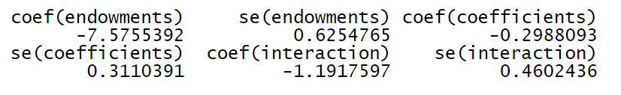

The results of the threefold decomposition suggest that of the -9.066% difference, approximately -7.575% can be attributed to group differences in endowments (i.e., race, English language), -0.299% to differences in coefficients, and the remaining -1.192% is accounted for by the interaction of the two.



Figure B 29 Plot of the Threefold Decomposition of Socioeconomic Status Model

Table B 13 Differences in the Regression Coefficients on NativeBorn_WorkedFulltime_From138to399poverty_MultiFactor



Table B 14 The Results of Twofold Decomposition

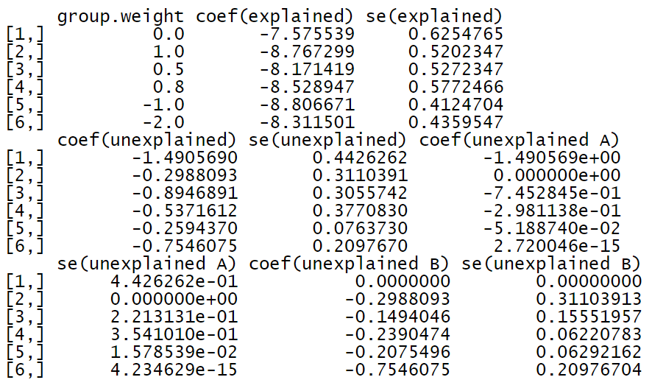

The results of the overall twofold decomposition indicate that the -9.066% uninsured percentage gap between the safe group and the risk group can be decomposed into -8.807%, which can be explained by group differences in the explanatory variables and -0.259% that is unexplained.

Let us assume that the unexplained component of the uninsured percentage gap occurs due to discrimination and that the pooled regression coefficients are non-discriminatory. The Blinder-Oaxaca decomposition would then also indicate that -0.052% of the unexplained part originates from discrimination in favor of safe group 0 (component "unexplained A"),

while -0.207% comes from discrimination against those who are in the risk group (component "unexplained B").



Figure B 30 The Explained and Unexplained Components of a Twofold Blinder-Oaxaca Decomposition of Safe Group 0 vs. Risk Group 1 Gap



Figure B 31 The unexplained portion's discrimination sub-components in a twofold Blinder-Oaxaca decomposition of safe group 0 vs. risk group 1 gap. An alternative presentation (1)



Figure B 32 The Unexplained Portion's Discrimination Sub-Components in a Twofold Blinder-Oaxaca Decomposition of Safe Group 0 vs. Risk Group 1 Gap. An Alternative Presentation (2)

Table B 15 Twofold Blinder-Oaxaca Decomposition

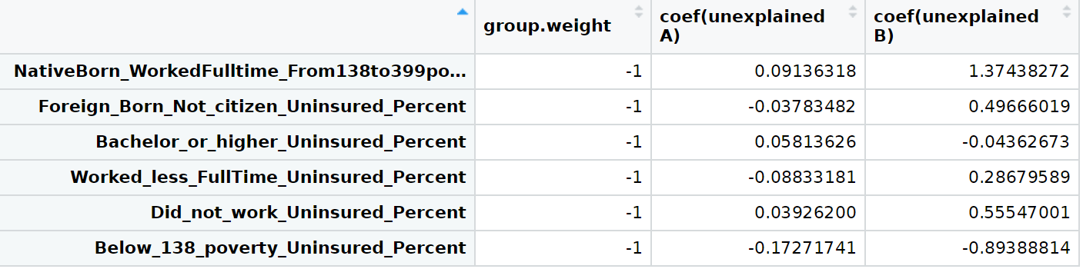

# Appendix C: Household Composition Model

1. **Correlation Analysis**

In this model, I do the correlation analysis of 9 factors, including the uninsured percent of males, uninsured percent of females, uninsured percent of age under 19 years, uninsured percent of age 19 to 64 years, uninsured percent of age 65 years, and older, uninsured percent of in family households, uninsured percent of in family households!! In married-couple families, uninsured percent of in family households!! In other families, the uninsured percent in non-family households and other living arrangements.

Table C 1 Correlation Coefficients (1)

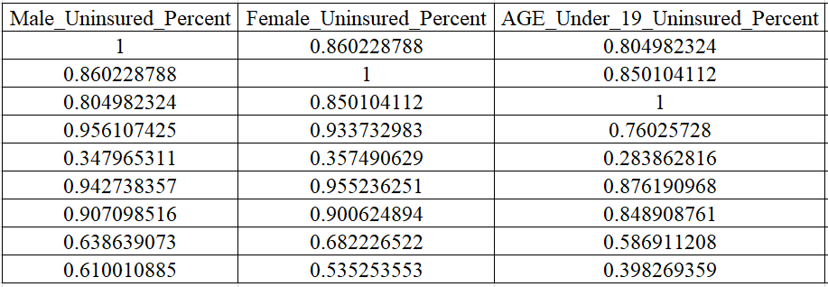

Table C 2 Correlation Coefficients (2)

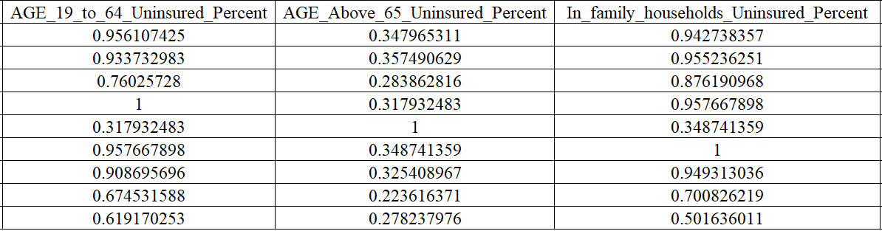

Table C 3 Correlation Coefficients (3)

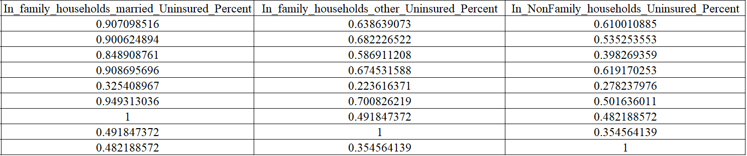

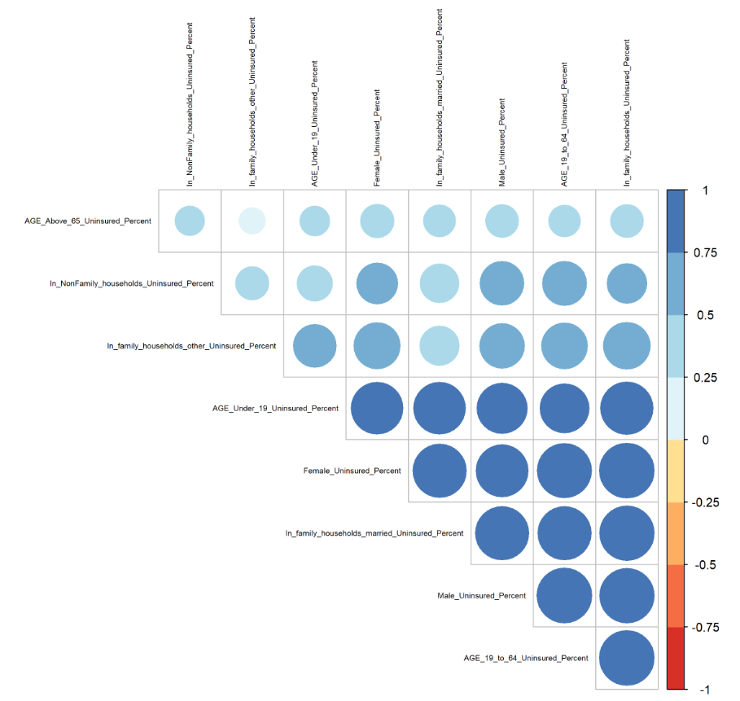

Figure C 1 Correlation Coefficients in Household Composition Model

In a multiple regression model, the high correlated influencing factors impact the valid results about any individual influencing factor. To avoid multicollinearity, I adopt two steps to fix the problem.

Step 1: Use the step() function to find the best linear model with the least AIC.

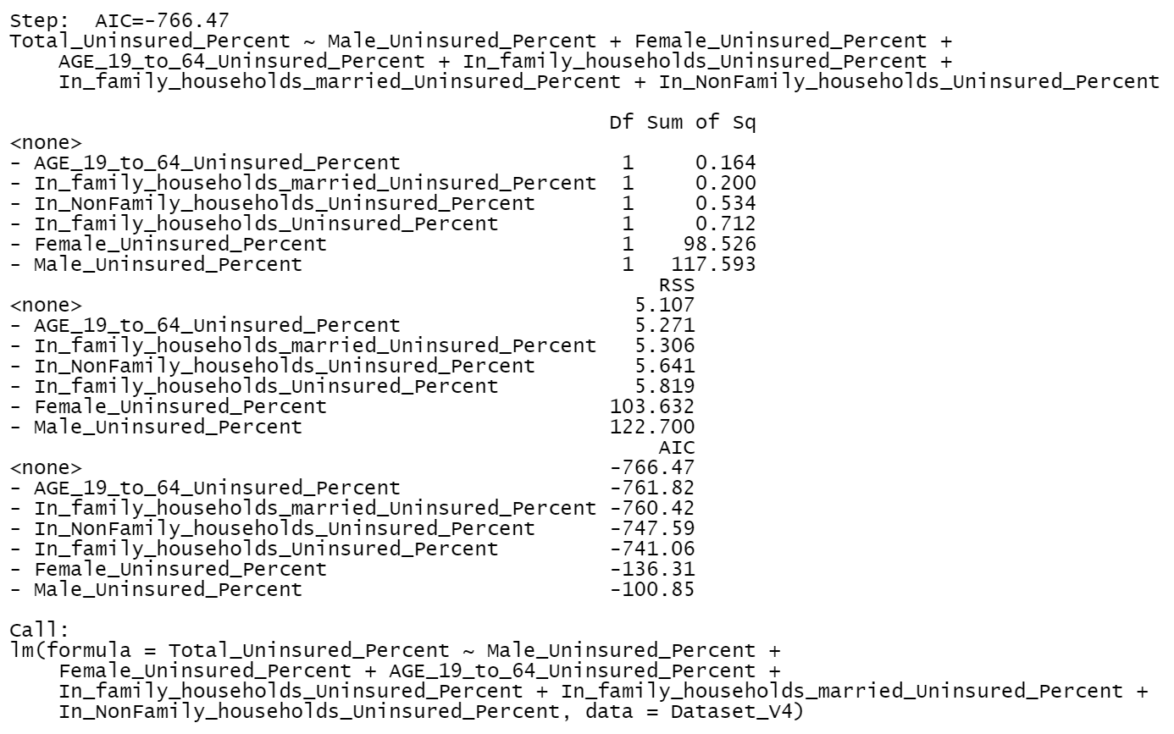

Figure C 2 The best linear model with the least AIC in Household Composition Model

Then I do the correlation analysis of 6 factors, including the uninsured percent of males, uninsured percent of females, uninsured percent of age 19 to 64 years, uninsured percent of in family households, and uninsured percent of in family households!! In married-couple families, uninsured percent of in non-family households and other living arrangements.

Table C 4 Correlation Coefficients after Using step() (1)

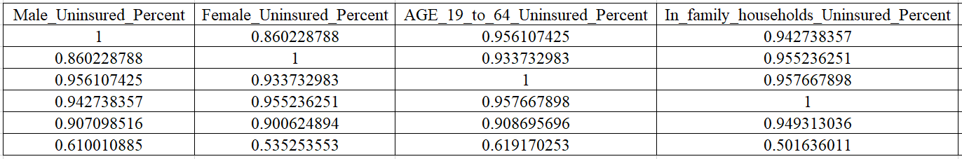

Table C 5 Correlation Coefficients after Using step() (2)

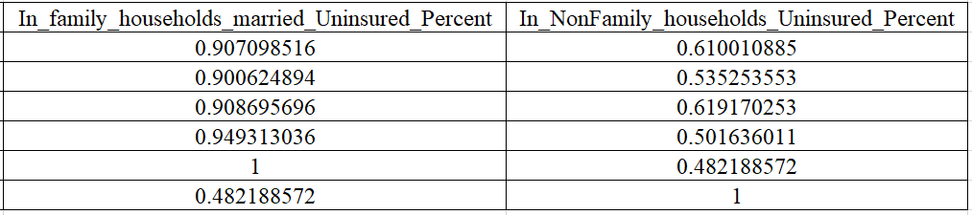

I find the uninsured percent of females, uninsured percent of males, uninsured percent of age 19 to 64 years, and uninsured percent in family households!!in married-couple families, the uninsured percent of in-family households with correlation coefficients is higher than 0.85.

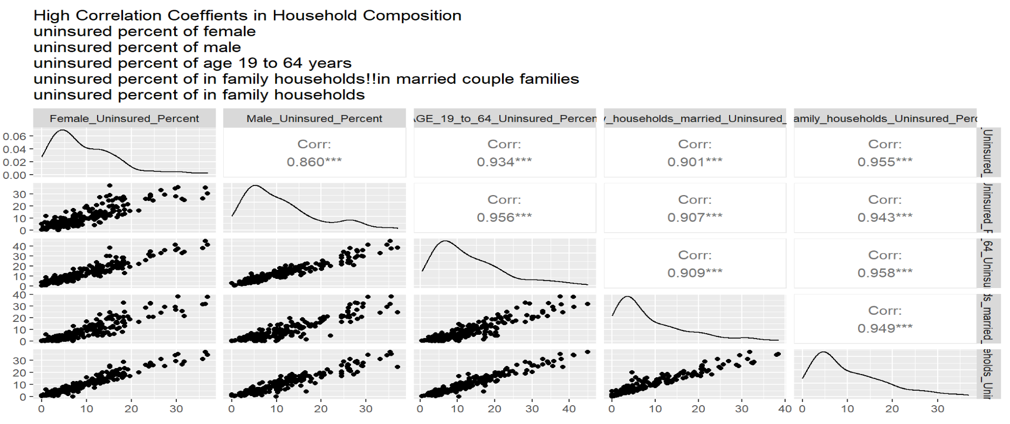

Figure C 3 High Correlation Coefficients in Household Composition

Step 2: Use the relative importance of regressors in linear models to merge highly correlated factors.

I build a household composition linear regression model using this formula

$$Uninsured Percent by Tracts \sim the uninsured percent of male+uninsured percent of female+uninsured percent of age 19 to 64 years+uninsured percent of in family households+uninsured percent of in family households‼ In married-couple families+ uninsured percent of in non-family households and other living arrangements$$

This is the results of Relative importance metrics using the linear regression model above:

Table C 6 Relative Importance Metrics in Household Composition

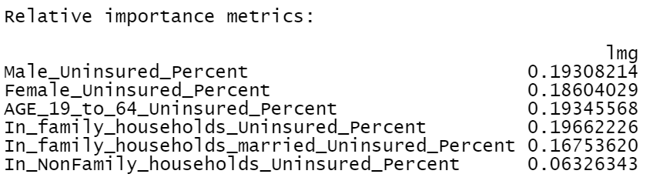

I merge these factors and generate a column called "Age19To64_Sex_InFamilyHousehold_married_multifactor" using this formula

I replace the five columns, including the uninsured percent of females, uninsured percent of males, uninsured percent of age 19 to 64 years, uninsured percent of in family households!!in married-couple families, uninsured percent of in family households with Age19To64_Sex_InFamilyHousehold_married_multifactor.

Table C 7 Correlation Coefficients after Using step() and Relative Importance of Regressors in Household Composition



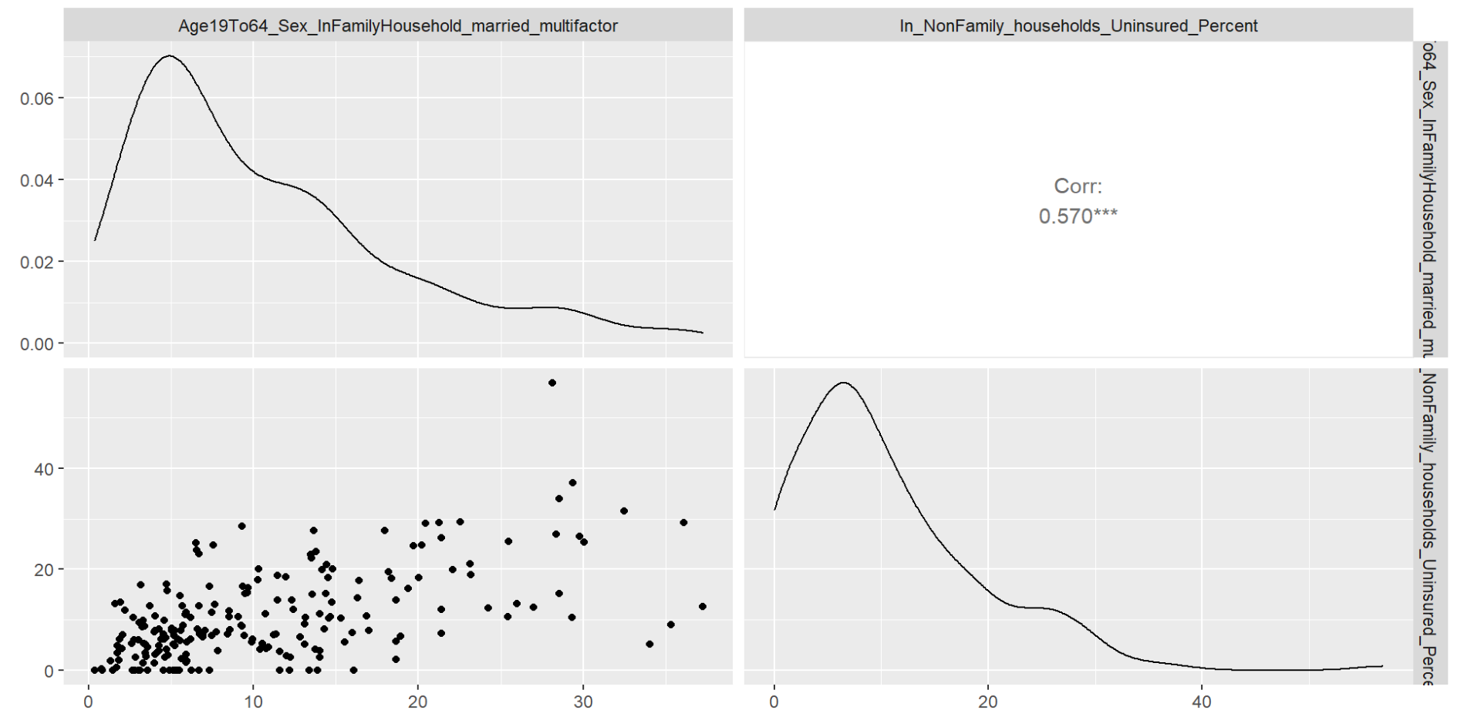

Figure C 4 Correlation Coefficients in Socioeconomic Status Model After Using step() and Relative Importance of Regressors in Household Composition

Now no correlation coefficients are higher than 0.85.

1. **Linear Regression Analysis**

I build a household composition linear regression model using this formula

$$Uninsured Percentage by Tracts \sim Age19To64_Sex_InFamilyHousehold_married_multifactor+uninsured percent of in non-family households and other living arrangements$$

*2.1 The Scatter plots of factors*

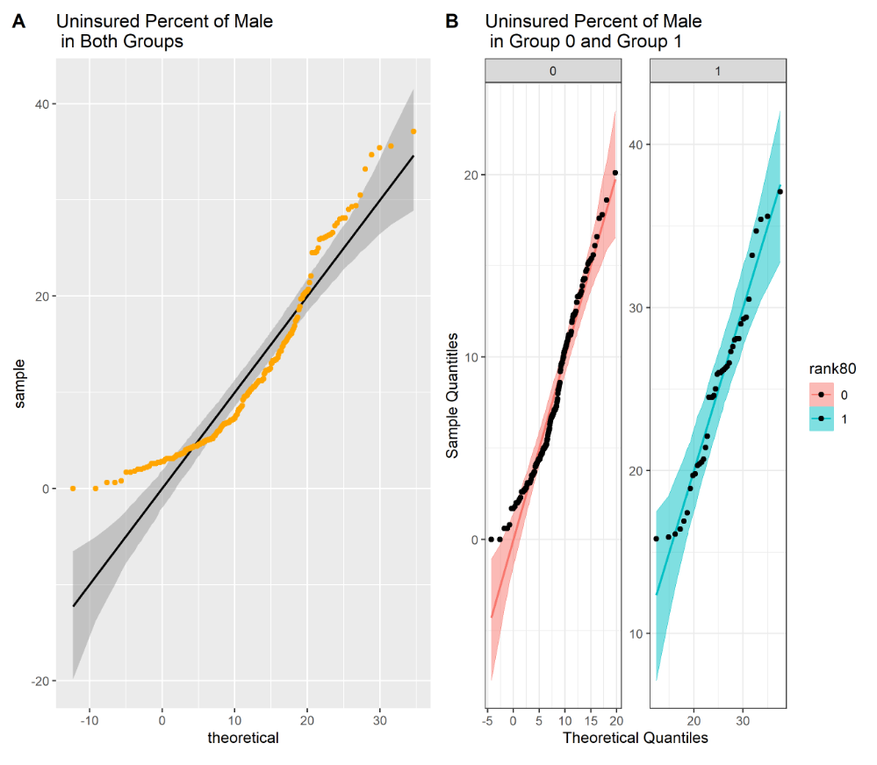

Figure C 5 Scatter Plots of Uninsured Percent of Male

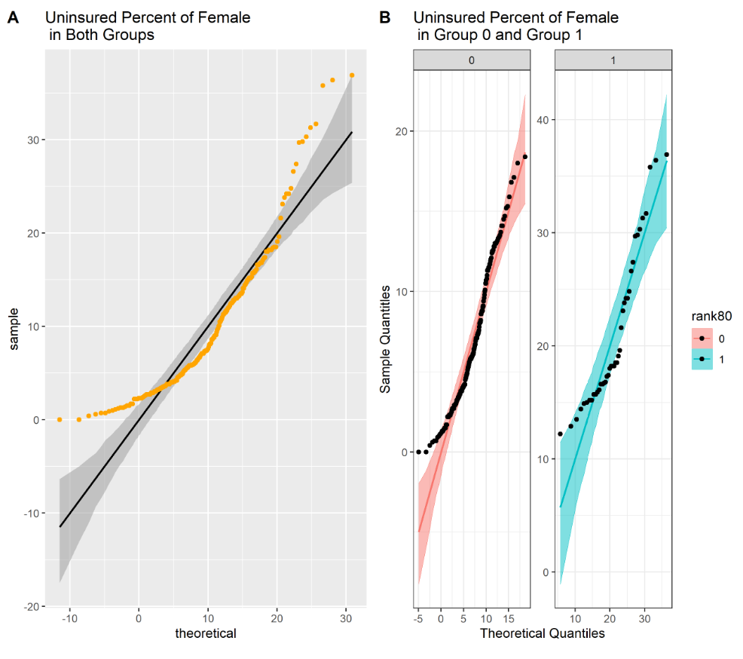

Figure C 6 Scatter Plots of Uninsured Percent of Female

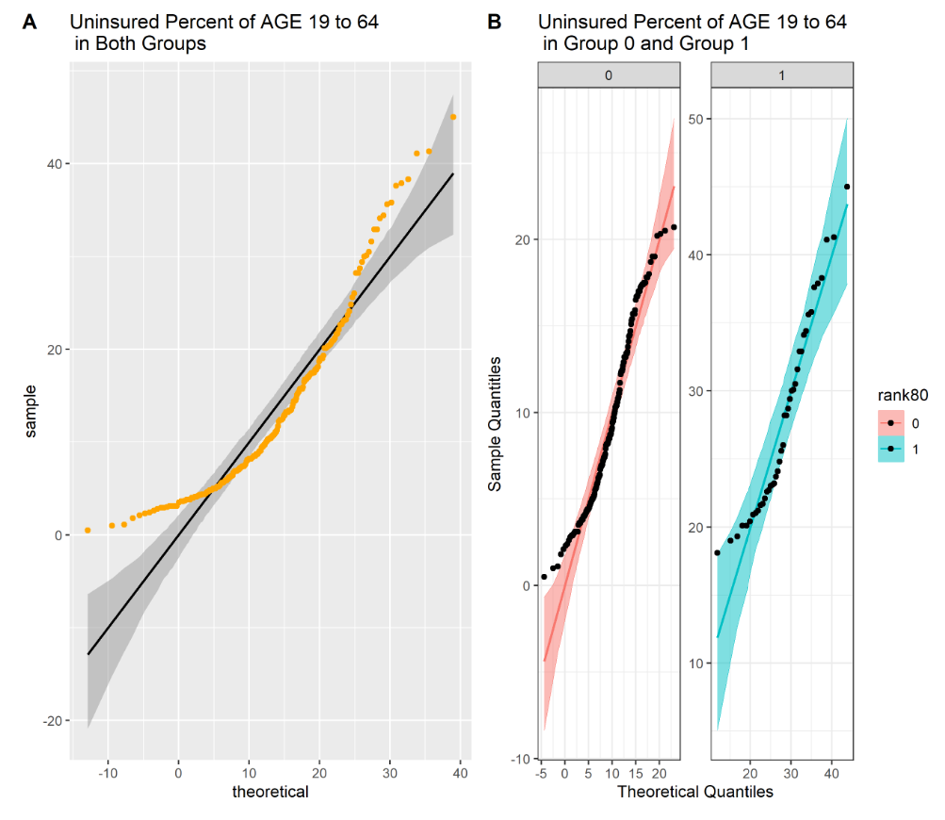

Figure C 7 Scatter Plots of Uninsured Percent of Age 19 to 64 Years

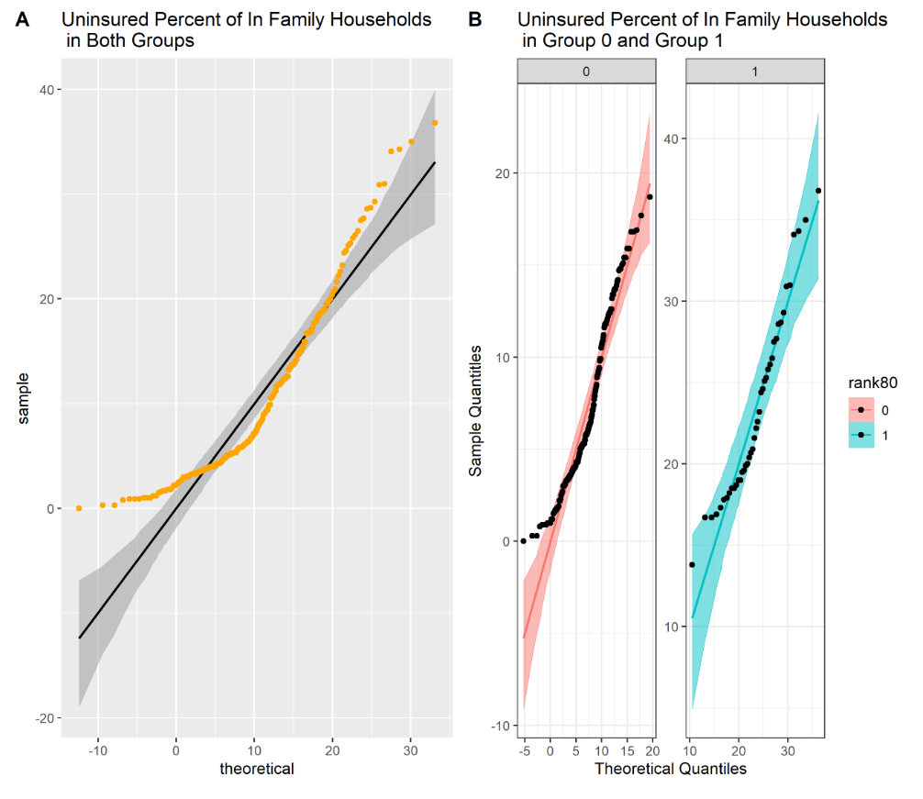

Figure C 8 Scatter Plots of Uninsured Percent of In Family Households

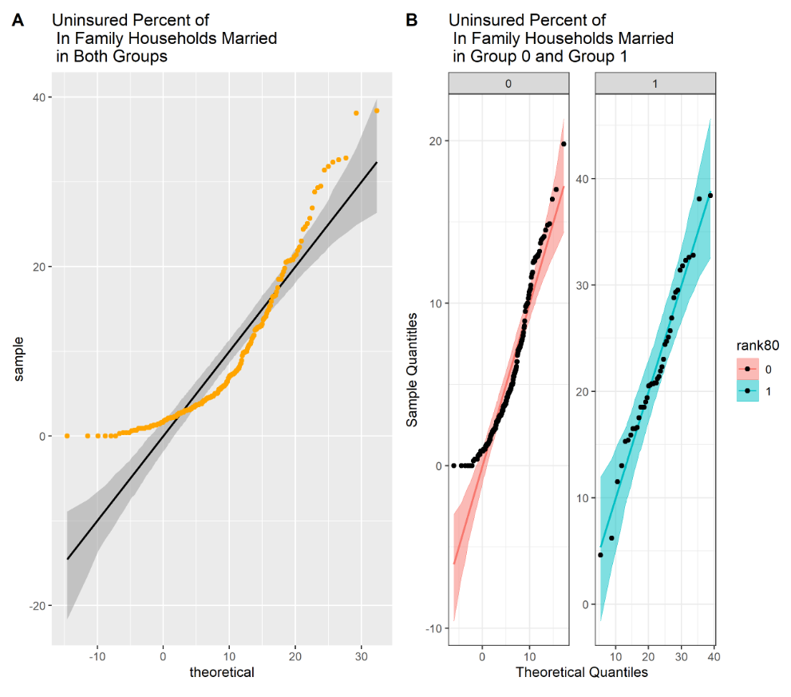

Figure C 9 Scatter Plots of Uninsured Percent of In Family Households!!In Married Couple Families

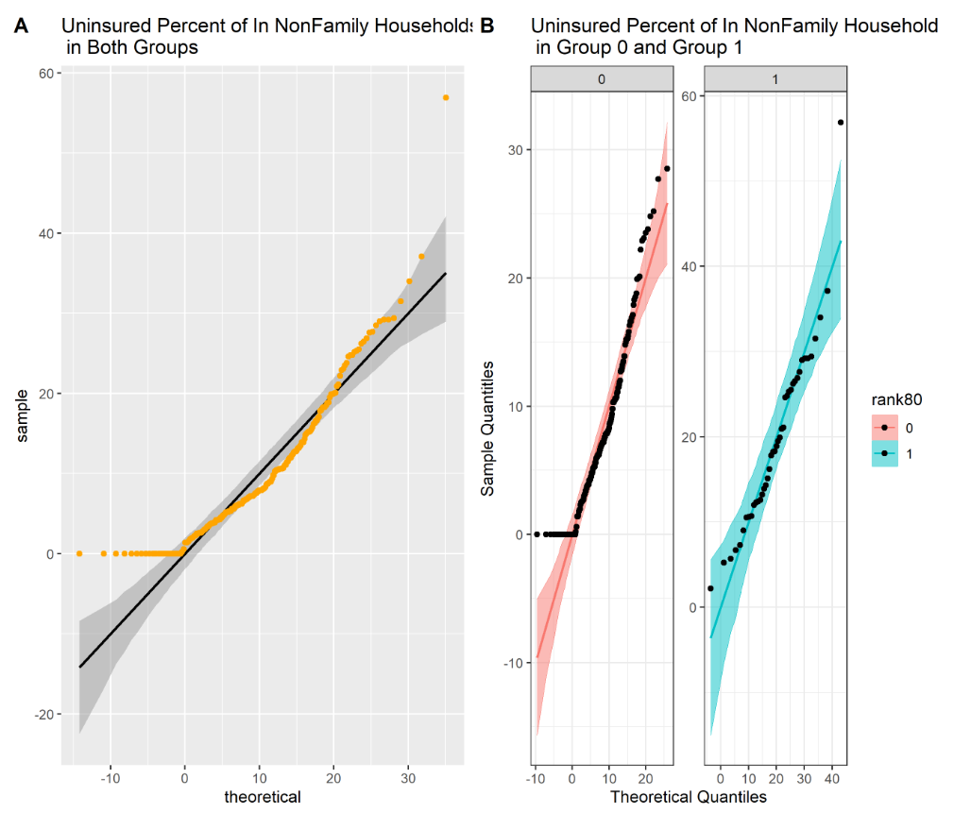

Figure C 10 Scatter Plots of Uninsured Percent of In Non-family Households and Other Living Arrangements

As we can see, most of the points lie within the confidence bands in group 1, which is expected for the given distribution. However, we observe that there are many outliers in the scatter plots of both groups and group 0.

*2.2 Box-Cox Transformation*

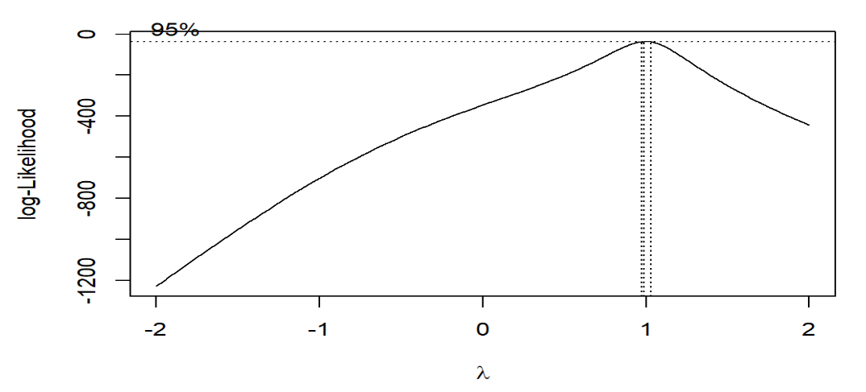

Figure C 11 Best λ

Best lambda= 0.989899

1. **Regression Diagnosis**
2. Check Both Groups
   1. *Check if residuals are normally distributed*

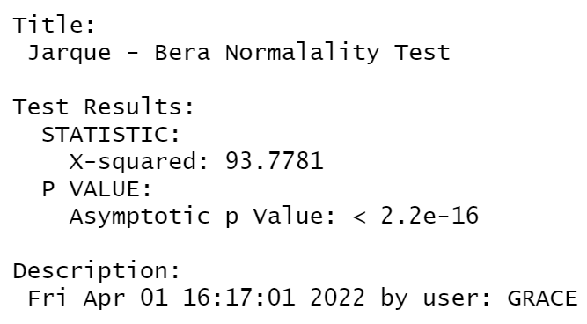

Figure C 12 Normality Test

Null Hypothesis: Skewness and Kurtosis are equal to zero(normal distribution). p <= 0.01 : very strong presumption against null hypothesis. It is not normally distributed.

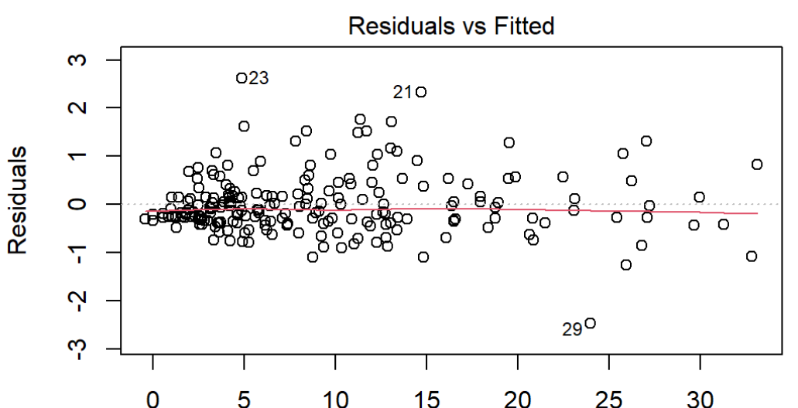

Figure C 13 Residual plot (1)

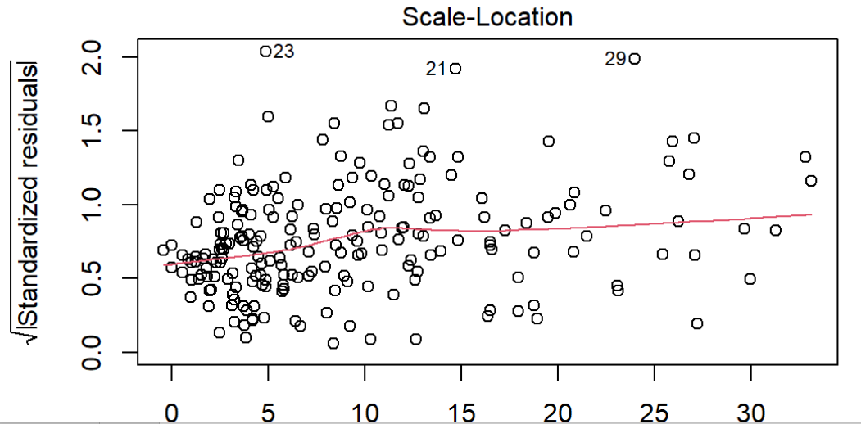

Figure C 14 Residual plot (2)

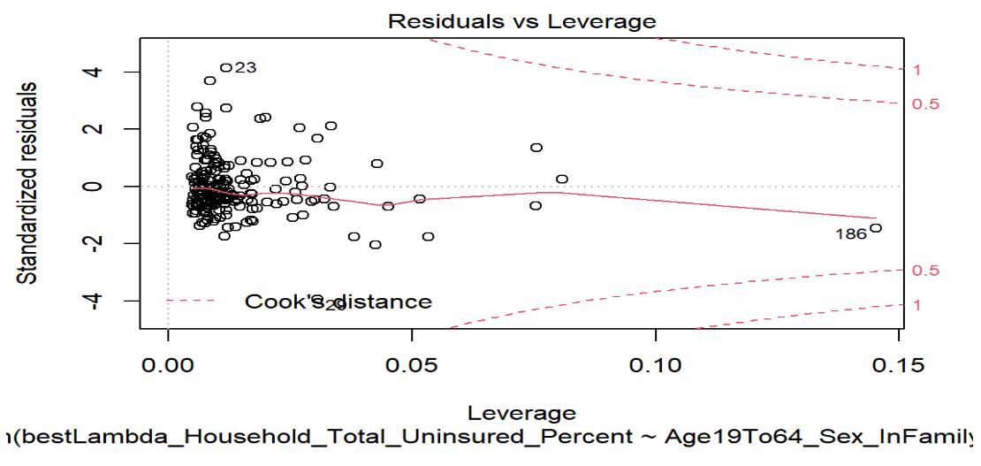

Figure C 15 Residual plot (3)

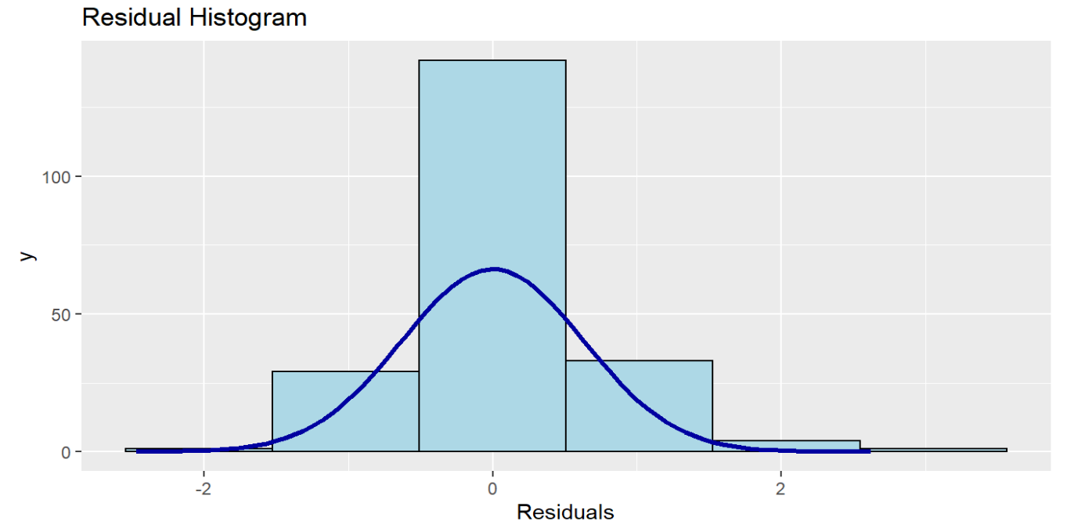

Figure C 16 Residual Histogram in Household Composition

The household composition linear regression model uses a large sample (210 entries which are bigger than 30), and the histogram of residuals is similar to the normal distribution. According to the Law of Large Numbers and Central Limit Theorem, we can accept the normality of residuals, although the residuals are not normally distributed using Jarque - Bera Normalality Test.

*3.2 Check if residuals are independent.*

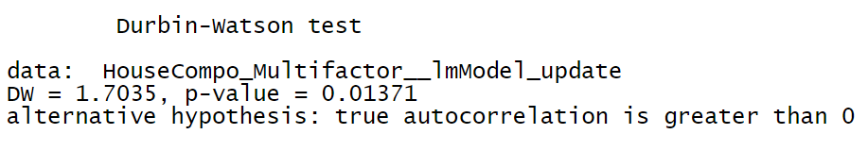

Figure C 17 Independence Test

The Durbin Watson statistic tests the hypothesis that there is no autocorrelation. If there is no autocorrelation (where subsequent observations are related), the Durbin-Watson statistic should be between 1.5 and 2.5, and the p-value will be above 0.05.

Our DW satisfies the condition (DW = 1.7035 (1.5<1.7035<2.5)) but p-value doesn’t (p-value = 0.01371 (0.01371<0.05)).

I deal with the influencing factors in the minority status model as independent ones, although it partly satisfies the DW test.

*3.3 Check if the mean of the residuals is zero and the sum of the residuals is zero.*

sum of the residuals = 5.689893e-15

mean of the residuals = 2.717733e-17

The mean of the errors is close to zero. The sum of the errors is close to zero.

*3.4 Check if residuals have constant variance*

However, it doesn't pass the studentized Breusch-Pagan test. Heteroscedasticity is present in the regression model.

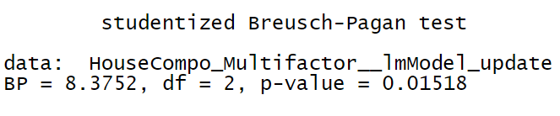

Figure C 18 Heteroscedasticity Test

From the scatter plots of the dataset, we have some outliers. And from plots of residuals, regression outliers with high leverage effect heteroscedasticity when performing a least-squares regression analysis. Because our columns are from different datasets that describe various factors, heteroscedasticity is reasonable.

b. Check Group 0

*3.5 Check if residuals are normally distributed*

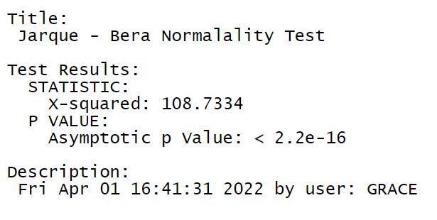

Figure C 19 Normality Test in Group 0

Null Hypothesis: Skewness and Kurtosis are equal to zero(normal distribution). p <= 0.01 : very strong presumption against null hypothesis. It is not normally distributed.

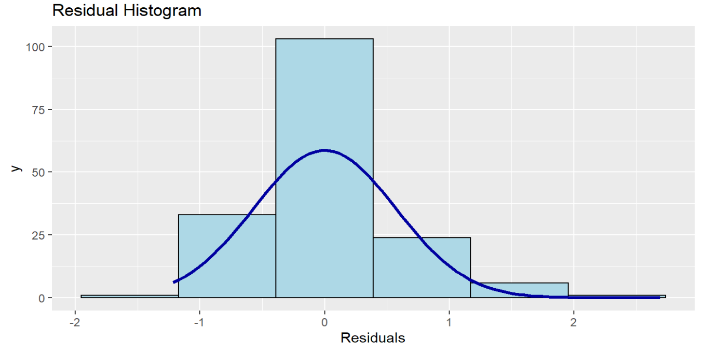

Figure C 20 Residual Histogram in Household Composition in Group 0

The minority status linear regression model uses a large sample (168 entries which are bigger than 30), and the histogram of residuals is similar to the normal distribution. According to the Law of Large Numbers and Central Limit Theorem, we can accept the normality of residuals, although the residuals are not normally distributed using Jarque - Bera Normalality Test.

*3.6 Check if residuals are independent.*

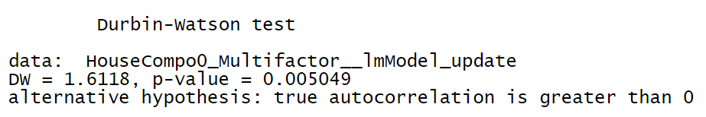

Figure C 21 Independence Test in Group 0

The Durbin Watson statistic tests the hypothesis that there is no autocorrelation. If there is no autocorrelation (where subsequent observations are related), the Durbin-Watson statistic should be between 1.5 and 2.5, and the p-value will be above 0.05.

Our DW satisfies the condition (DW = 1.6118 (1.5<1.6118<2.5)) but p-value doesn’t (p-value = 0.005049 (0.005049<0.05)).

*3.7 Check if the mean of the residuals is zero and the sum of the residuals is zero.*

sum of the residuals = 7.577272e-15

mean of the residuals = 4.510281e-17

The mean of the errors is close to zero. The sum of the errors is close to zero.

*3.8 Check if residuals have constant variance*

However, it doesn't pass the studentized Breusch-Pagan test. Heteroscedasticity is present in the regression model.

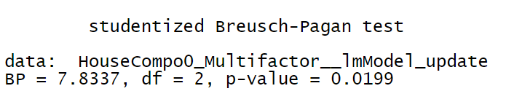

Figure C 22 Heteroscedasticity Test in Group 0

From the scatter plots of the dataset, we have some outliers. And from plots of residuals, regression outliers with high leverage effect heteroscedasticity when performing a least-squares regression analysis. Because our columns are from different datasets that describe various factors, heteroscedasticity is reasonable.

c. Check Group 1

*3.9 Check if residuals are normally distributed*

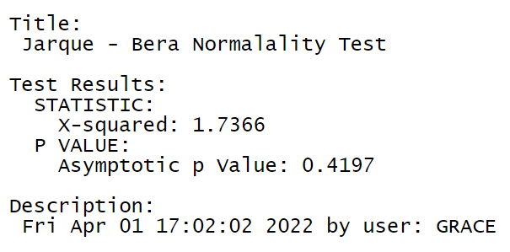

Figure C 23 Normality Test in Group 1

Null Hypothesis: Skewness and Kurtosis are equal to zero(normal distribution). p <= 0.01 : very strong presumption against null hypothesis. It is normally distributed.

Table C 8 K-S Normality Test in Group 1

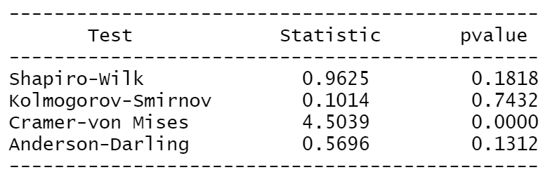

Kolmogorov-Smirnov p value 0.7432 >0.05. Residuals of group 1 are normally distributed.

*3.10 Check if residuals are independent.*

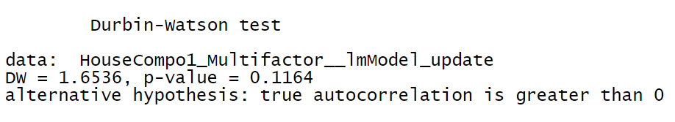

Figure C 24 Independence Test in Group 1

The Durbin Watson statistic tests the hypothesis that there is no autocorrelation. If there is no autocorrelation (where subsequent observations are related), the Durbin-Watson statistic should be between 1.5 and 2.5, and the p-value will be above 0.05.

Our DW satisfies the condition (DW = 1.6536 (1.5< 1.6536<2.5)) but p-value doesn’t (p-value = 0.1164 (0.1164>0.05)).

The influencing factors in group 1 are independent.

*3.11 Check if the mean of the residuals is zero and the sum of the residuals is zero.*

sum of the residuals = 3.608225e-16

mean of the residuals = 8.536801e-18

The mean of the errors is close to zero. The sum of the errors is close to zero.

*3.12 Check if residuals have constant variance*

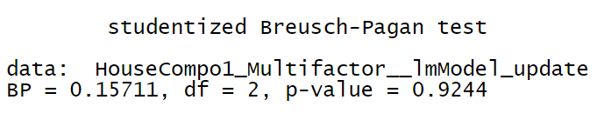

Figure C 25 Heteroscedasticity Test in Group 1

The null hypothesis of the Breusch-Pagan test is homoscedasticity (= variance does not depend on auxiliary regressors). If the p-value becomes "small"(the p-value is less than 0.05), the null hypothesis is rejected. Residuals have constant variance in group 1.

d. Summary of Regression Diagnosis

Table C 9 Summary of Regression Diagnosis in Household Composition Model

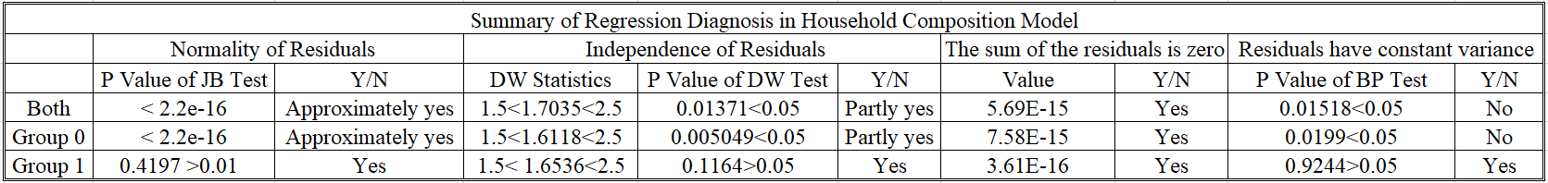

Residuals in both groups and group 0 do not pass the test of homoscedasticity because there are many outliers in the scatter plots of both groups and group 0.

As we can see, residuals in group 1 pass the normality, independence, and homoscedasticity tests because most of the points lie within the confidence bands in group 1, which is expected for the given distribution.

**4 Blinder-Oaxaca Decomposition**



Figure C 26 The Mean Uninsured Percentage by Tracts after Transformation

Table C 10 The Results of the Threefold Decomposition

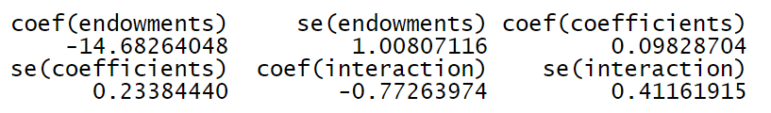

The results of the threefold decomposition suggest that, of the -15.357% difference, approximately -14.682% can be attributed to group differences in endowments (i.e., race, English language), 0.098% to differences in coefficients, and the remaining -0.773% is accounted for by the interaction of the two.



Figure C 27 Threefold Decomposition of Household Composition Status



Figure C 28 Differences in the Regression Coefficients on Age19To64_Sex_InFamilyHousehold_married_multifactor

Table C 11 The Results of Twofold Decomposition

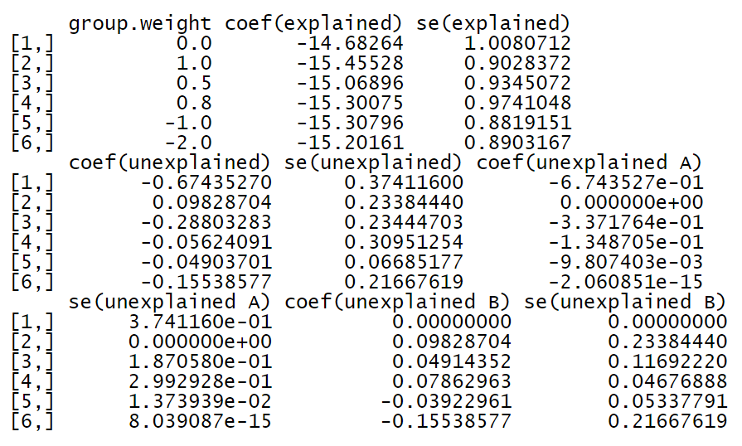

The results of the overall twofold decomposition indicate that the -15.357% uninsured percentage gap between the safe group and the risk group can be decomposed into -15.308%, which can be explained by group differences in the explanatory variables -0.049% that is unexplained.

Let us assume that the unexplained component of the uninsured percentage gap occurs due to discrimination and that the pooled regression coefficients are non-discriminatory. The Blinder-Oaxaca decomposition would then also indicate that -0.01% of the unexplained part originates from discrimination in favor of safe group 0 (component "unexplained A"),

while -0.039% comes from discrimination against those who are in the risk group (component "unexplained B").



Figure C 29 The Explained and Unexplained Components of a Twofold Blinder-Oaxaca Decomposition of Safe Group 0 vs. Risk Group 1 Gap



Figure C 30 The Unexplained Portion's Discrimination Sub-Components in a Twofold Blinder-Oaxaca Decomposition of Safe Group 0 vs. Risk Group 1 Gap



Figure C 31 The Unexplained Portion's Discrimination Sub-Components in a Twofold Blinder-Oaxaca Decomposition of Safe Group 0 vs. Risk Group 1 Gap. An Alternative Presentation

Table C 12 Results of Twofold Blinder-Oaxaca Decomposition

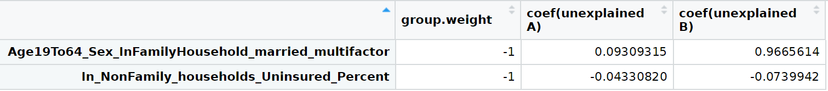

# Appendix D: Complete Model

**(minority status and language, socioeconomic status, household composition, environmental impact assessment)**

1. **Correlation Analysis**

In this model, I do the correlation analysis of 26 factors, including three factors of minority status and language Model (uninsured percentage of Hispanic or Latino (of any race), percentage of persons who speak English "less than well," and uninsured percentage of white alone (not Hispanic or Latino)), 13 factors of the socioeconomic status model (the uninsured percent of native-born, uninsured percent of foreign-born!! Naturalized, uninsured percentage of foreign-born!! not a citizen, uninsured percent of less than high school graduate, uninsured percent of high school graduate (includes equivalency), uninsured percent of some college or associate's degree, uninsured percent of Bachelor's degree or higher, uninsured percent of worked full-time, uninsured percent of worked less than full-time, uninsured percent of did not work, uninsured percent of below 138 percent of the poverty threshold, uninsured percent of 138 to 399 percent of the poverty threshold, uninsured percent of at or above 400 percent of the poverty threshold), nine factors of household composition model (the uninsured percent of male, uninsured percent of female, uninsured percent of age under 19 years, uninsured percent of age 19 to 64 years, uninsured percent of age 65 years and older, uninsured percent of in family households, uninsured percent of in family households!! In married-couple families, uninsured percent of in family households!! In other families, uninsured percent of in non-family households and other living arrangements), and ADI80.

Table D 1 Correlation Coefficients (1)

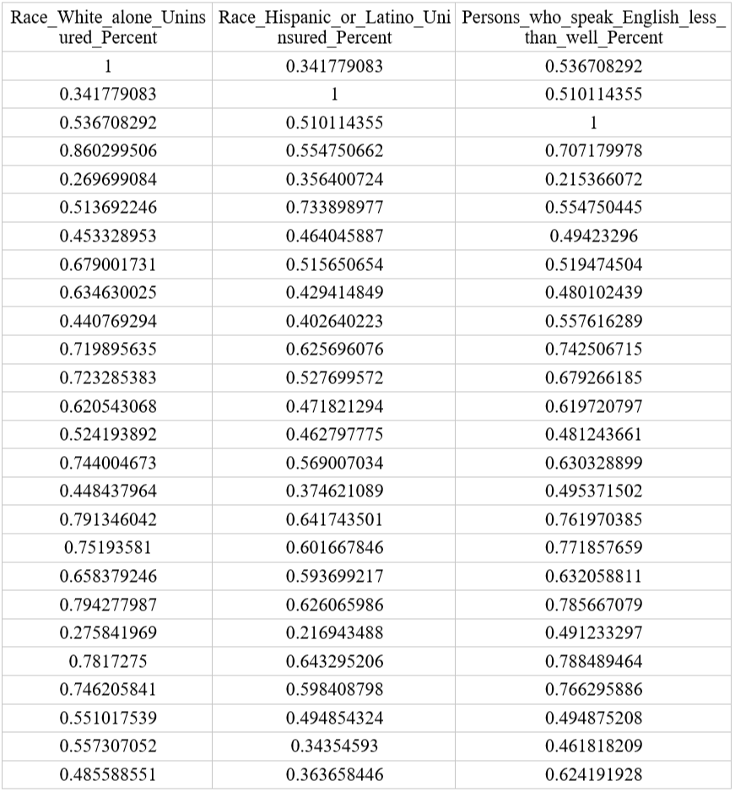

Table D 2 Correlation Coefficients (2)

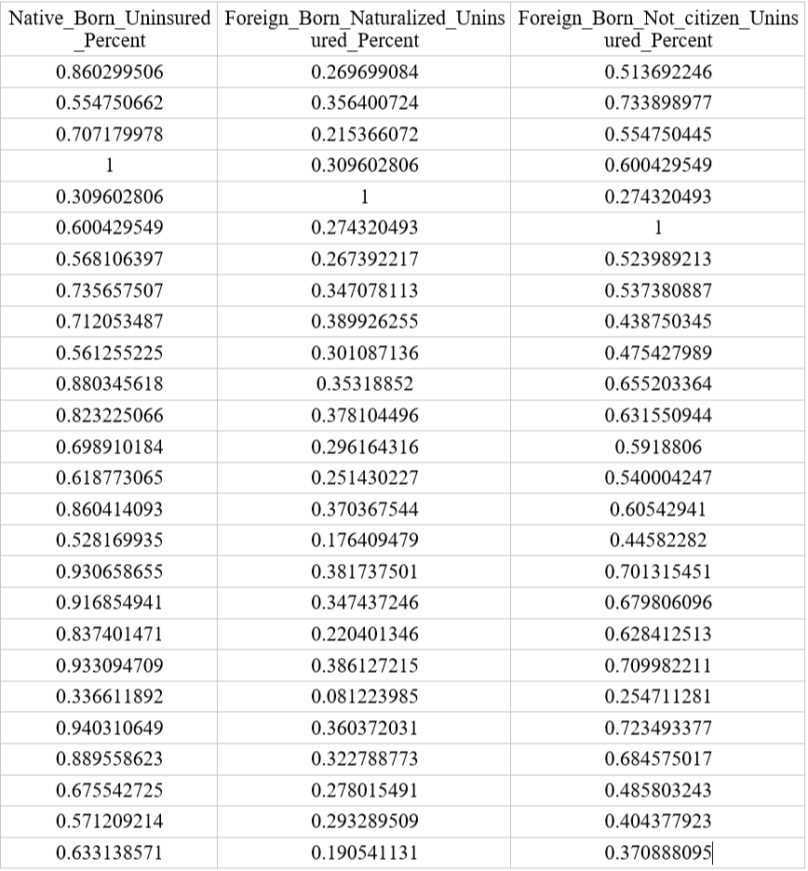

Table D 3 Correlation Coefficients (3)

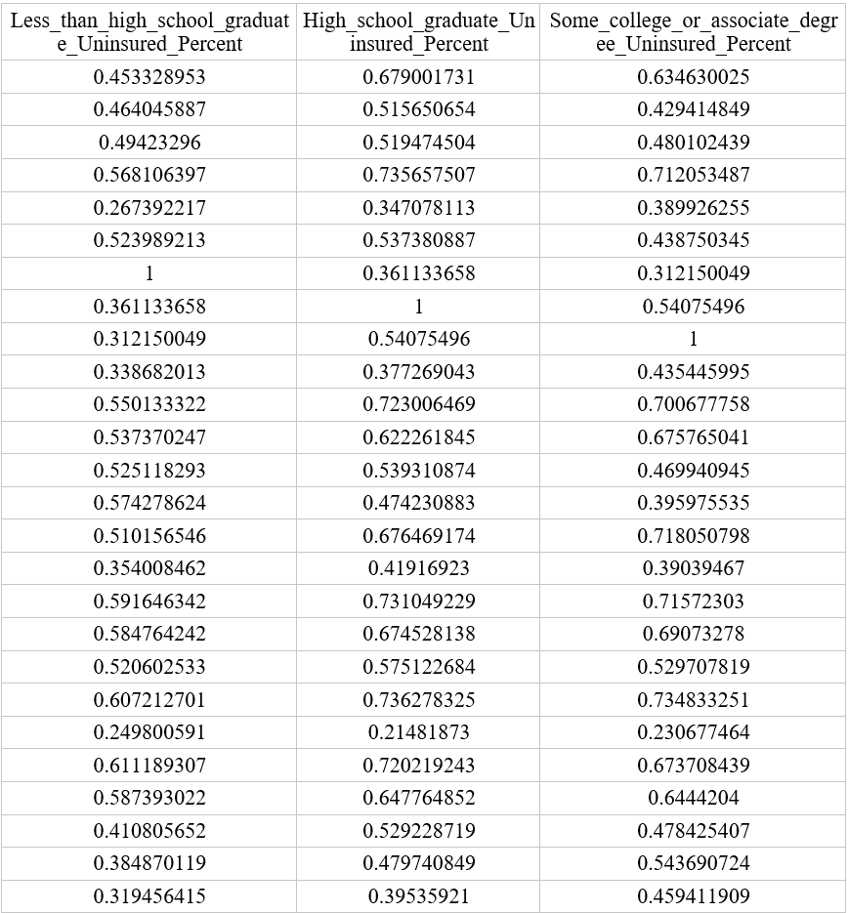

Table D 4 Correlation Coefficients (4)

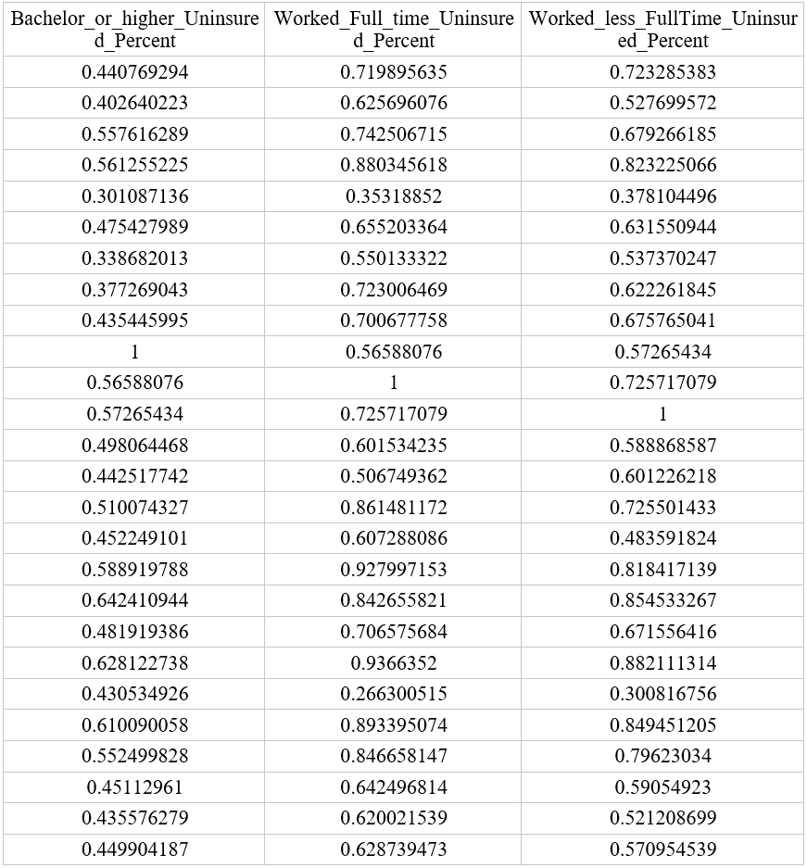

Table D 5 Correlation Coefficients (5)

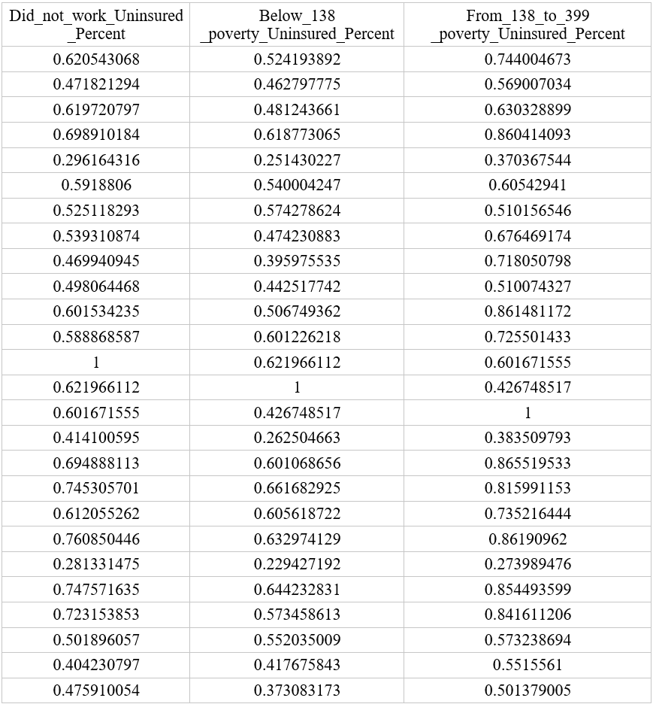

Table D 6 Correlation Coefficients (6)

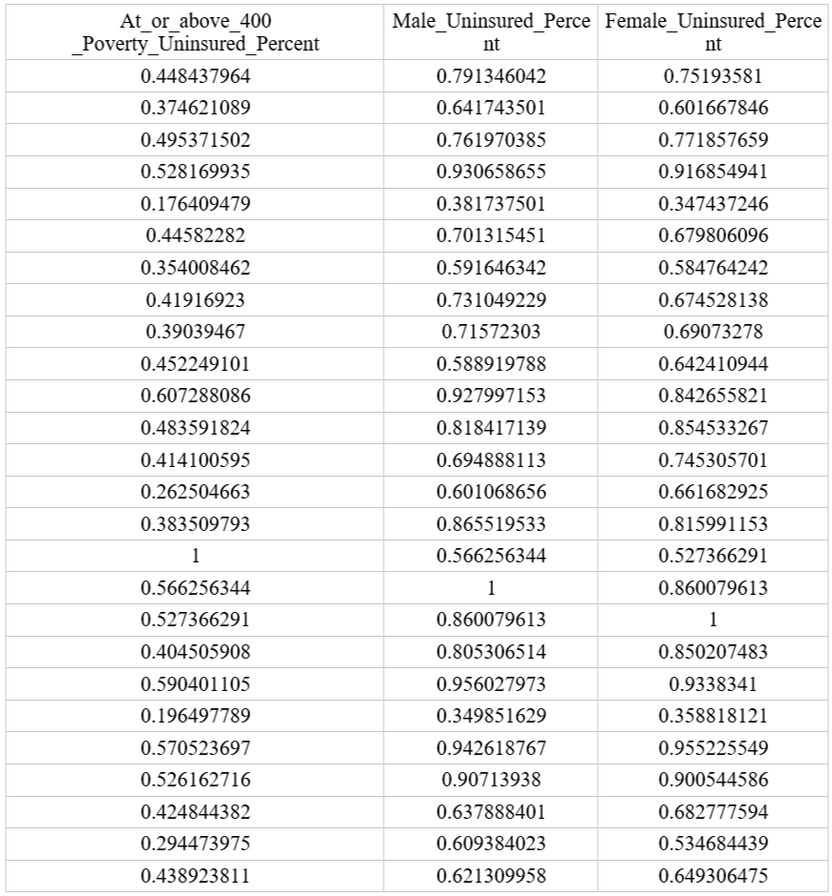

Table D 7 Correlation Coefficients (7)

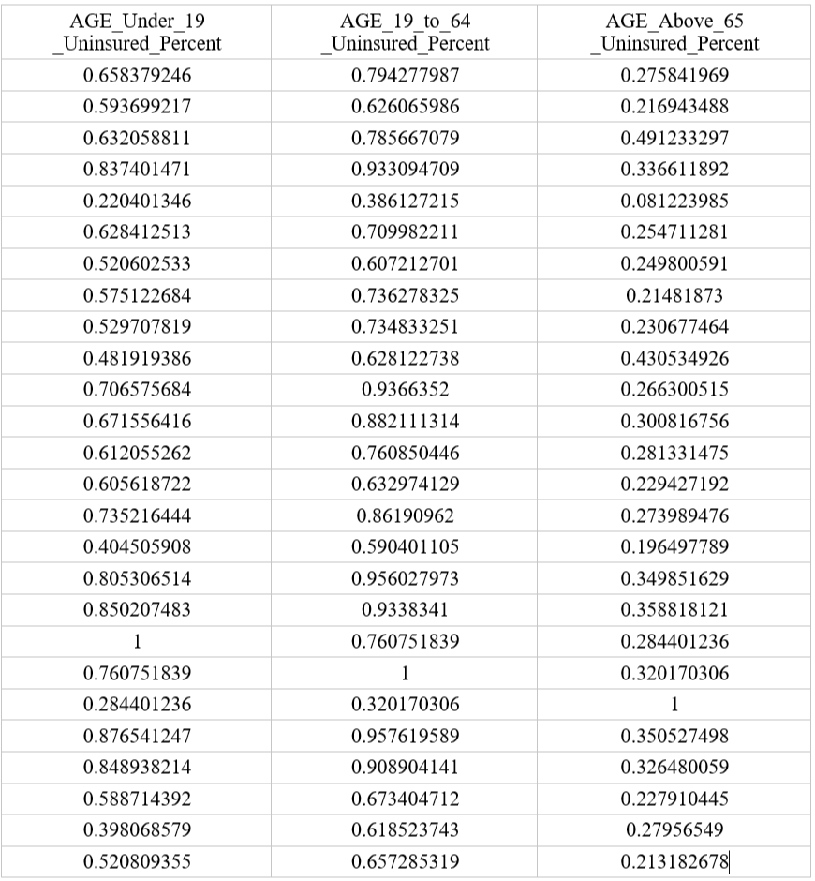

Table D 8 Correlation Coefficients (8)

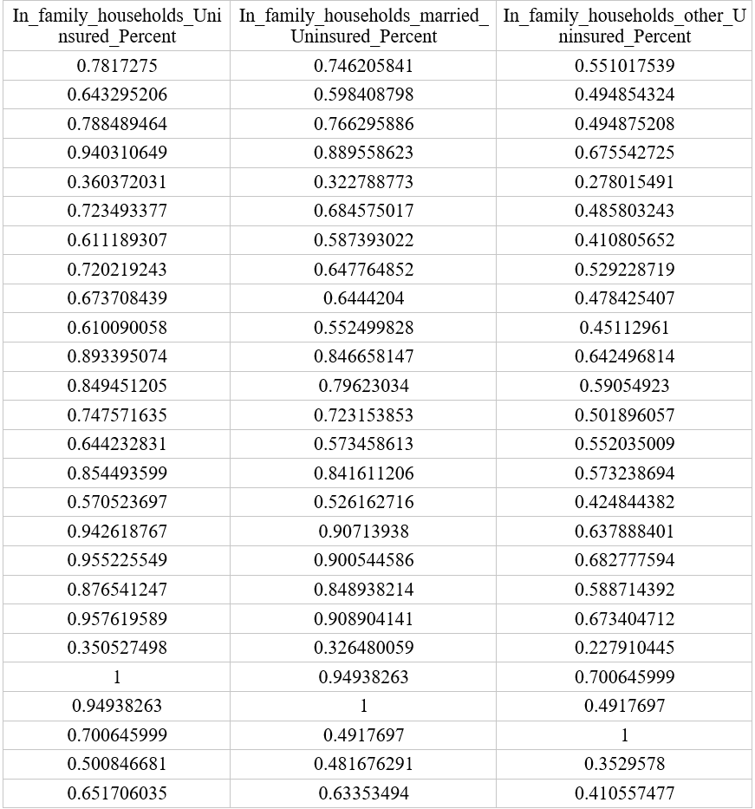

Table D 9 Correlation Coefficients (9)

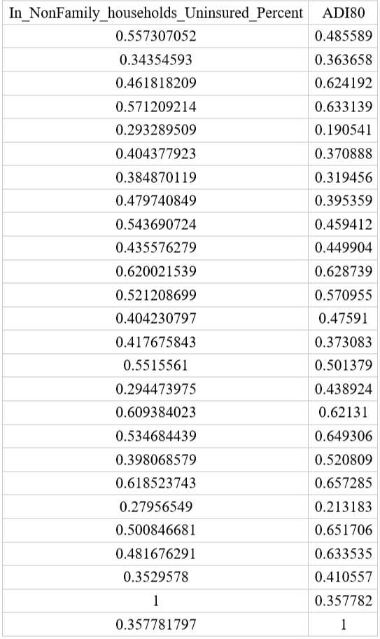

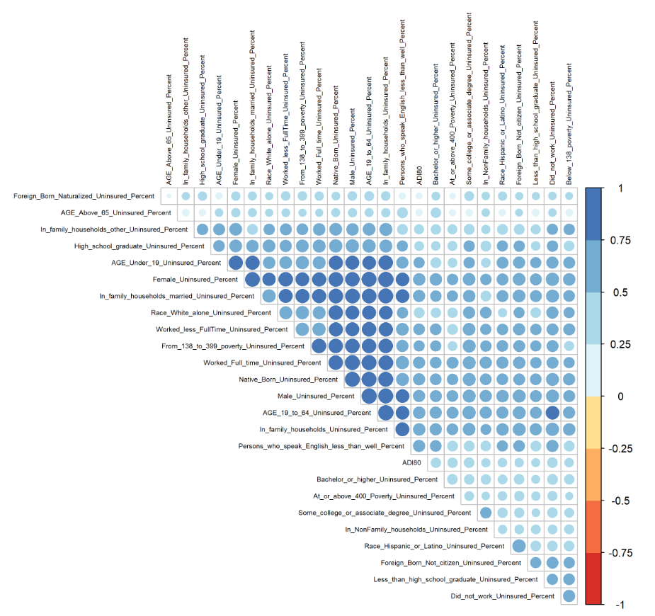

Figure D 1 Correlation Coefficients in Complete Model

In a multiple regression model, the high correlated influencing factors impact the valid results about any individual influencing factor. To avoid multicollinearity, I adopt two steps to fix the problem.

Step 1: Use the step() function to find the best linear model with the least AIC.

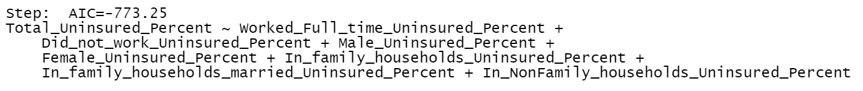

Figure D 2 The best linear model with the least AIC in Complete Model

This linear model misses race information. It is not suitable for the complete model. Therefore, we merge highly correlated factors with more than 0.85 first.

I find six factors are highly correlated: uninsured percent of native-born, uninsured percent of worked full-time, uninsured percent of male, uninsured percent of the age 19 to 64 years, uninsured percent of in family households, uninsured percent of in family households!! In married-couple families.

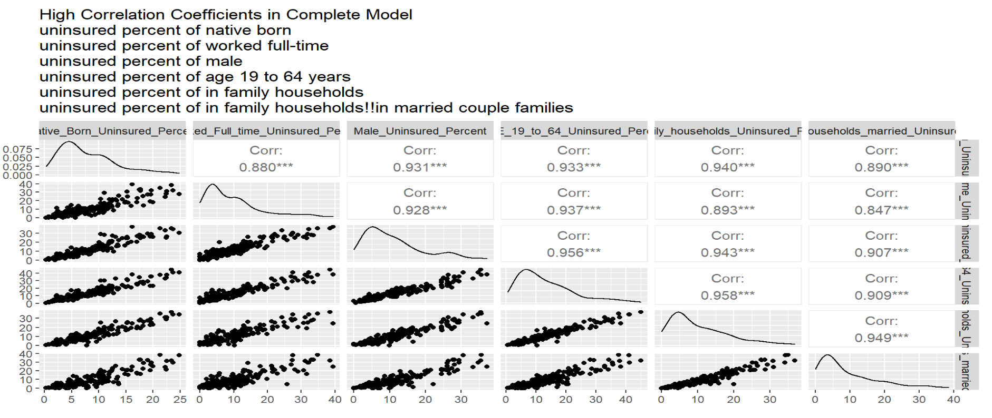

Figure D 3 High Correlation Coefficients in Complete Model (1)

Step 2: Use the relative importance of regressors in linear models to merge highly correlated factors.

I built a linear regression model using highly correlated factors

$$the uninsured percentage by tracts \sim uninsured percent of native born+uninsured percent of worked full-time+ uninsured percent of male + uninsured percent of age 19 to 64 years+ uninsured percent of in family households + uninsured percent of in family households!!in married couple families$$

This is the results of Relative importance metrics using the linear regression model above:

Table D 10 Relative Importance Metrics (1)

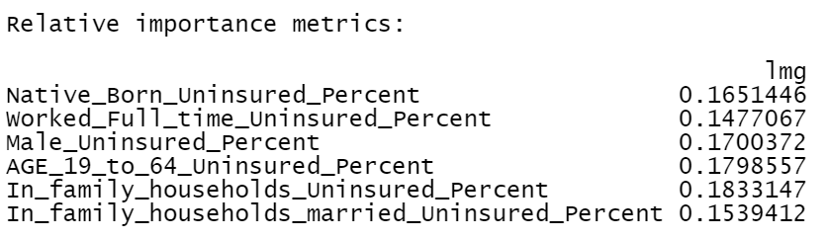

I merge them into one column called "NativeBorn_WorkFullTime_Male_Age19To64_InFamilyHouseholds_married_multifactor" using this formula

I replace the 6 columns with " NativeBorn_WorkFullTime_Male_Age19To64_InFamilyHouseholds_married_multifactor ".

Then I do the correlation analysis of 21 factors, including NativeBorn_WorkFullTime_Male_Age19To64_InFamilyHouseholds_married_multifactor,

uninsured percentage of white alone (not Hispanic or Latino), uninsured percentage of Hispanic or Latino (of any race), percentage of persons who speak English "less than well," uninsured percent of foreign-born!! Naturalized, uninsured percentage of foreign-born!! not a citizen, uninsured percent of less than high school graduate, uninsured percent of high school graduate (includes equivalency), uninsured percent of some college or associate's degree, uninsured percent of Bachelor's degree or higher, uninsured percent of worked less than full-time, uninsured percent of did not work, uninsured percent of below 138 percent of the poverty threshold, uninsured percent of 138 to 399 percent of the poverty threshold, uninsured percent of at or above 400 percent of the poverty threshold, uninsured percent of female, uninsured percent of age under 19 years, uninsured percent of age 65 years and older, uninsured percent of in family households!! In other families, uninsured percent of in non-family households and other living arrangements), ADI80.

Table D 11 Correlation Coefficients after Using Relative Importance of Regressors in Complete Model (1)

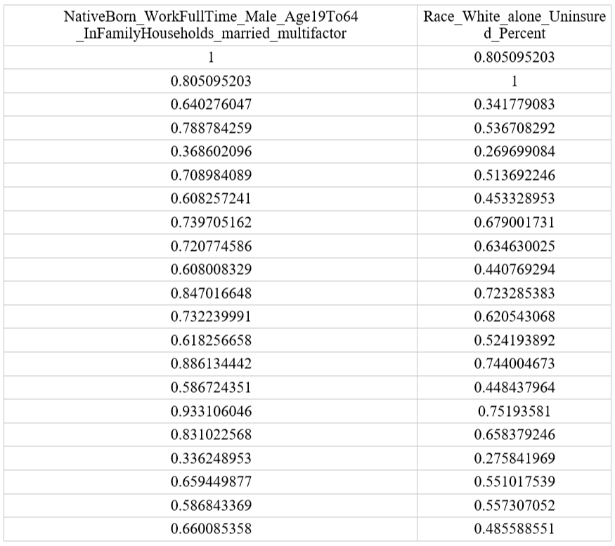

Table D 12 Correlation Coefficients after Using Relative Importance of Regressors in Complete Model (2)

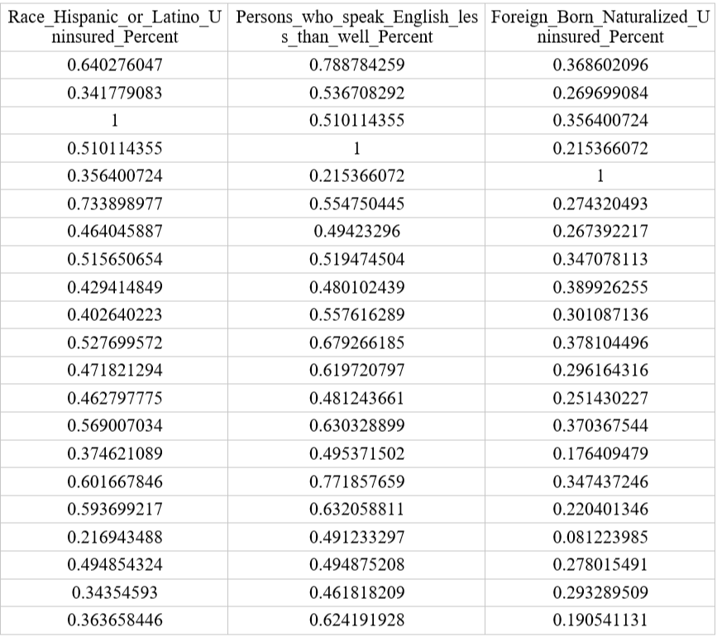

Table D 13 Correlation Coefficients after Using Relative Importance of Regressors in Complete Model (3)

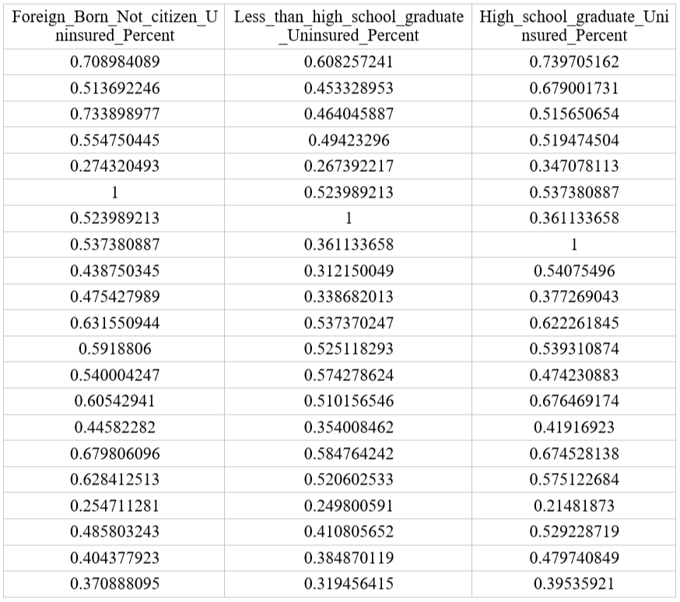

Table D 14 Correlation Coefficients after Using Relative Importance of Regressors in Complete Model (4)

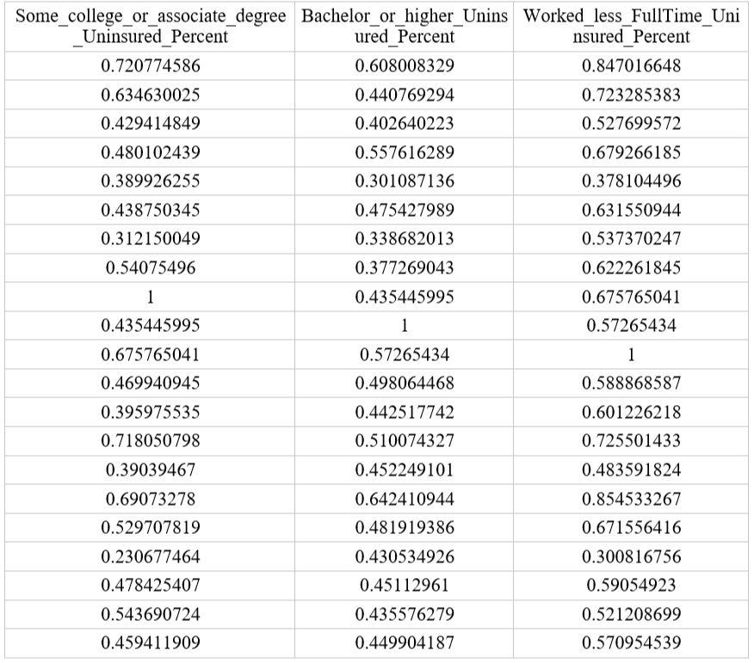

Table D 15 Correlation Coefficients after Using Relative Importance of Regressors in Complete Model (5)

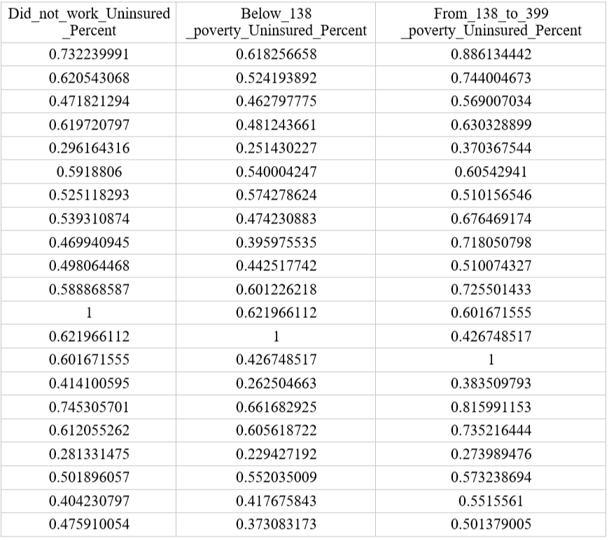

Table D 16 Correlation Coefficients after Using Relative Importance of Regressors in Complete Model (6)

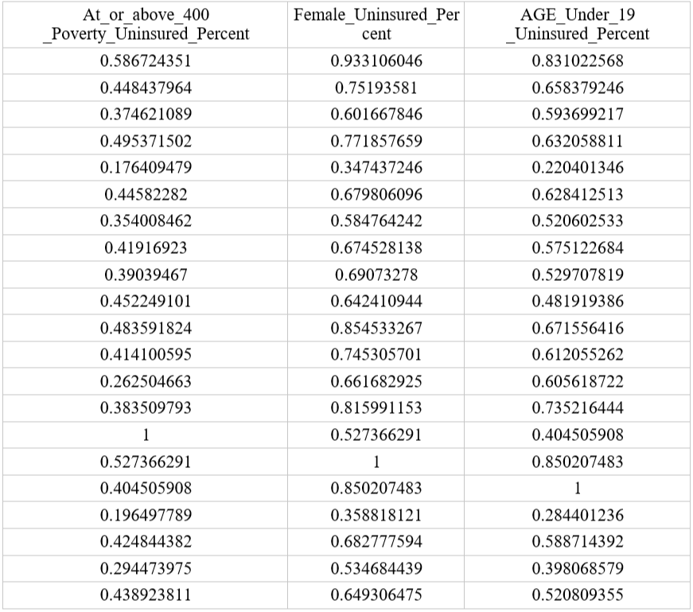

Table D 17 Correlation Coefficients after Using Relative Importance of Regressors in Complete Model (7)

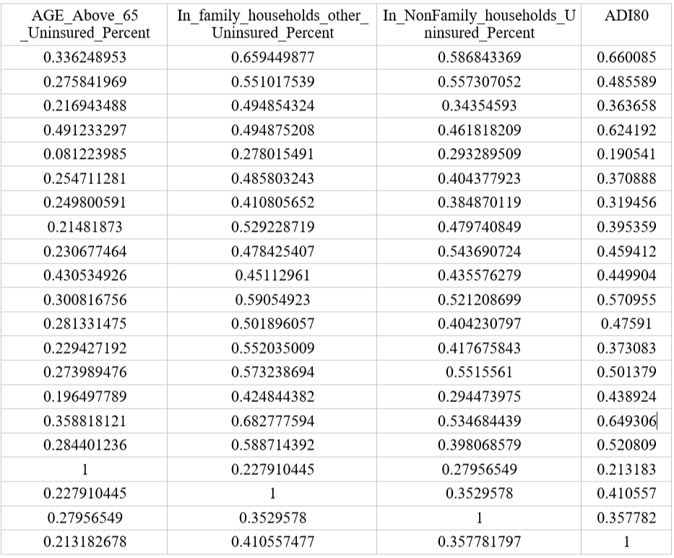

Then I find "NativeBorn_WorkFullTime_Male_Age19To64_InFamilyHouseholds_married_multifactor", uninsured percent of worked less than full-time, uninsured percent of the female are highly correlated too.

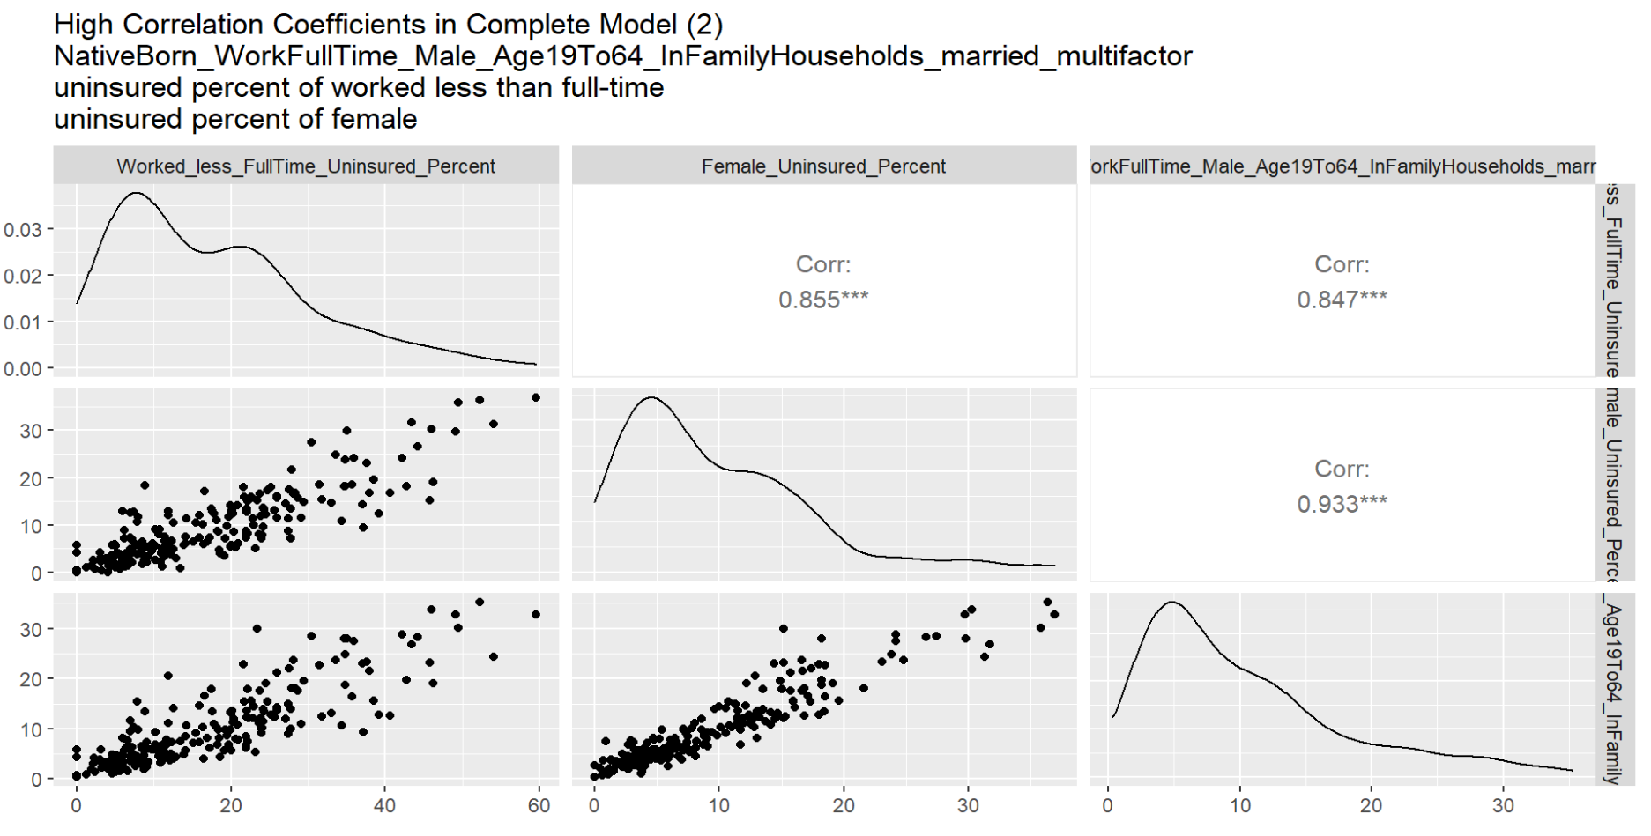

Figure D 5 High Correlation Coefficients in Complete Model (2)

I build a linear regression model using highly correlated factors

$$Uninsured Percent by Tracts \sim uninsured percent of worked less than full-time+NativeBorn_WorkFullTime_Male_Age19To64_InFamilyHouseholds_married_multifactor+uninsured percent of female$$

This is the results of Relative importance metrics using the linear regression model above:

Table D 18 Relative Importance Metrics (2)



Then I merge these 3 columns and generate a new column called “WorkLessFullTime_Female_ NativeBorn_WorkFullTime_Male_Age19To64_InFamilyHouseholds_married_multifactor2” using this formula

I replace the three columns with " WorkLessFullTime_Female_ NativeBorn_WorkFullTime_Male_Age19To64_InFamilyHouseholds_married_multifactor2".

Then I do the correlation analysis of 19 factors including WorkLessFullTime_Female_ NativeBorn_WorkFullTime_Male_Age19To64_InFamilyHouseholds_married_multifactor2,

uninsured percentage of white alone (not Hispanic or Latino), uninsured percentage of Hispanic or Latino (of any race), percentage of persons who speak English "less than well," uninsured percent of foreign-born!! Naturalized, uninsured percentage of foreign-born!! not a citizen, uninsured percent of less than high school graduate, uninsured percent of high school graduate (includes equivalency), uninsured percent of some college or associate's degree, uninsured percent of Bachelor's degree or higher, uninsured percent of did not work, uninsured percent of below 138 percent of the poverty threshold, uninsured percent of 138 to 399 percent of the poverty threshold, uninsured percent of at or above 400 percent of the poverty threshold, uninsured percent of age under 19 years, uninsured percent of age 65 years and older, uninsured percent of in family households!! In other families, uninsured percent of in non-family households and other living arrangements), ADI80.

Table D 19 Correlation Coefficients after Using Relative Importance of Regressors for the 2nd time in Complete Model (1)

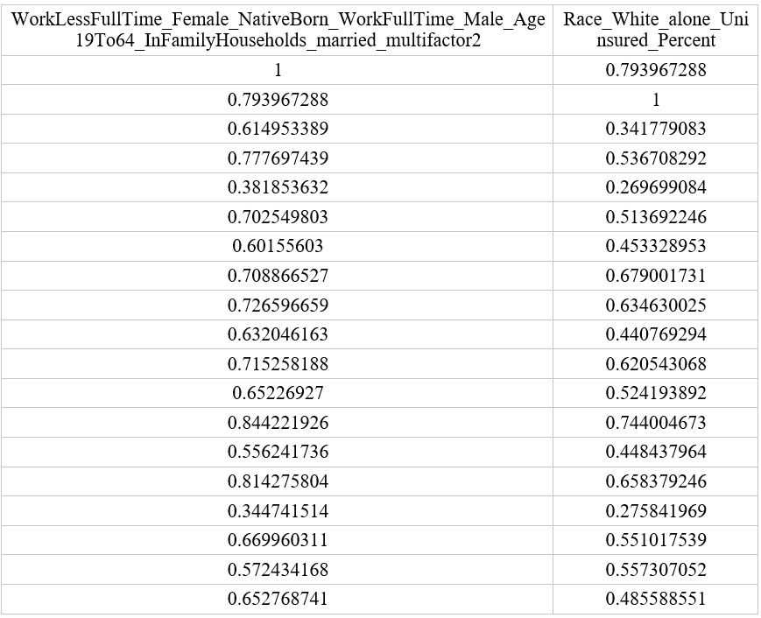

Table D 20 Correlation Coefficients after Using Relative Importance of Regressors for the 2nd time in Complete Model (2)

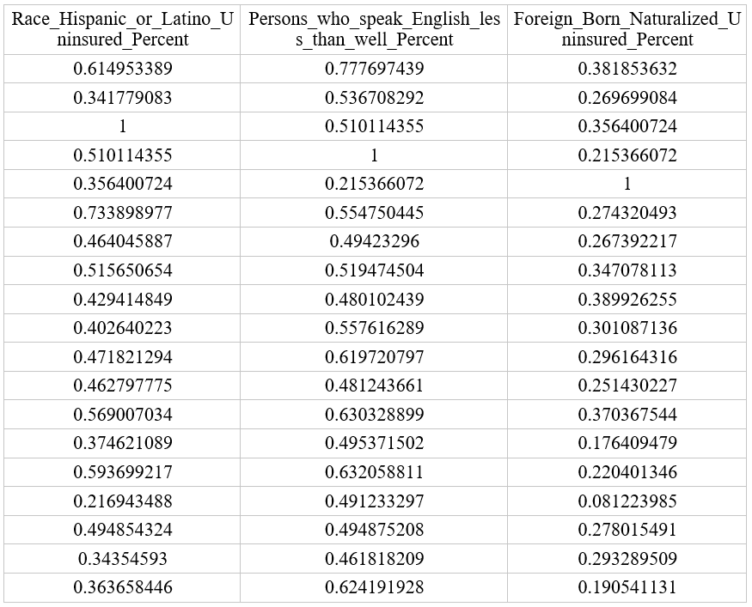

Table D 21 Correlation Coefficients after Using Relative Importance of Regressors for the 2nd time in Complete Model (3)

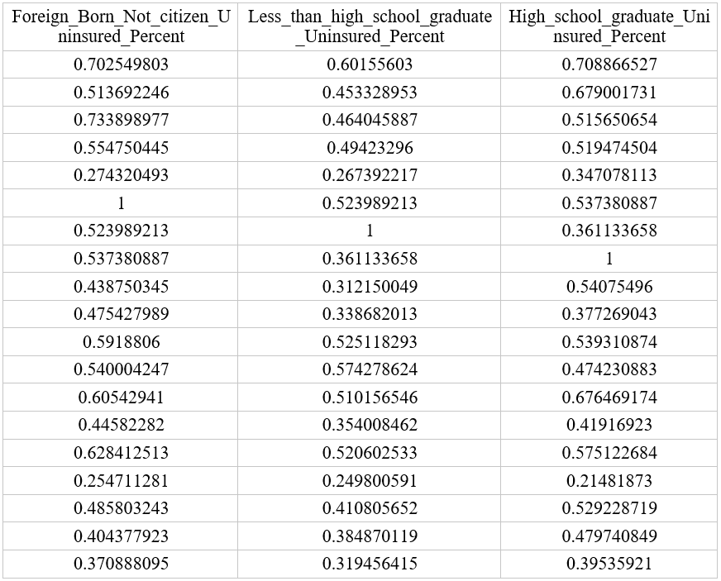

Table D 22 Correlation Coefficients after Using Relative Importance of Regressors for the 2nd time in Complete Model (4)

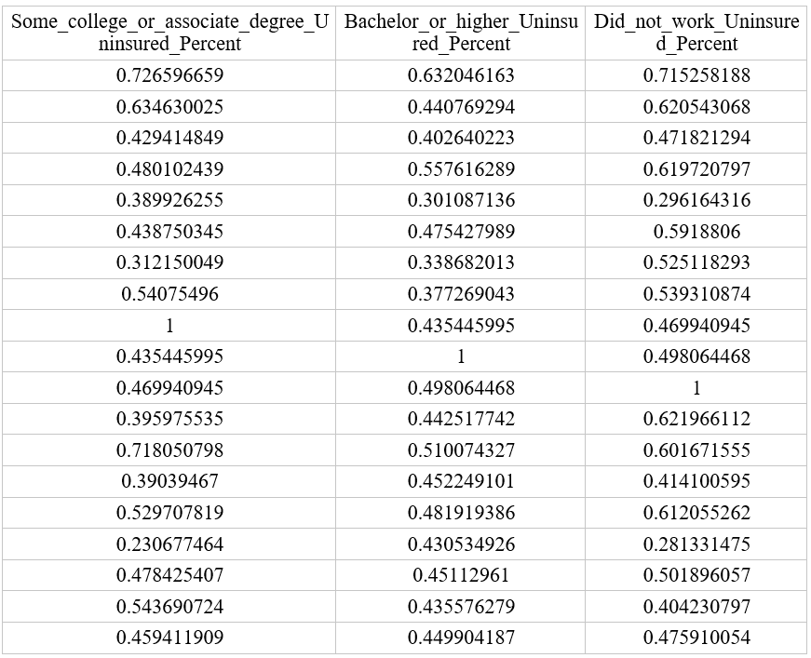

Table D 23 Correlation Coefficients after Using Relative Importance of Regressors for the 2nd time in Complete Model (5)

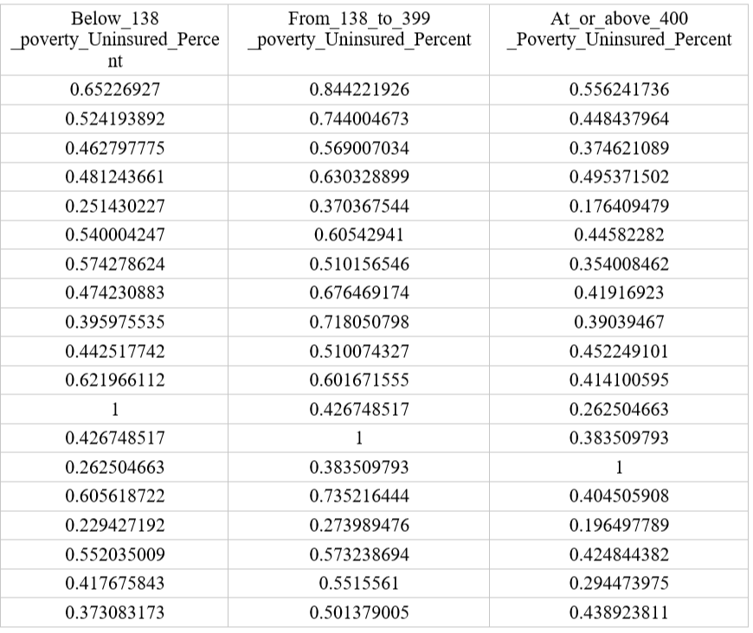

Table D 24 Correlation Coefficients after Using Relative Importance of Regressors for the 2nd time in Complete Model (6)

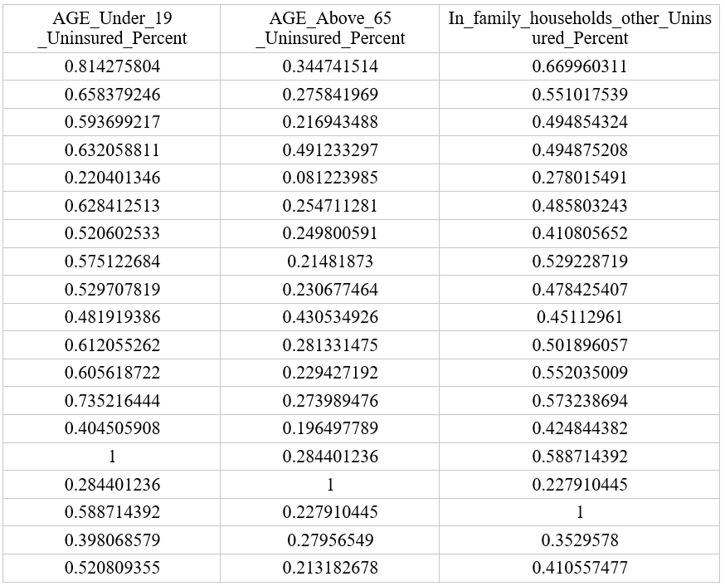

Table D 25 Correlation Coefficients after Using Relative Importance of Regressors for the 2nd time in Complete Model (7)

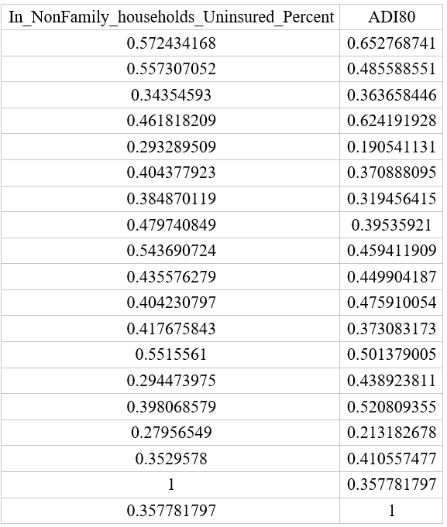

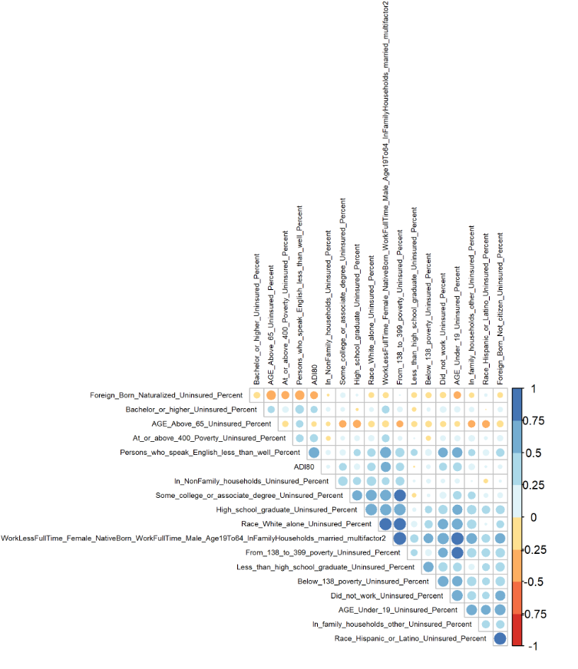

Figure D 6 Correlation Coefficients in Complete Model After Using Relative Importance of Regressors for the 2nd time

Now no correlation coefficients are higher than 0.85.

1. **Linear Regression Analysis**

I build a complete model using this formula

* 1. *The Scatter plots of factors*

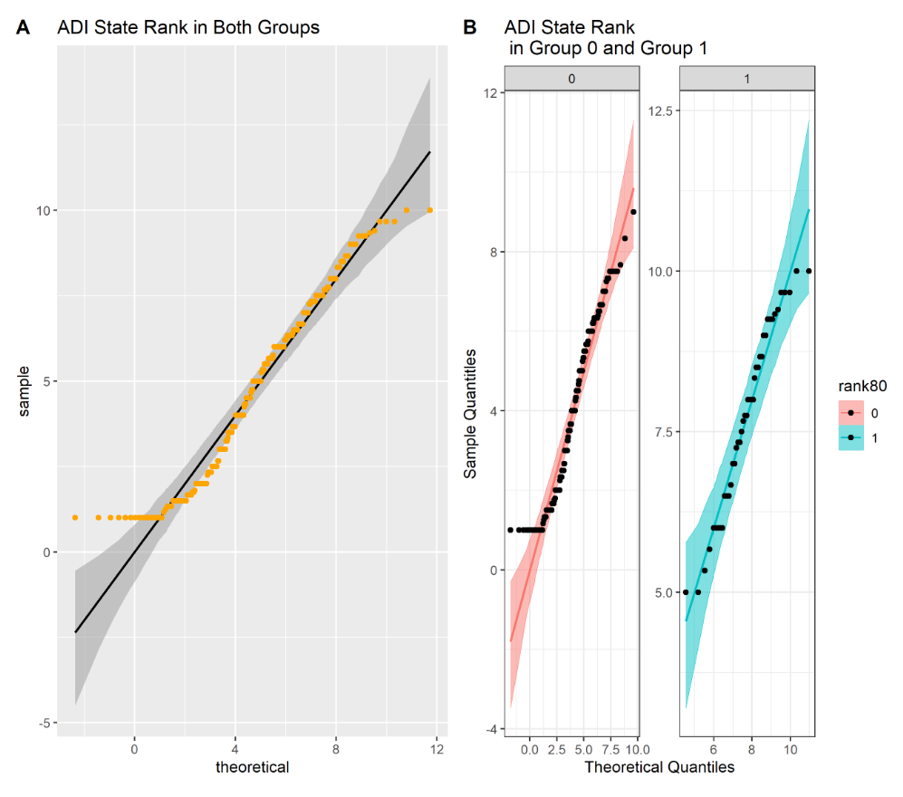

Figure D 7 Scatter Plots of ADI State Rank under Rank80 Groups

As we can see, most of the points lie within the confidence bands in group 1, which is expected for the given distribution. However, we observe that there are many outliers in the scatter plots of both groups and group 0.

* 1. *Box-Cox Transformation*

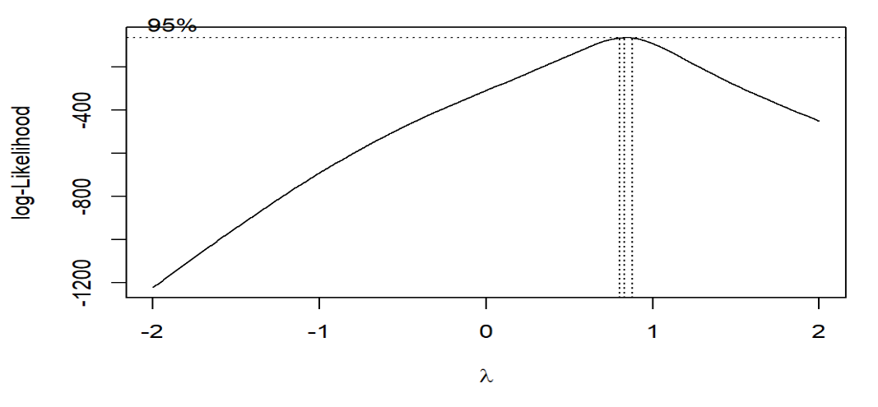

*Figure D 8 Best λ*

Best lambda= 0.8282828

1. **Regression Diagnosis**
2. Check Both Groups
   1. *Check if residuals are normally distributed*

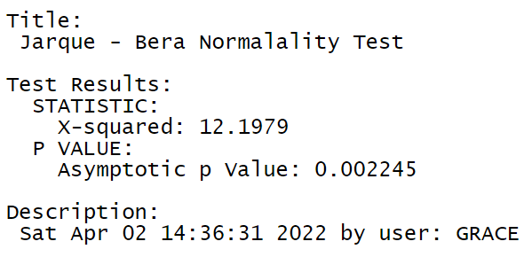

*Figure D 9 Normality Test*

Null Hypothesis: Skewness and Kurtosis are equal to zero(normal distribution). P> 0.01 : very strong presumption against the null hypothesis. It is not normally distributed.

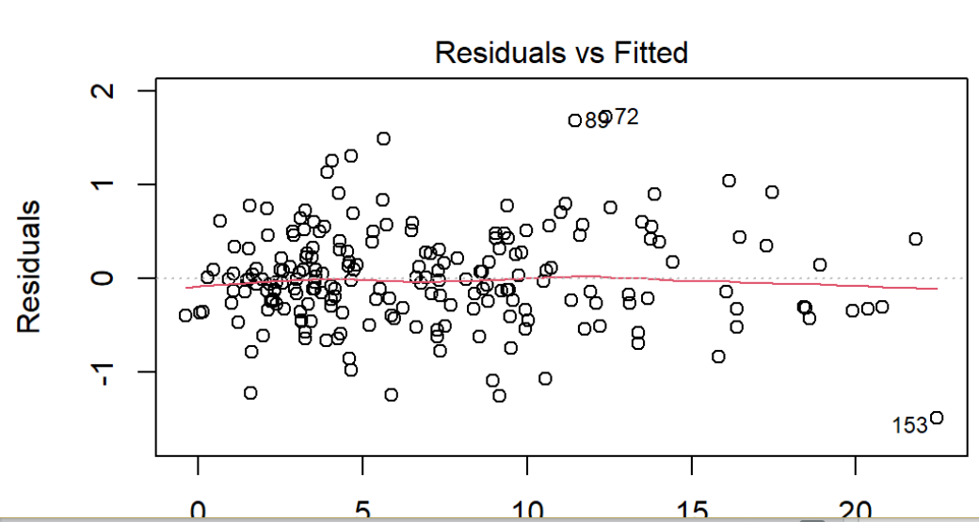

*Figure D 10 Residual plot (1)*

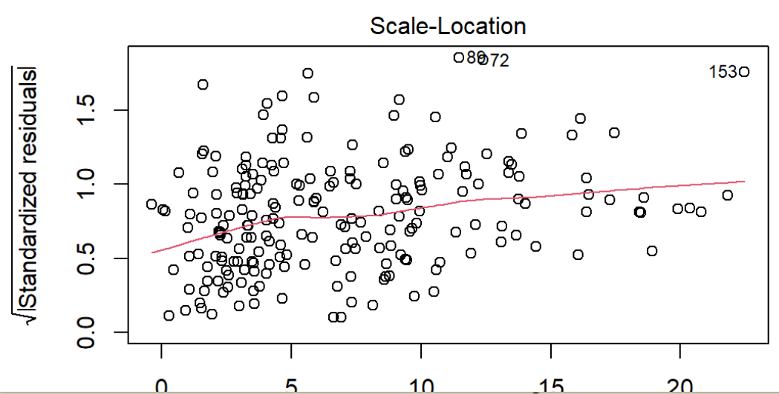

*Figure D 11 Residual plot (2)*

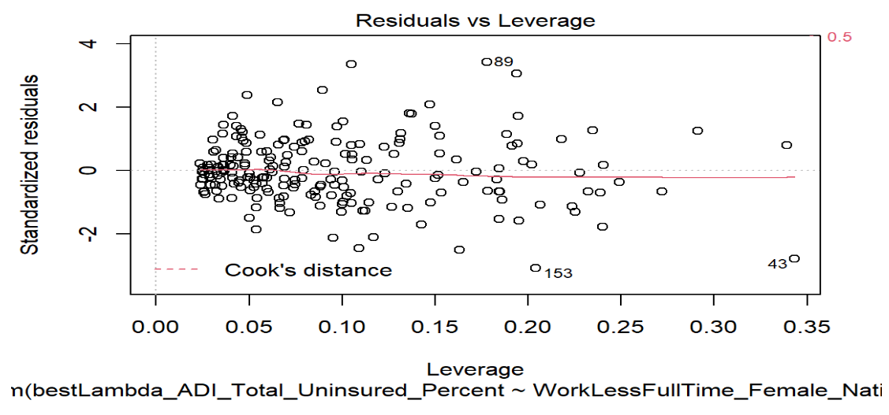

*Figure D 12 Residual plot (3)*

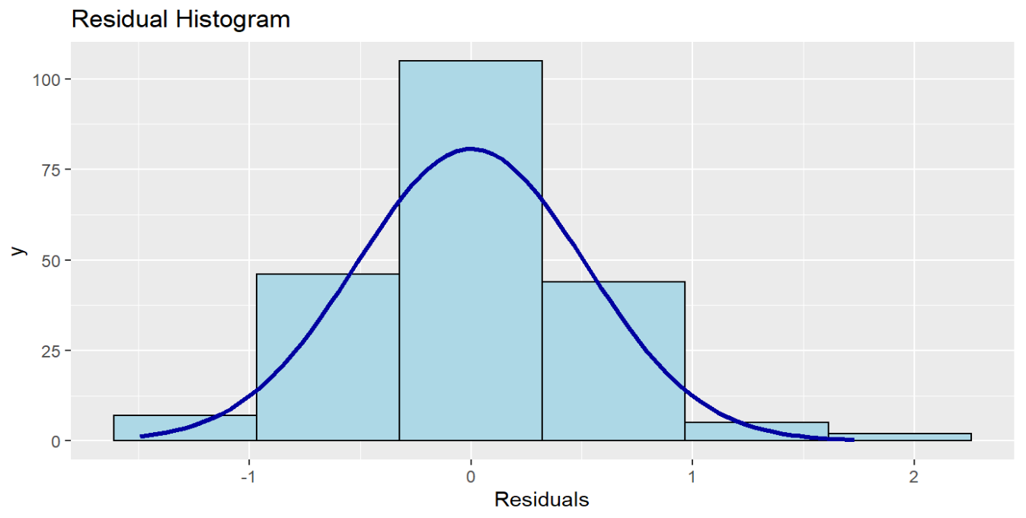

*Figure D 13 Residual Histogram in Complete Model*

The complete linear regression model uses a large sample (210 entries which are bigger than 30), and the histogram of residuals is similar to normal distribution. According to the Law of Large Numbers and Central Limit Theorem, we can accept the normality of residuals, although the residuals are not normally distributed using Jarque - Bera Normalality Test.

*3.2 Check if residuals are independent.*

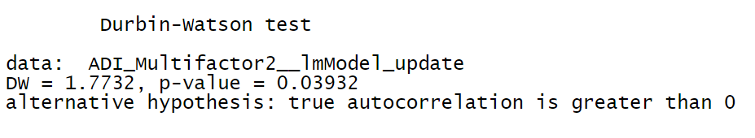

*Figure D 14 Independence Test*

The Durbin Watson statistic tests the hypothesis that there is no autocorrelation. If there is no autocorrelation (where subsequent observations are related), the Durbin-Watson statistic should be between 1.5 and 2.5, and the p-value will be above 0.05.

Our DW satisfies the condition (DW = 1.7732 (1.5< 1.7732<2.5)) but p-value doesn’t (p-value = 0.03932(0.03932<0.05)).

I deal with the influencing factors in the minority status model as independent ones, although it partly satisfies the DW test.

*3.3 Check if the mean of the residuals is zero and the sum of the residuals is zero.*

sum of the residuals = -8.222589e-16

mean of the residuals = -3.955133e-18

The mean of the errors is close to zero. The sum of the errors is close to zero.

*3.4 Check if residuals have constant variance*

However, it doesn't pass the studentized Breusch-Pagan test. Heteroscedasticity is present in the regression model.

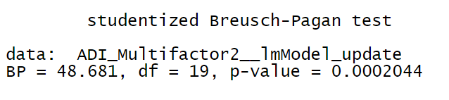

Figure D 15 Heteroscedasticity Test

From the scatter plots of the dataset, we have some outliers. And from plots of residuals, regression outliers with high leverage effect heteroscedasticity when performing a least-squares regression analysis. Because our columns are from different datasets that describe various factors, heteroscedasticity is reasonable.

b. Check Group 0

*3.5 Check if residuals are normally distributed*

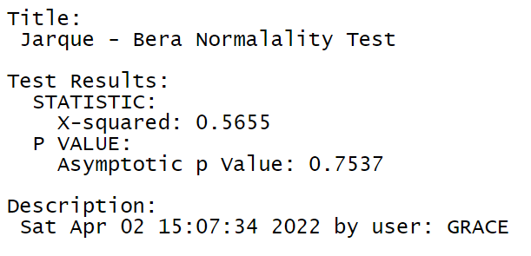

Figure D 16 Normality Test in Group 0

Null Hypothesis: Skewness and Kurtosis are equal to zero(normal distribution). p <= 0.01 : very strong presumption against null hypothesis. It is normally distributed.

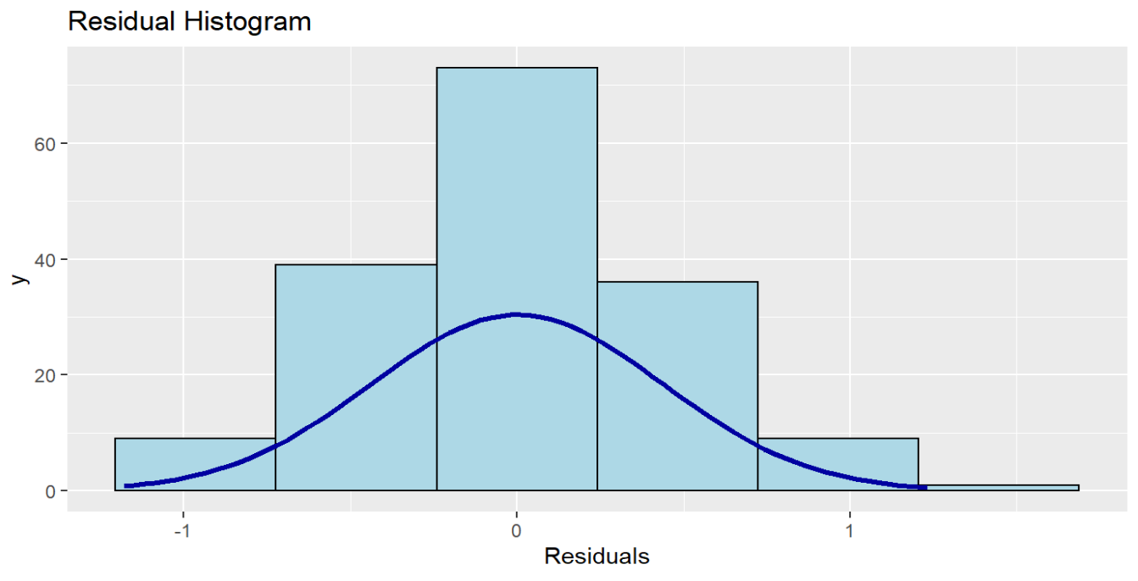

Figure D 17 Residual Histogram in Group 0

*3.6 Check if residuals are independent.*

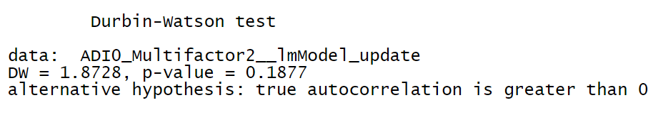

Figure D 17 Independence Test in Group 0

The Durbin Watson statistic tests the hypothesis that there is no autocorrelation. If there is no autocorrelation (where subsequent observations are related), the Durbin-Watson statistic should be between 1.5 and 2.5, and the p-value will be above 0.05.

Our DW satisfies the condition (DW = 1.8728 (1.5<1.8728<2.5)) but p-value doesn’t (p-value = 0.1877 (0.1877>0.05)).

*3.7 Check if the mean of the residuals is zero and the sum of the residuals is zero.*

sum of the residuals = -1.908196e-16

mean of the residuals = -1.139974e-18

The mean of the errors is close to zero. The sum of the errors is close to zero.

*3.8 Check if residuals have constant variance*

However, it doesn't pass the studentized Breusch-Pagan test. Heteroscedasticity is present in the regression model.

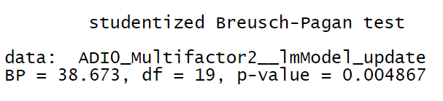

Figure D 18 Heteroscedasticity Test in Group 0

From the scatter plots of the dataset, we have some outliers. And from plots of residuals, regression outliers with high leverage effect heteroscedasticity when performing a least-squares regression analysis. Because our columns are from different datasets that describe various factors, heteroscedasticity is reasonable.

c. Check Group 1

*3.9 Check if residuals are normally distributed*

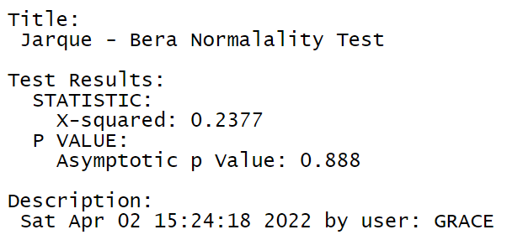

Figure D 19 Normality Test in Group 1

Null Hypothesis: Skewness and Kurtosis are equal to zero(normal distribution). p <= 0.01 : very strong presumption against null hypothesis. It is normally distributed.

*3.10 Check if residuals are independent.*

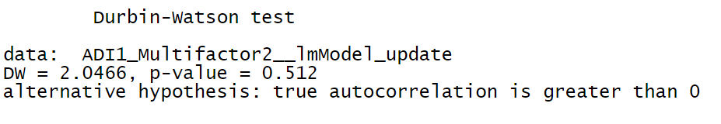

Figure D 20 Independence Test in Group 1

The Durbin Watson statistic tests the hypothesis that there is no autocorrelation. If there is no autocorrelation (where subsequent observations are related), the Durbin-Watson statistic should be between 1.5 and 2.5, and the p-value will be above 0.05.

Our DW satisfies the condition (DW = 2.0466 (1.5< 2.0466<2.5)) but p-value doesn’t (p-value = 0.512(0.512>0.05)).

The influencing factors in group 1 are independent.

*3.11 Check if the mean of the residuals is zero and the sum of the residuals is zero.*

sum of the residuals = 3.26128e-16

mean of the residuals = 7.752046e-18

The mean of the errors is close to zero. The sum of the errors is close to zero.

*3.12 Check if residuals have constant variance*

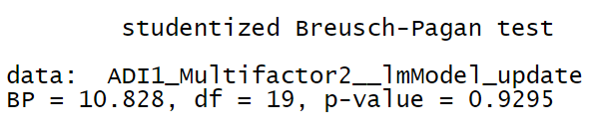

Figure D 21 Heteroscedasticity Test in Group 1

The null hypothesis of the Breusch-Pagan test is homoscedasticity (= variance does not depend on auxiliary regressors). If the p-value becomes "small"(the p-value is less than 0.05), the null hypothesis is rejected. Residuals have constant variance in group 1.

d. Summary of Regression Diagnosis

Table D 26 Summary of Regression Diagnosis in Complete Model

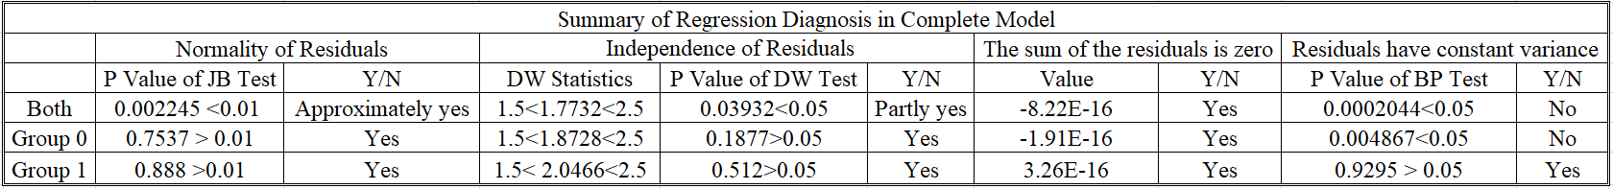

As we can see, when we add more influencing factors (19 x variables) into the model, the complete model in both groups and group 0 passes the normality and independence test. And the homoscedasticity test results have increased from the more significant p-value of the BP test.

Residuals in both groups and group 0 do not pass the test of homoscedasticity because there are many outliers in the scatter plots of both groups and group 0. Residuals in group 1 pass the normality, independence, and homoscedasticity tests because most of the points lie within the confidence bands in group 1, which is expected for the given distribution.

**4 Blinder-Oaxaca Decomposition**



Figure D 22 The Mean Uninsured Percentage by Tracts after Transformation

Table D 49 The Results of the Threefold Decomposition

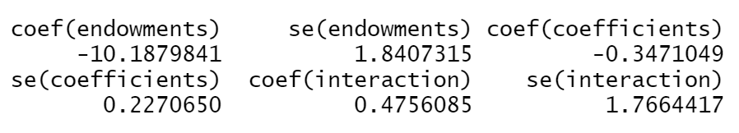

The results of the threefold decomposition suggest that, of the -10.059% difference, approximately -10.188% % can be attributed to group differences in endowments (i.e., race, English language), -0.347% to differences in coefficients, and the remaining 0.476% is accounted for by the interaction of the two.



Figure D 23 Plot of the Threefold Decomposition of Complete (ADI) Model



Figure D 24 Differences in the Regression Coefficients on Bachelor or Higher



Figure D 25 Differences in the Regression Coefficients on Multifactor 2



Figure D 26 Differences in the Regression Coefficients on White Alone

Table D 50 The Results of Twofold Decomposition

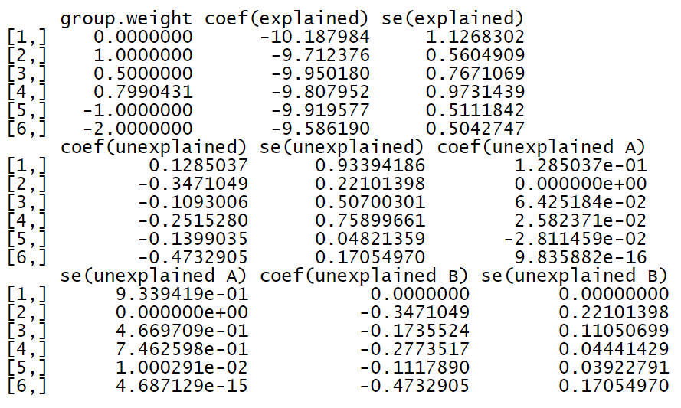

The results of the overall twofold decomposition indicate that the -10.059% uninsured percentage gap between the safe group and risk group can be decomposed into -9.919%, which can be explained by group differences in the explanatory variables -0.14% that is unexplained.

Let us assume that the unexplained component of the uninsured percentage gap occurs due to discrimination and that the pooled regression coefficients are non-discriminatory. The Blinder-Oaxaca decomposition would then also indicate that -0.028% of the unexplained part originates from discrimination in favor of safe group 0 (component "unexplained A"),

while -0.112% comes from discrimination against those who are in the risk group (component "unexplained B").



Figure D 27 The Explained and Unexplained Components of a Twofold Blinder-Oaxaca Decomposition of Safe Group 0 vs. Risk Group 1 Gap



Figure D 28 The Unexplained Portion's Discrimination Sub-Components in a Twofold Blinder-Oaxaca Decomposition of Safe group 0 vs. Risk Group 1 Gap.



Figure D 29 The Unexplained Portion's Discrimination Sub-Components in a Twofold Blinder-Oaxaca Decomposition of Safe Group 0 vs. Risk Group 1 Gap. An Alternative Presentation (1)



Figure D 30 The Unexplained Portion's Discrimination Sub-Components in a Twofold Blinder-Oaxaca Decomposition of Safe Group 0 vs. Risk Group 1 Gap. An Alternative Presentation (2)

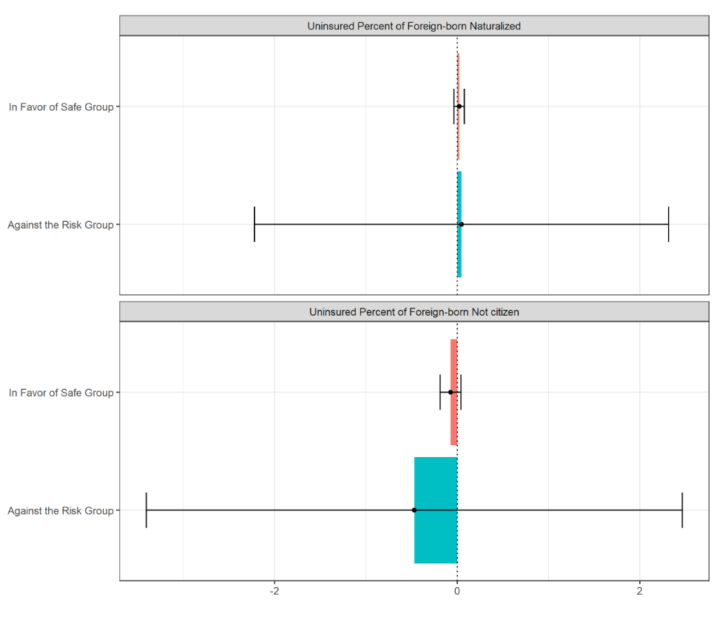

Figure D 31 The Unexplained Portion's Discrimination Sub-Components in a Twofold Blinder-Oaxaca Decomposition of Safe Group 0 vs. Risk Group 1 Gap. An Alternative Presentation (3)



Figure D 32 The Unexplained Portion's Discrimination Sub-Components in a Twofold Blinder-Oaxaca Decomposition of Safe Group 0 vs. Risk Group 1 Gap. An Alternative Presentation (4)

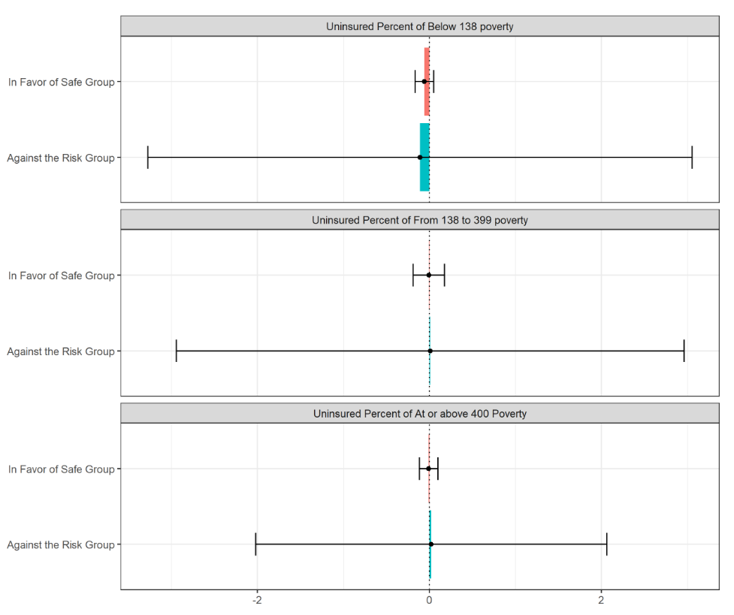

Figure D 33 The Unexplained Portion's Discrimination Sub-Components in a Twofold Blinder-Oaxaca Decomposition of Safe Group 0 vs. Risk Group 1 Gap. An Alternative Presentation (5)



Figure D 34 The Unexplained Portion's Discrimination Sub-Components in a Twofold Blinder-Oaxaca Decomposition of Safe Group 0 vs. Risk Group 1 Gap. An Alternative Presentation (6)

Table D 51 Results of Twofold Blinder-Oaxaca Decomposition

